PROJECT REPORT ON

***EVENT MANAGEMENT WEBSITE***

(UNDER THE PARTIAL FULFILLMENT OF THE

UNIVERSITY FOR COURSE OF T.Y.BSC

COMPUTER SCIENCE)

SUBMITTED BY:

**MR. VISHAL MAURYA**

GUIDED BY:

**PROF MS.BHUMIKA NAKUM**

DEPARTMENT OF COMPUTER SCIENCE

PARLE TILAK VIDYALAYA ASSOCIATION’S

MULUND COLLEGE OF COMMERCE S.N. ROAD,

MULUND (WEST), MUMBAI-80

UNIVERSITY OF MUMBAI 2020-2021



Plagiarism Checker X Originality Report

**Similarity Found: 4%**

Date: Tuesday, October 12, 2021

Statistics: 541 words Plagiarized / 14072 Total words

Remarks: Low Plagiarism Detected - Your Document needs Optional Improvement.

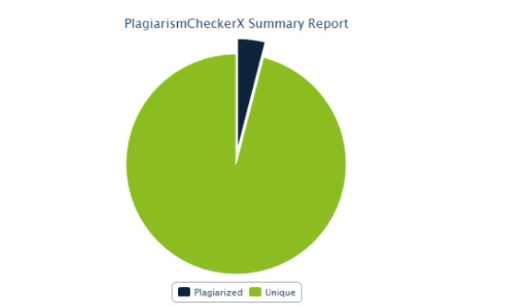

**ACKNOWLEDGEMENT**

I like to extend my gratitude to **Dr. Sonali Pednekar**, our Principal and all staff of Mulund College of Commerce for providing us moral support, conducivework environment and the much needed inspiration to complete this project on time.

I also take this opportunity to thank our Course Coordinator **Prof. Reena Shah** and all the faculties of Department of Computer Science for giving us the most needed guidance and continuous encouragementthroughout the duration of the Programme.

I wish to extend my deepest gratitude and special thanks to my project guide **Prof. Bhumika Nakum**, for giving their generous support, necessary inputs and companionship during my project work.

I would like to convey my special thanks to the Management and all the staff of the college for providing the required infrastructure and resource to enable the completion and enrichment of my project.

I am extremely grateful to the University of Mumbai for having prescribed this project work to me as a part of the academic requirement in the Final year of Bachelor of Science in Computer Science.

Finally I thank all my fellow friends who have directly or indirectly helped me in completing my project.

1. **TITLE**

**EVENT MANAGEMENT SYSTEM**

1. **INTRODUCTION**

2.1 **Objective of the project:**

* To design an online system where you can host or join any event around you.
* Design a system to fully manage the visitor in the event.

2.2 **Description of the current system:**

* Currently, the event hoster uses google forms or uses paper to note and gather visitors.
* The PR team goes to every person and tries to convince them to join the event with the new system. It can be done from anywhere without the hassle of going and convincing them.

2.3 **Limitation of the current system:**

* The current system is slow and time-consuming for both event heads and visitors.
* Hard to manage the record since the pages can be lost.
* It is hard to manage the visitor details since some data contain sensitive information which can be leaked to other people.
* The current system can only work within the given time frame.

2.4 **Description of the proposed system:**

* The proposed system will be deployed on the Internet so that it can be accessible to any other person in the world and can see or join the event with a click.
* The new system will have advanced features for maintaining the records.
* Students or any interested person can join the event just by a click and their record will be redirected to Event Head.
* Anyone can join the event which will be held in Online / Offline mode without actually going to colleges or to event heads.

2.5 **Advantages of the proposed system:**

* In the proposed system you can easily join or unjoin the event without any hassle.
* This system does not rely on the event head to get confirmation of every member joining the event. As soon as the joiner joins the event he will get confirmation about his joining.
* Each event has been dynamically generated from the database which displays the details about every event.
* Members can join or event heads can host events at any time.

**3. Data Requirement**

**3.1 Software requirement**

1. FRONT END - HTML, CSS, BOOTSTRAP
2. BACKEND - PHP

3.2 **Hardware Requirement**

Developer side:

1. Processor - 2.0 GHz
2. RAM - 4 GB or more
3. Disk space - 3GB for more

Client-side:

1. Any Browser

3.3 **Data requirement**

1. First name (text)
2. Last name (text)
3. Email (varchar)
4. Phone number (int)
5. Location (text)
6. Date of birth (date)
7. Event_id (int)

3.4 **Fact-finding questions**

1. Who will be accessing the hosted events?
2. Who will be creating the event?
3. Why do we need this new system?
4. What is the scope of the new system?
5. How will the data be stored and accessed?

**4. System Design Table**

**4.1 Event Table**

|  |  |  |  |  |  |  |
| --- | --- | --- | --- | --- | --- | --- |
| Sr No. | Events | Trigger | Source | Activity | Response | Destination |
| 1 | Register | Sign Up Button | Users, Event Head | Validating data | Successful or Unsuccessful message | Redirect to login.php |
| 2 | Login | Login Button | Users, Event Head | Verifying data | On successful login redirect to index.php else give error message | index.php |
| 3 | Forgot Password | Forgot-password button | Users, Event Head | Verifying data | When changed the password gives a successful message else give error message | login.php |
| 4 | Host Event | Host-event button | Event Heads | Host a new event | On successful hosting of the event, it returns a success message | add-sub-events.php |
| 5 | Add Sub event | add-sub-event button | Event Head | Add the sub-event of hosted event | By adding sub-event it gives a success message else gives a warning | manage-event.php |
| 6 | Delete sub-event | Delete-sub-event.php button | Event Head | Delete the sub-event | On deletion of sub-event, it gives a success message. | manage-event.php |
| 7 | Update sub-event | Update sub-event button | Event Head | Update the sub-event | After updating sub-event give success message else give warning messgae | manage-event.php |
| 8 | Save Subevent | Save subevent button | User | Save the event in database | After saving redirect to all saved event page | Save-event.php |
| 9 | Join Event | Join-event button | User | Join the event | Join the event and redirect to event schedule | Event.php |
| 10 | Unjoin Event | Unjoin-evemt.php | User | Unjoin the event | Unjoin the event and redirect to event schedle | Event.php |
| 11 | View Profile | View the profile | User / Admin | View the profile | View profile with update button | View-profile.php |
| 12 | Report | Report LinkButton | Admin | View the report of event | View all the response on event | Report.php |

**4.2 CLASS DIAGRAM**

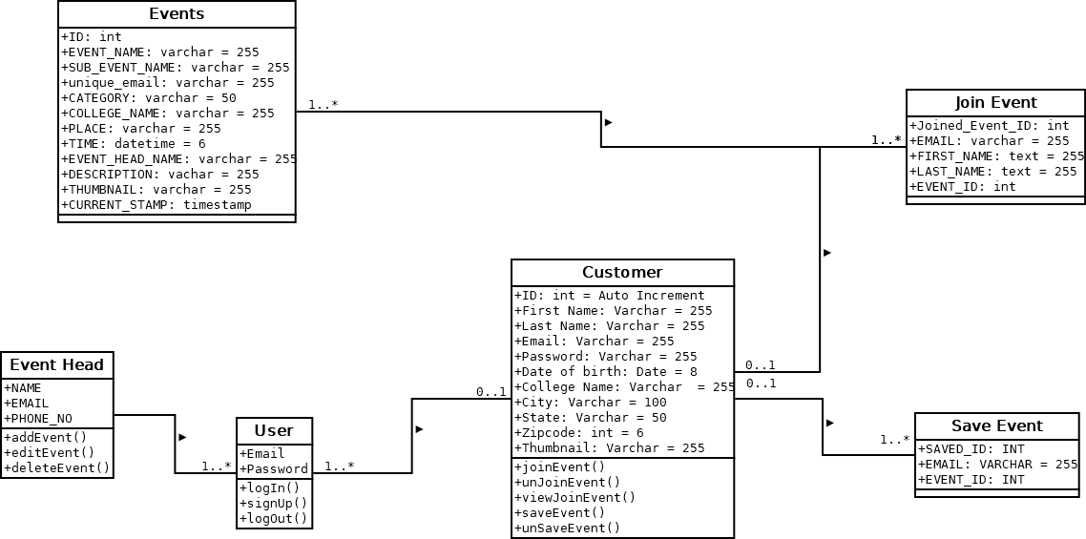

**4.3 USE CASE DIAGRAM**

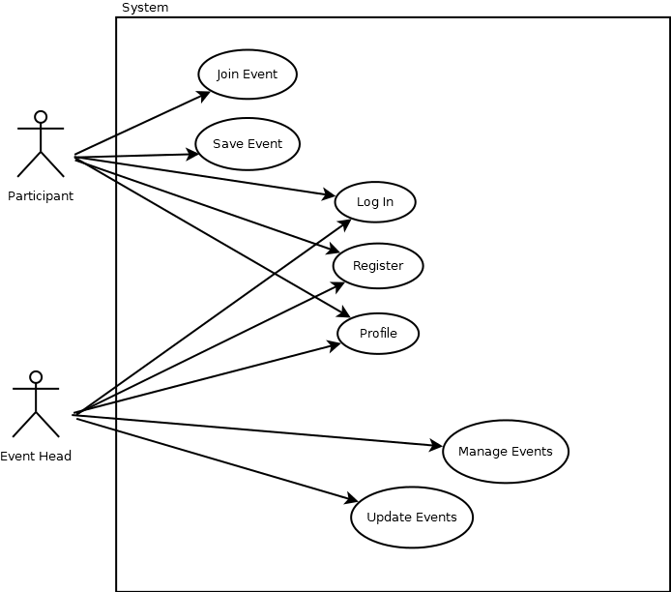

**4.4 SEQUENCE DIAGRAM**

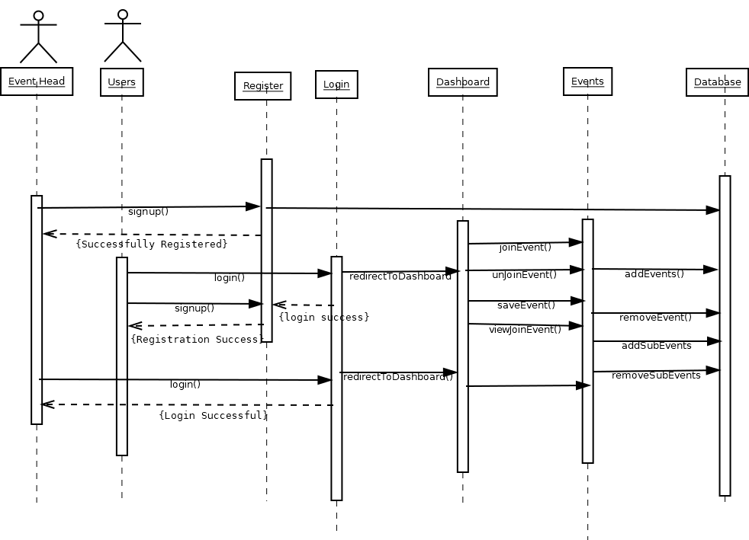

**4.5 ACTIVITY DIAGRAM**

**4.5.1 USER SIDE**

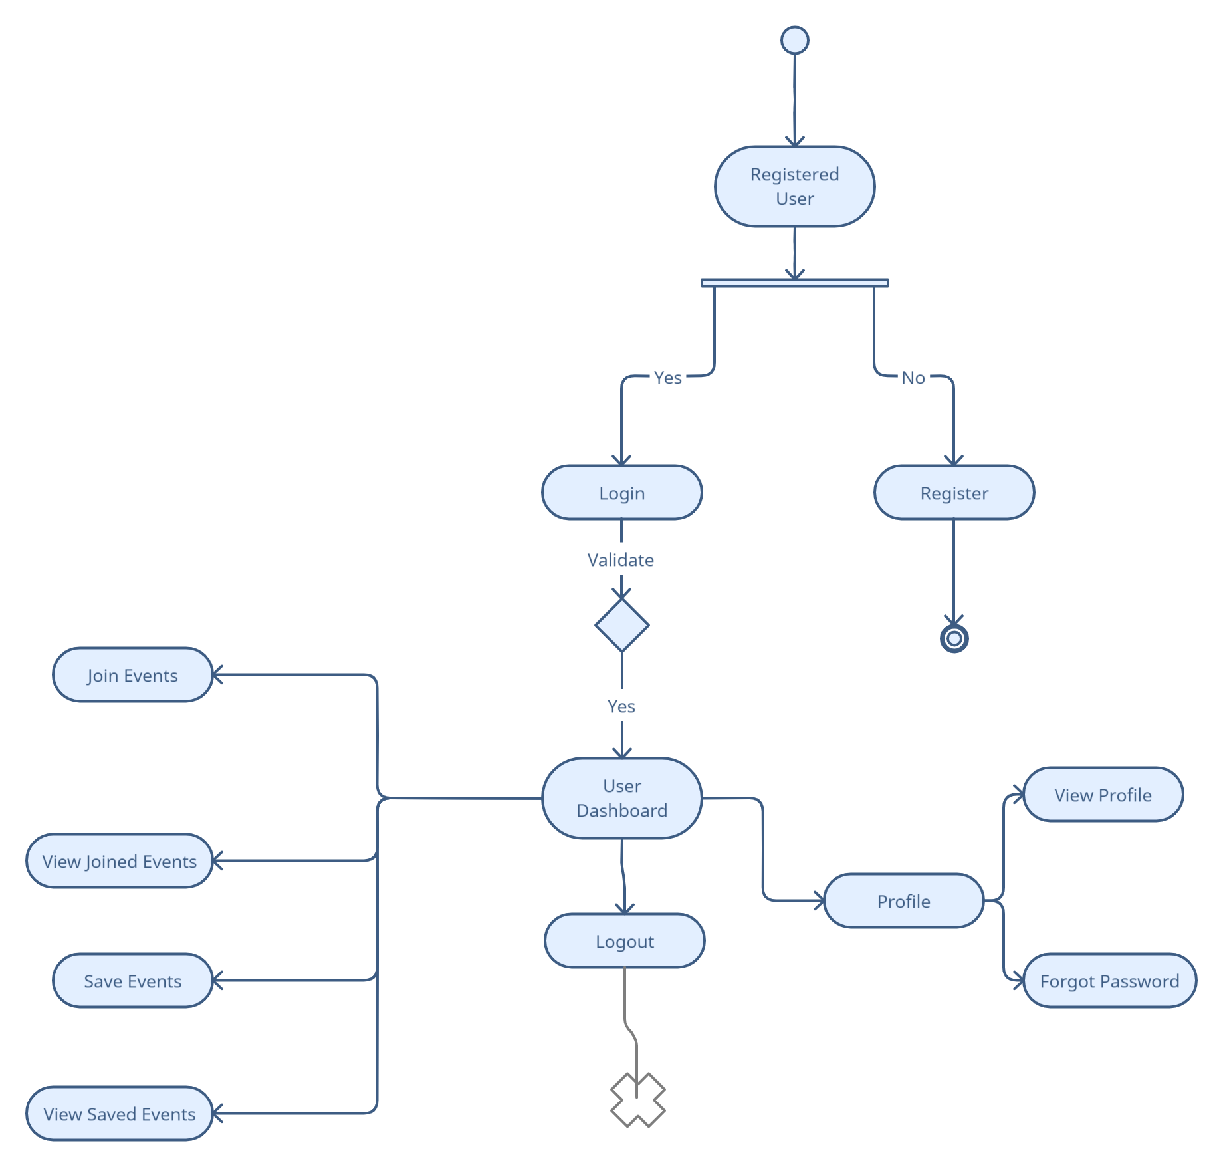

**4.5.2 ADMIN SIDE**

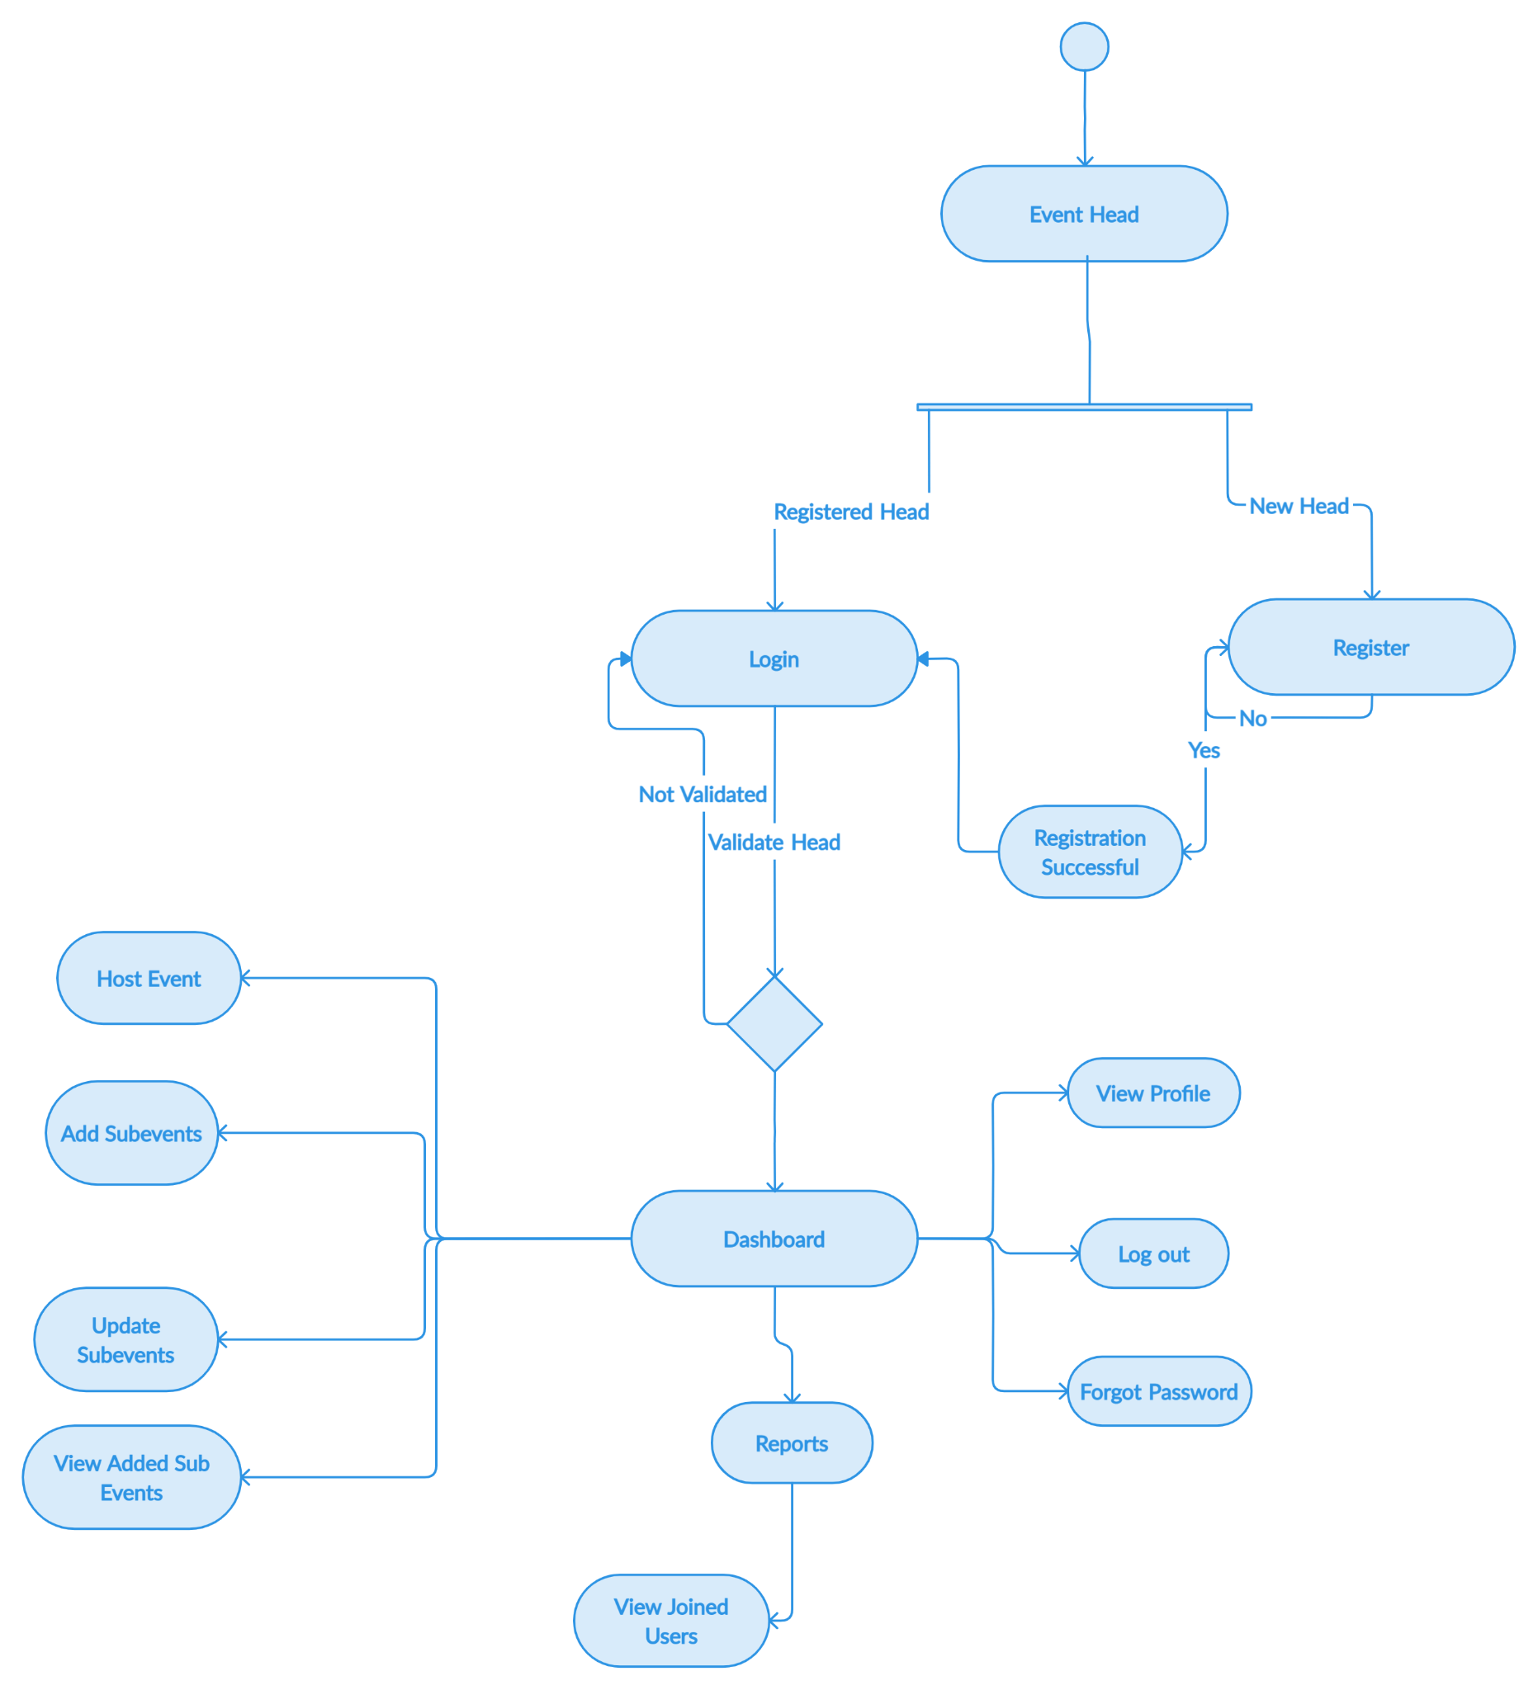

**4.6 STATE DIAGRAM**

**4.6.1 CLIENT SIDE**

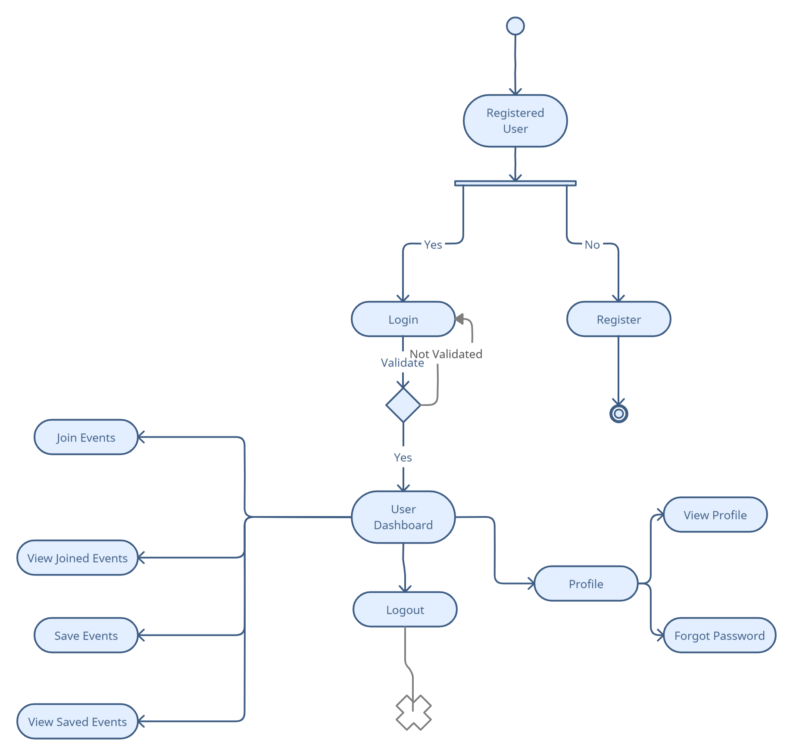

**4.6.2 ADMIN SIDE**

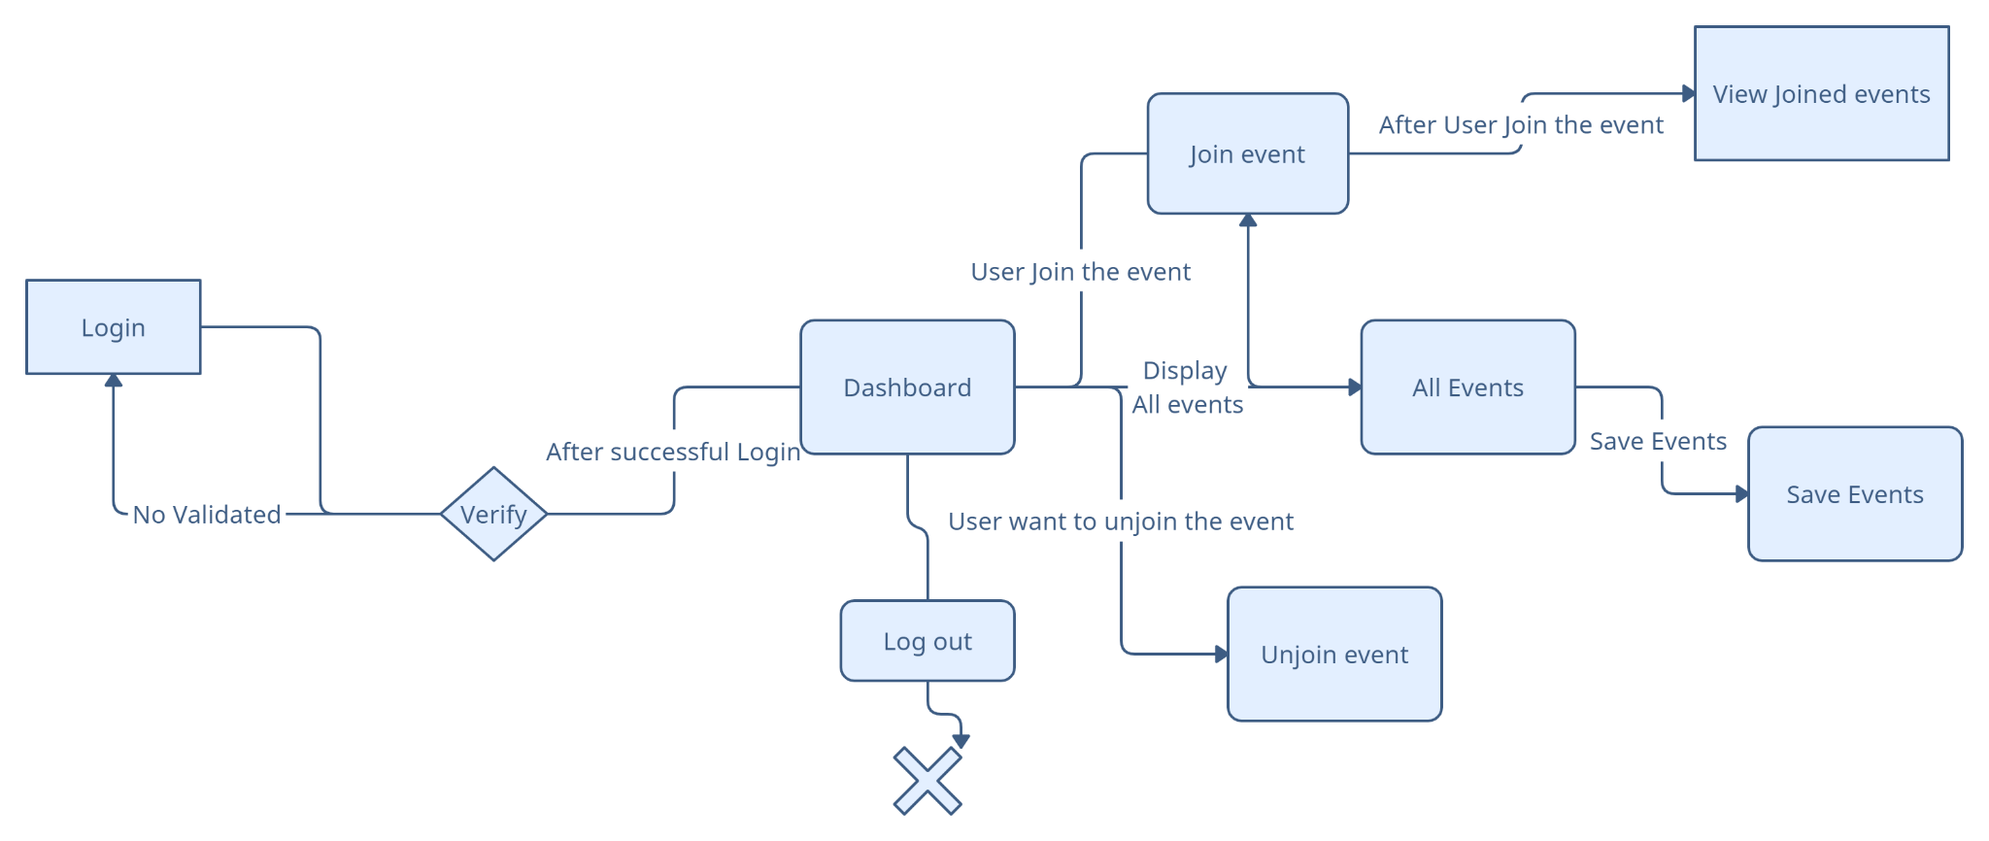

**4.7 PACKAGE DIAGRAM**

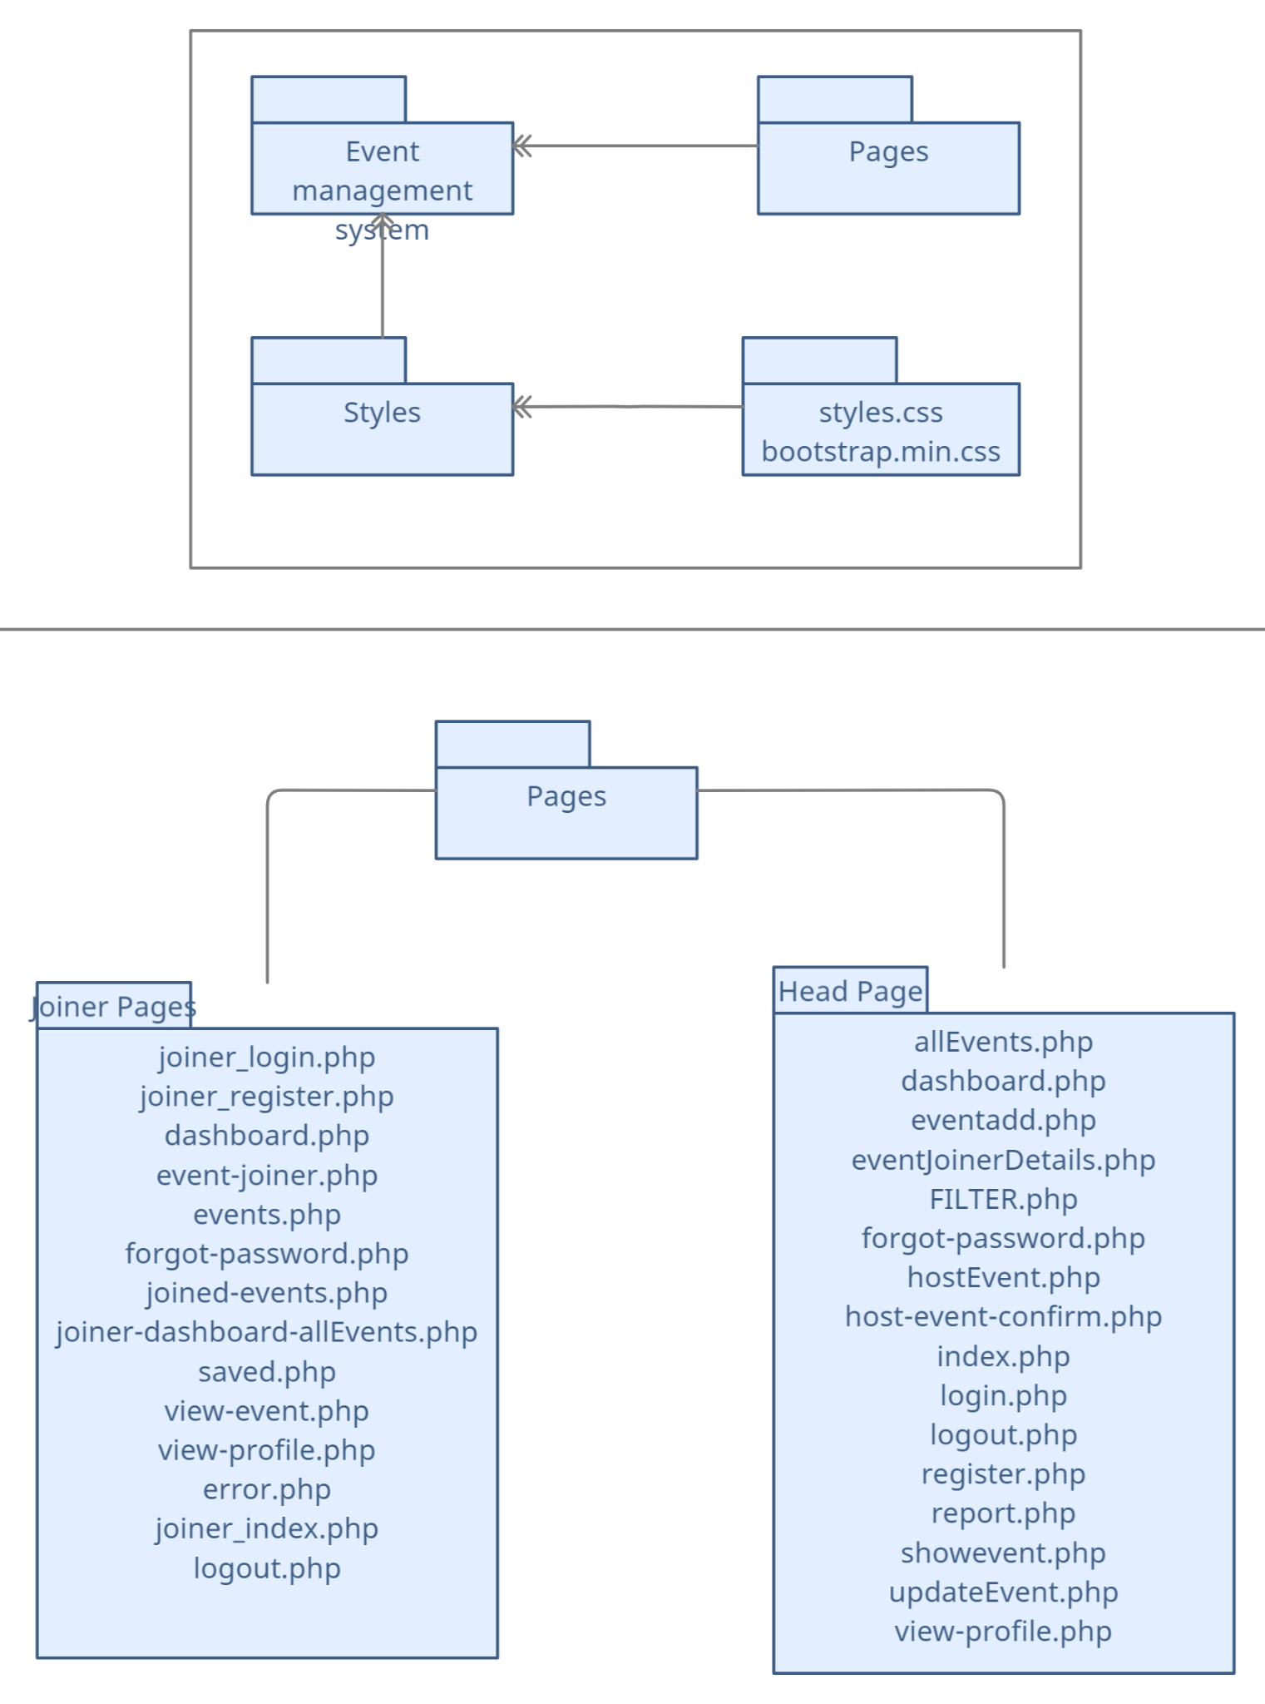

**4.8 COMPONENT DIAGRAM**

**4.8.1 USER SIDE**

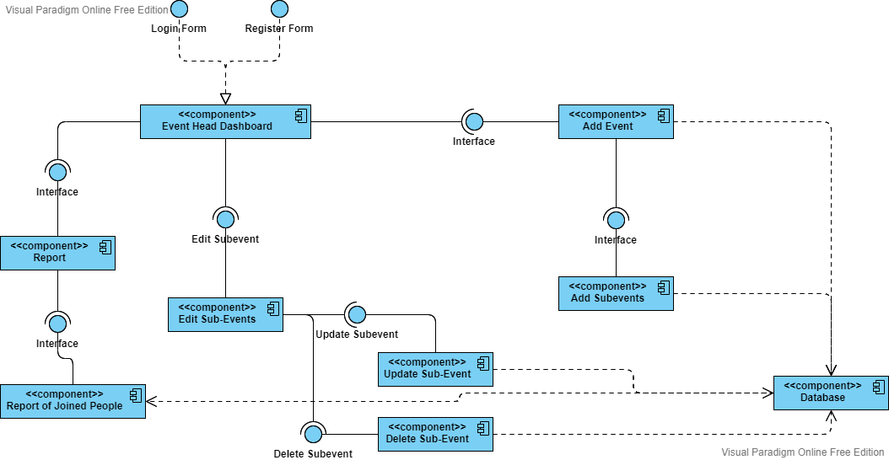

**4.8.2 ADMIN SIDE**

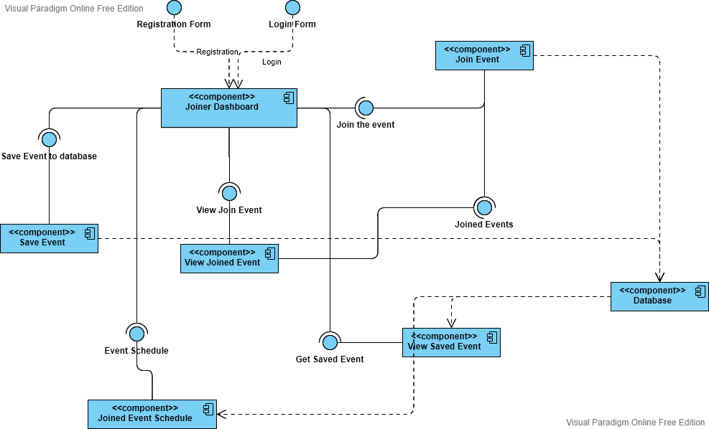

**4.9 DEPLOYMENT DIAGRAM**

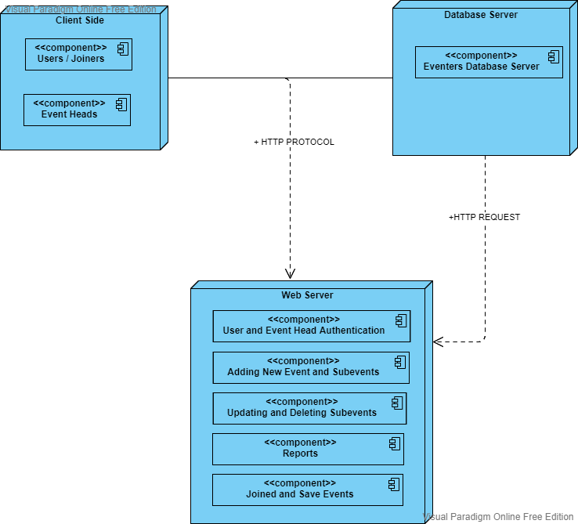

**4.10 DATABASE DESIGN**

DATABASE TABLES

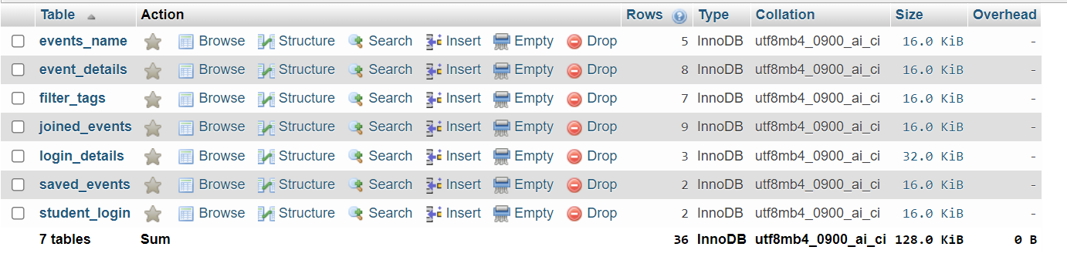

EVENT NAMES

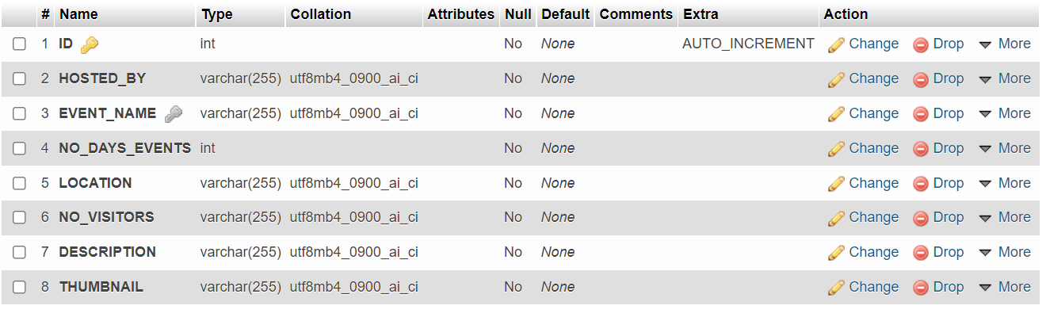

|  |  |  |  |
| --- | --- | --- | --- |
| **FIELD** | **DATA TYPES** | **DESCRIPTION** | **ATTRIBUTES** |
| ID | INT | ID OF EVENTS | NOT NULL, PRIMARY, AUTO-INCREMENT |
| HOSTED BY | VARCHAR | EMAIL OF HEAD | NOT NULL |
| EVENT NAME | VARCHAR | NAME OF EVENT | UNIQUE, NOT NULL |
| NO OF DAYS EVENTS | INT | NUMBER OF DAYS EVENT WILL TAKE PLACE | NOT NULL |

|  |  |  |  |
| --- | --- | --- | --- |
| LOCATION | VARCHAR | LOCATION OF EVENT | NOT NULL |
| NO OF VISITORS | INT | NUMBER OF VISITORS IN EVENT | NOT NULL |
| DESCRIPTION | VARCHAR | DESCRIPTION OF EVENT | NOT NULL |
| THUMBNAIL | VARCHAR | PHOTO FOR EVENT | NOT NULL |

Sub-event Details

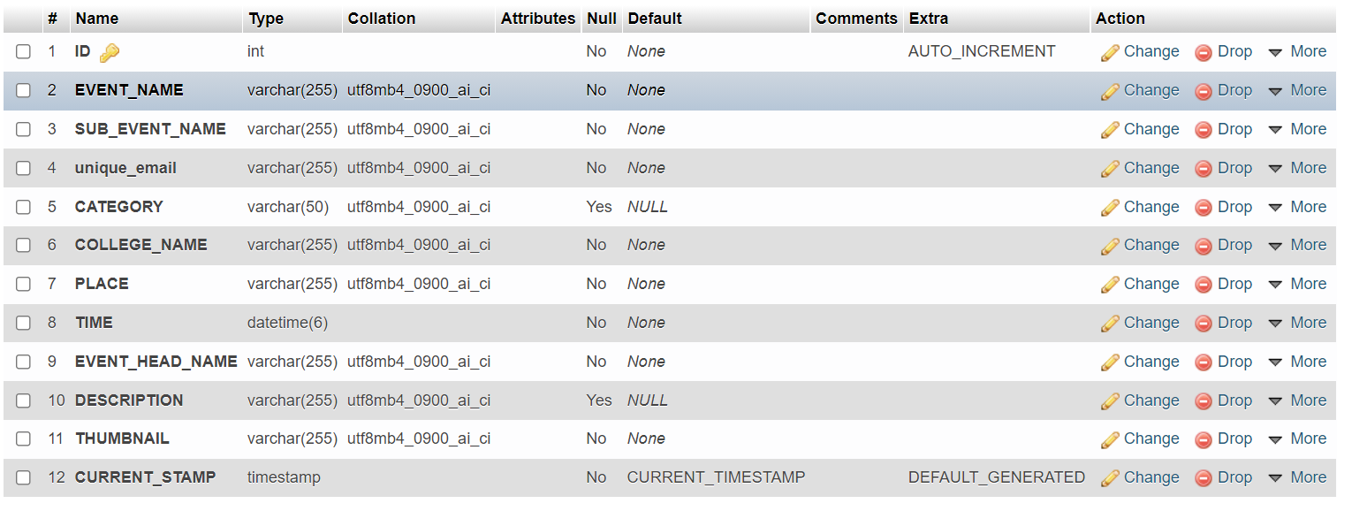

|  |  |  |  |
| --- | --- | --- | --- |
| ID | INT | ID OF SUBEVENT | NOT NULL, PRIMARY, AUTO INCREMENT |
| EVENT_NAME | VARCHAR | NAME OF EVENT | NOT NULL |
| SUB_EVENT_NAME | VARCHAR | NAME OF SUBEVENT | NOT NULL |
| UNIQUE_EMAIL | VARCHAR | EMAIL OF HEAD | NOT NULL |
| CATEGORY | INT | CATEGORY OF SUBEVENT | NOT NULL |
| COLLEGE_NAME | VARCHAR | NAME OF THE COLLEGE | NOT NULL |
| PLACE | VARCHAR | LOCATION | NOT NULL |
| TIME | DATETIME | TIME OF EVENT | NOT NULL |
| EVENT_HEAD_NAME | VARCHAR | NAME OF HEAD | NOT NULL |
| DESCRIPTION | VARCHAR | DESCRIPTION OF SUBEVENT | NOT NULL |
| THUMBNAIL | VARCHAR | PHOTO FOR SUB EVENT | NOT NULL |

FILTER_TAGS

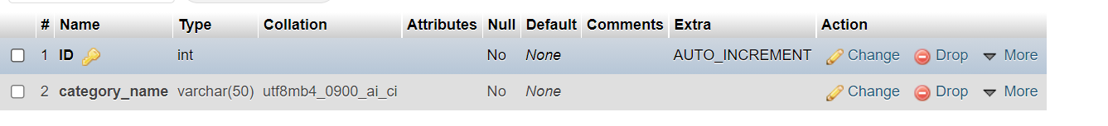

|  |  |  |  |
| --- | --- | --- | --- |
| FIELD | DATA TYPE | DESCRIPTION | ATTRIBUTE |
| ID | INT | ID OF THE CATEGORY | NOT NULL, PRIMARY, AUTO-INCREMENT |
| CATEGORY NAME | VARCHAR | NAME OF CATEGORY | NOT NULL |

JOINED SUBEVENTS

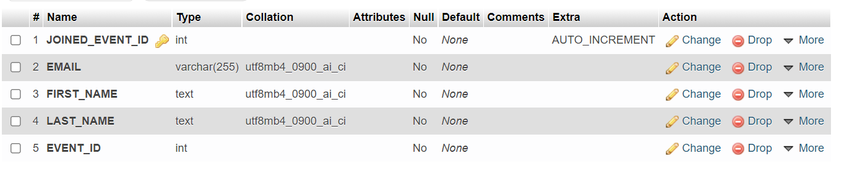

|  |  |  |  |
| --- | --- | --- | --- |
| FIELD | DATA TYPE | DESCRIPTION | ATTRIBUTE |
| JOINED_EVENT_ID | INT | ID OF JOINED EVENT | NOT NULL, PRIMARY, AUTO INCREMENT |
| EMAIL | VARCHAR | EMAIL OF USER | NOT NULL |
| FIRST NAME | VARCHAR | NAME OF USER | NOT NULL |
| LAST NAME | VARCHAR | LAST NAME OF USER | NOT NULL |
| EVENT_ID | INT | JOINED EVENT ID | NOT NULL |

LOGIN DETAILS

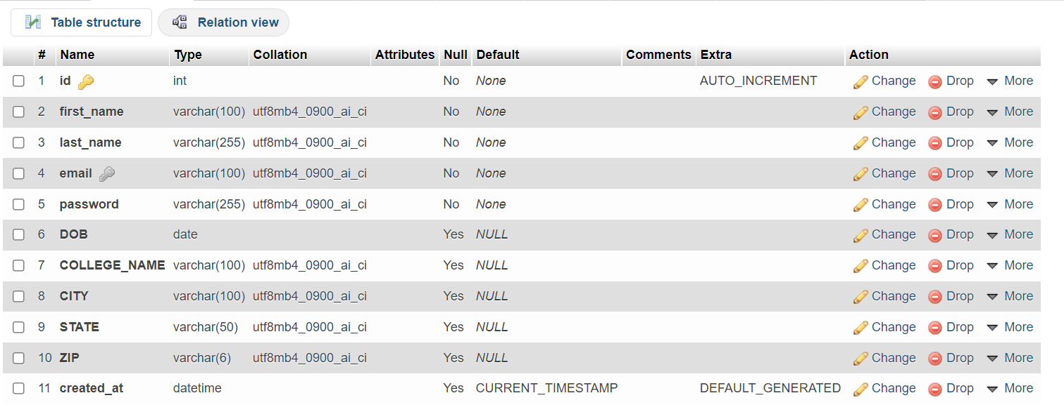

|  |  |  |  |
| --- | --- | --- | --- |
| FIELD | DATA TYPES | DESCRIPTION | ATTRIBUTES |
| ID | INT | ID OF USER | NOT NULL, PRIMARY, AUTO-INCREMENT |
| FIRST_NAME | VARCHAR | FIRST NAME OF USER | NOT NULL |
| LAST NAME | VARCHAR | LAST NAME OF USER | NOT NULL |
| EMAIL | VARCHAR | EMAIL OF USER | NOT NULL |
| PASSWORD | VARCHAR | PASSWORD | NOT NULL |
| DOB | DATE | DATE OF BORTH | NULL |
| COLLEGE_NAME | VARCHAR | COLLEGE NAME | NULL |
| CITY | VARCHAR | CITY | NULL |
| STATE | VARCHAR | STATE | NULL |
| ZIP | VARCHAR | ZIP | NULL |

SAVED EVENTS

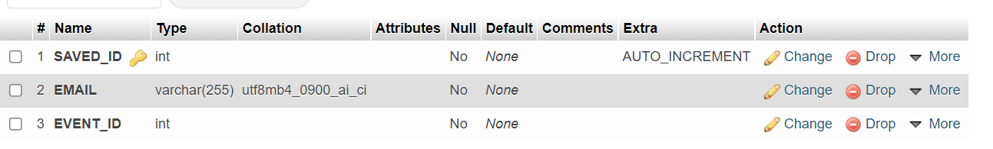

|  |  |  |  |
| --- | --- | --- | --- |
| FIELD | DATA TYPE | DESCRIPTION | ATTRIBUTE |
| SAVED_ID | INT | ID | NOT NULL, PRIMARY, AUTO-INCREMENT |
| EMAIL | VARCHAR | EMAIL OF USER | NOT NULL |
| EVENT_ID | INT | SAVED EVENT ID | NOT NULL |

STUDENT LOGIN DETAILS

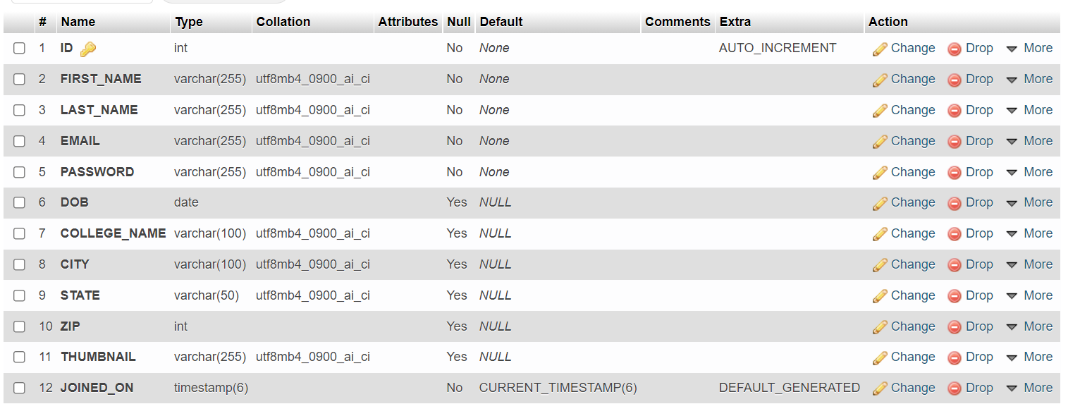

|  |  |  |  |
| --- | --- | --- | --- |
| FIELD | DATA TYPES | DESCRIPTION | ATTRIBUTES |
| ID | INT | ID OF USER | NOT NULL, PRIMARY, AUTO-INCREMENT |
| FIRST_NAME | VARCHAR | FIRST NAME OF USER | NOT NULL |
| LAST NAME | VARCHAR | LAST NAME OF USER | NOT NULL |
| EMAIL | VARCHAR | EMAIL OF USER | NOT NULL |
| PASSWORD | VARCHAR | PASSWORD | NOT NULL |
| DOB | DATE | DATE OF BORTH | NULL |
| COLLEGE_NAME | VARCHAR | COLLEGE NAME | NULL |
| CITY | VARCHAR | CITY | NULL |
| STATE | VARCHAR | STATE | NULL |
| ZIP | VARCHAR | ZIP | NULL |
| THUMBNAIL | VARCHAR | PROFILE PHOTO OF USER | NULL |

**5.1 SYSTEM IMPLEMENTATION**

**MODULE 1 - EVENT HEADS**

**Header.php**

<?php

session_start();

?>

<!DOCTYPE html>

<html lang="en">

<head>

<meta charset="utf-8">

<meta http-equiv="X-UA-Compatible" content="IE=edge">

<meta name="viewport" content="width=device-width, initial-scale=1, shrink-to-fit=no">

<meta name="description" content="">

<meta name="author" content="">

<title><?php echo $title; ?></title>

<link href="https://fonts.googleapis.com/css2?family=Roboto+Slab:wght@100;200;400;800&display=swap" rel="stylesheet">

<!-- Boxicons CSS -->

<link href='https://unpkg.com/boxicons@2.0.7/css/boxicons.min.css' rel='stylesheet'>

<link href="styles/bootstrap.min.css" rel="stylesheet">

<link href="styles/EH-style.css" rel="stylesheet">

</head>

<body class =<?php echo $bodyColor; ?>>

Navbar.php

<!-- header -->

<header class="header shadow bg-white mb-4 shadow">

<div class="header__container ">

<a href="EH_index.php" class="header__logo">Eventers - Event Heads</a>

<div class="header_search">

<!-- <input type="search" placeholder="Search event..." class="header__input">

<i class='bx bx-search search__icon'></i> -->

<form class="d-none d-sm-inline-block form-inline mr-auto ml-md-3 my-2 my-md-0 mw-100 navbar-search">

<div class="input-group">

<input type="text" class="form-control bg-light border-0 small" placeholder="Search for..." aria-label="Search" aria-describedby="basic-addon2" style="border-radius: 0 !important;">

<div class="input-group-append">

<button class="btn btn-primary" type="button">

<i class='bx bx-search'></i>

</button>

</div>

</div>

</form>

</div>

<div class="header__toggle">

<i class='bx bx-menu' id='header_toggle'></i>

</div>

<!-- Nav Item - User Information -->

<li class="nav-item dropdown no-arrow" style="list-style-type: none;">

<a class="nav-link dropdown-toggle" id="userDetailDropdown" role="button" data-toggle="dropdown" aria-haspopup="true" aria-expanded="true">

<span class="mr-2 d-none d-lg-inline text-gray-600 small"><?php echo "Hello&nbsp;" . $_SESSION['first_name']; //echo str_repeat('&nbsp;', 2); echo $_SESSION['last_name'];

?></span>

<img class="img-profile rounded-circle" src="img/undraw_profile.svg">

</a>

<!-- Dropdown - User Information -->

<div class="dropdown-menu dropdown-menu-right shadow animated--grow-in" aria-labelledby="userDetailDropdown">

<a class="dropdown-item" href="view-profile.php">

<i class="fas fa-user fa-sm fa-fw mr-2 text-gray-400"></i>

Profile

</a>

<a class="dropdown-item" href="#">

<i class="fas fa-cogs fa-sm fa-fw mr-2 text-gray-400"></i>

Settings

</a>

<a class="dropdown-item" href="#">

<i class="fas fa-list fa-sm fa-fw mr-2 text-gray-400"></i>

Activity Log

</a>

<div class="dropdown-divider"></div>

<a class="dropdown-item" href="logout.php" data-toggle="modal" data-target="#logoutModal">

<i class="fas fa-sign-out-alt fa-sm fa-fw mr-2 text-gray-400"></i>

Logout

</a>

</div>

</li>

</div>

</header>

<!-- Navbar -->

<nav id="navbar" class="nav">

<div class="nav__container">

<a href="index.php" class="nav__links nav__logo">

<i class='bx bx-disc nav__box_icons'></i>

<span class="nav__logo__name">Eventers</span>

</a>

<div class="nav__list">

<div class="nav__items">

<h3 class="nav__subtitle">Details</h3>

</div>

<a href="dashboard.php" class="nav__links">

<i class='bx bx-home-alt nav__box_icons'></i>

<span class="nav__name">Home</span>

</a>

<div class="nav__dropdown active">

<a href="view-profile.php" class="nav__links">

<i class='bx bx-user nav__box_icons'></i>

<span class="nav__name">Profile</span>

<i class='bx bx-chevron-down nav__icon nav__dropdown_icon'></i>

</a>

<div class="nav__dropdown__collapse bg-white">

<div class="nav__dropdown__content">

<a href="viewProfile.php" class="nav__dropdown__item">Account</a>

<a href="forgot-password.php" class="nav__dropdown__item">Password</a>

</div>

</div>

</div>

<a href="report.php" class="nav__links margin__bottom__2rem">

<i class='bx bx-message nav__box_icons'></i>

<span class="nav__name">Report</span>

</a>

</div>

<div class="nav__list">

<div class="nav__items">

<h3 class="nav__subtitle">Events</h3>

</div>

<a href="index.php" class="nav__links">

<i class='bx bx-compass nav__box_icons'></i>

<span class="nav__name">Explore</span>

</a>

<a href="allEvents.php" class="nav__links">

<i class='bx bx-purchase-tag-alt nav__box_icons'></i>

<span class="nav__name">All events</span>

</a>

<a href="hostEvent.php" class="nav__links">

<i class='bx bx-plus-medical nav__box_icons'></i>

<span class="nav__name">Host an event</span>

</a>

<a href="eventadd.php" class="nav__links">

<i class='bx bx-edit-alt nav__box_icons'></i>

<span class="nav__name">Manage events

</span>

</a>

</div>

<a href="logout.php" class="nav__links nav__logout">

<i class='bx bx-log-out nav__box_icons'></i>

<span class="nav__name">Log out</span>

</a>

</div>

</div>

</nav>

<!-- Logout Modal-->

<div class="modal fade" id="logoutModal" tabindex="-1" role="dialog" aria-labelledby="exampleModalLabel" aria-hidden="true">

<div class="modal-dialog" role="document">

<div class="modal-content">

<div class="modal-header">

<h5 class="modal-title" id="exampleModalLabel">Ready to Leave?</h5>

<button class="close" type="button" data-dismiss="modal" aria-label="Close">

<span aria-hidden="true">×</span>

</button>

</div>

<div class="modal-body">Select "Logout" below if you are ready to end your current session.</div>

<div class="modal-footer">

<button class="btn btn-secondary" type="button" data-dismiss="modal">Cancel</button>

<a class="btn btn-primary" href="login.php">Logout</a>

</div>

</div>

</div>

</div>

Footer.php

<!-- Footer -->

<footer class="sticky-footer">

<div class="container my-auto">

<div class="copyright text-center my-auto">

<span>Copyright &copy; Vishal Maurya</span>

</div>

</div>

</footer>

<!-- End of Footer -->

<script src="https://code.jquery.com/jquery-3.2.1.slim.min.js" integrity="sha384-KJ3o2DKtIkvYIK3UENzmM7KCkRr/rE9/Qpg6aAZGJwFDMVNA/GpGFF93hXpG5KkN" crossorigin="anonymous"></script>

<script src="https://code.jquery.com/jquery-3.2.1.slim.min.js" integrity="sha384-KJ3o2DKtIkvYIK3UENzmM7KCkRr/rE9/Qpg6aAZGJwFDMVNA/GpGFF93hXpG5KkN" crossorigin="anonymous"></script>

<script src="js/admin_main.js"></script>

<script src="https://cdnjs.cloudflare.com/ajax/libs/popper.js/1.12.9/umd/popper.min.js" integrity="sha384-ApNbgh9B+Y1QKtv3Rn7W3mgPxhU9K/ScQsAP7hUibX39j7fakFPskvXusvfa0b4Q" crossorigin="anonymous"></script>

<script src="https://maxcdn.bootstrapcdn.com/bootstrap/4.0.0/js/bootstrap.min.js" integrity="sha384-JZR6Spejh4U02d8jOt6vLEHfe/JQGiRRSQQxSfFWpi1MquVdAyjUar5+76PVCmYl" crossorigin="anonymous"></script>

</body>

</html>

**Dashboard.php**

<?php

$title = "Dashboard - Eventers";

$bodyColor = 'bg-white';

include 'includes/header.php';

include 'includes/navbar.php';

?>

<div class="container-fluid mt-5">

<div class="row">

<div class="col">

<div class="card border-0 text-white bg-success mb-3" style="max-width: 20rem;">

<div class="card-header">Responses</div>

<div class="card-body bg-light">

<p class="dashboard-card-title">255 New Responses</p>

<button class="btn btn-success btn-sm">Check</button>

</div>

</div>

</div>

<div class="col">

<div class="card border-0 text-white bg-info mb-3" style="max-width: 20rem;">

<div class="card-header">Number of events</div>

<div class="card-body bg-light">

<p class="dashboard-card-title">6</p>

<button class="btn btn-info btn-sm">Check</button>

</div>

</div>

</div>

<div class="col">

<div class="card border-0 text-white bg-dark mb-3" style="max-width: 20rem;">

<div class="card-header">Most Liked Event</div>

<div class="card-body bg-light">

<p class="dashboard-card-title">BGMI - no of likes</p>

<button class="btn btn-dark btn-sm">Check</button>

</div>

</div>

</div>

</div>

<div class="row">

<div class="col-4">

<div class="card rounded mb-3">

<h3 class="card-header bg-primary">Ready to host a event</h3>

<img src="img/party.jpg" alt="" class="dashboard-add-event">

<div class="card-body">

<p class="card-text">Host a event for your college or your own free of cost.</p>

</div>

<div class="card-body">

<a href="eventadd.php" class="card-link btn btn-sm btn-primary">Host event</a>

</div>

</div>

</div>

</div>

</div>

<?php

include 'includes/footer.php';

?>

**Allevents.php**

<?php

session_start();

require '../db/dbconfig.php';

?>

<!DOCTYPE html>

<html lang="en">

<head>

<meta charset="UTF-8">

<meta http-equiv="X-UA-Compatible" content="IE=edge">

<meta name="viewport" content="width=device-width, initial-scale=1.0">

<title>Eventers</title>

<link rel="stylesheet" href="https://use.fontawesome.com/releases/v5.15.3/css/all.css" integrity="sha384-SZXxX4whJ79/gErwcOYf+zWLeJdY/qpuqC4cAa9rOGUstPomtqpuNWT9wdPEn2fk" crossorigin="anonymous">

<link href="https://fonts.googleapis.com/css2?family=Roboto+Slab:wght@100;300;400;700&display=swap" rel="stylesheet">

<!-- Boxicons CSS -->

<link href='https://unpkg.com/boxicons@2.0.7/css/boxicons.min.css' rel='stylesheet'>

<!-- Bootstrap CSS -->

<link rel="stylesheet" href="styles/bootstrap.min.css">

<!-- Custom CSS -->

<link rel="stylesheet" href="styles/indexStyle.css">

</head>

<body>

<nav class="navbar navbar-expand-lg navbar-light bg-white shadow p-2 static-top">

<div class="container-fluid">

<a class="navbar-brand" href="index.php">

<lottie-player src="https://assets7.lottiefiles.com/temporary_files/PH5YkW.json" background="transparent" speed="1" style="width: 70px; height: 35px;" class="d-inline-block align-text-top mt-0" loop autoplay></lottie-player>

<strong>Eventers</strong>

</a>

<button class="navbar-toggler" type="button" data-bs-toggle="collapse" data-bs-target="#navbarColor01" aria-controls="navbarColor01" aria-expanded="true" aria-label="Toggle navigation">

<span class="navbar-toggler-icon"></span>

</button>

<div class="navbar-collapse collapse show" id="navbarColor01">

<ul class="navbar-nav" style="margin-left: auto; margin-right:5%">

<li class="nav-item">

<form>

<div class="input-group ">

<input type="txt" class="form-control border-0 border-circle" name="search" placeholder="Search event...">

<div class="input-group-btn">

<button class="btn btn-default" type="submit">

<i class="fas fa-search"></i>&nbsp;

</button>

</div>

</div>

</form>

</li>

<li class="nav-item">

<a class="nav-link active" href="index.php"><i class="fas fa-home"></i> Home

<span class="visually-hidden">(current)</span>

</a>

</li>

<li class="nav-item">

<a class="nav-link" href="allEvents.php"><i class="fas fa-calendar-alt"></i> Events</a>

</li>

<li class="nav-item">

<a class="nav-link" href="../public_html/pages/about-us.php"><i class="fas fa-info"></i> About</a>

</li>

<li class="nav-item">

<a class="nav-link" href="../public_html/pages/contact-us.php"><i class="fas fa-id-card"></i> Contact us</a>

</li>

<li class="nav-item dropdown">

<a class="nav-link dropdown-toggle user-account-toggle" data-bs-toggle="dropdown" href="#" role="button" aria-haspopup="true" aria-expanded="false"><i class="fas fa-user-circle"></i> Account</a>

<div class="dropdown-menu dropdown-menu-left">

<a class="dropdown-item dropdown-item-or"><?php echo "Hello " . $_SESSION['first_name']; ?></a>

<a class="dropdown-item dropdown-item-or" href="dashboard.php">Dashboard</a>

<a class="dropdown-item dropdown-item-or" href="#">Something</a>

<div class="dropdown-divider"></div>

<a class="dropdown-item dropdown-item-or" href="logout.php">Log out</a>

</div>

<style>

.user-account-toggle::after {

content: none;

}

</style>

</li>

</ul>

</div>

</div>

</nav>

<div class="container mt-3">

<div class="container mt-4">

<div class="row">

<div class="col-lg-4 col-md-6 mb-4">

<div class="card h-100">

<form action="" method="GET">

<div class="card border-0">

<div class="card-header">

<h5>Filter

<button type="submit" class="btn btn-primary btn-sm float-end">Search</button>

</h5>

</div>

<div class="card-body">

<h6>Category List</h6>

<hr>

<?php

$filter_query = "SELECT * FROM `filter_tags`";

$filter_query_run = mysqli_query($link, $filter_query);

if (mysqli_num_rows($filter_query_run) > 0) {

foreach ($filter_query_run as $filterlist) {

$checked = [];

if (isset($_GET['filters'])) {

$checked = $_GET['filters'];

}

?>

<div>

<input type="checkbox" name="filters[]" value="<?= $filterlist['ID']; ?>" <?php if (in_array($filterlist['ID'], $checked)) {

echo "checked";

} ?> />

<?php echo $filterlist['category_name']; ?>

</div>

<?php

}

} else {

echo "No Events Found";

}

?>

</div>

</div>

</form>

</div>

</div>

<?php

$filedestination = "../global/uploads/subEventThumbnail/";

if (isset($_GET['filters'])) {

$filterchecked = [];

$filterchecked = $_GET['filters'];

foreach ($filterchecked as $filter_data) {

$filter_query_2 = "SELECT * FROM `event_details` WHERE CATEGORY IN ($filter_data)";

$filter_query_run_2 = mysqli_query($link, $filter_query_2);

if (mysqli_num_rows($filter_query_run_2) > 0) {

foreach ($filter_query_run_2 as $filter_data_2) :

?>

<div class="col-3 col-lg-4 col-md-6 mb-4">

<div class="card h-100">

<img class="img card-img-top" width="250px" height="200px" src="<?php

if ($filter_data_2['THUMBNAIL']) {

echo $filedestination . $filter_data_2['THUMBNAIL'];

} else {

echo 'images/placeholder.jpg';

}

?>" alt="">

<div class="card-footer bg-white">

<h3><?php echo $filter_data_2['SUB_EVENT_NAME'] ?></h3>

<p><?= date('d F Y', strtotime($filter_data_2['TIME'])); ?></p>

<form action="joined_the_event.php" method="get">

<input type="hidden" name="eventjoin" value=<?php echo $filter_data_2["ID"]; ?>>

<button type="submit" class="btn btn-outline-primary btn-sm btn-block w-50">Join</button>

<a href="joined-event.php" class="btn btn-outline-primary btn-sm btn-block w-30">

Read more

</a>

<a href="#" class="btn btn-outline-secondary btn-sm">

<i class='bx bx-heart'></i>

</a>

</form>

</div>

</div>

</div>

<?php

endforeach;

}

}

} else {

$sql_all = "SELECT * FROM `event_details`";

$sql_all_run = mysqli_query($link, $sql_all);

if (mysqli_num_rows($sql_all_run) > 0) {

foreach ($sql_all_run as $sql_all_data) :

?>

<div class="col-3 col-lg-4 col-md-6 mb-4">

<div class="card h-100 p-0">

<img class="img card-img-top" width="250px" height="200px" src="<?php

if ($sql_all_data['THUMBNAIL']) {

echo $filedestination . $sql_all_data['THUMBNAIL'];

} else {

echo 'images/placeholder.jpg';

}

?>" alt="">

<div class="card-footer bg-white">

<h3><?php echo $sql_all_data['SUB_EVENT_NAME'] ?></h3>

<p><?= date('d F Y', strtotime($sql_all_data['TIME'])); ?></p>

<form action="joined_the_event.php" method="get">

<input type="hidden" name="eventjoin" value=<?php echo $sql_all_data["ID"]; ?>>

<button type="submit" class="btn btn-outline-primary btn-sm btn-block w-50">Join</button>

<a href="joined-event.php" class="btn btn-outline-primary btn-sm btn-block w-30">

Read more

</a>

<a href="#" class="btn btn-outline-secondary btn-sm">

<i class='bx bx-heart'></i>

</a>

</form>

</div>

</div>

</div>

<?php

endforeach;

} else {

echo "No Events Found";

}

}

?>

</div>

</div>

</div>

<!-- Footer -->

<footer class="sticky-footer bg-white">

<div class="container my-auto">

<div class="copyright text-center my-auto">

<span>Made with ❤️ by Vishal Maurya</span>

</div>

</div>

</footer>

<!-- End of Footer -->

<!-- Bootstrap Bundle with Popper -->

<script src="http://ajax.googleapis.com/ajax/libs/jquery/1.9.1/jquery.min.js"></script>

<script src="https://cdnjs.cloudflare.com/ajax/libs/owl-carousel/1.3.3/owl.carousel.min.js" crossorigin="anonymous"></script>

<script src="https://cdn.jsdelivr.net/npm/bootstrap@5.0.2/dist/js/bootstrap.bundle.min.js" integrity="sha384-MrcW6ZMFYlzcLA8Nl+NtUVF0sA7MsXsP1UyJoMp4YLEuNSfAP+JcXn/tWtIaxVXM" crossorigin="anonymous"></script>

<script src="https://unpkg.com/@lottiefiles/lottie-player@latest/dist/lottie-player.js"></script>

</body>

</html>

**Eventadd.php**

<?php

$title = "Manage events - Eventers";

$bodyColor = "bg-white";

include 'includes/header.php';

include 'includes/navbar.php';

?>

<!-- Checking the url and getting the validation alerts -->

<?php

$currentURL = (isset($_SERVER['HTTPS']) && $_SERVER['HTTPS'] === 'on' ?

"https" : "http") . "://" . $_SERVER['HTTP_HOST'] .

$_SERVER['REQUEST_URI'];

$url = substr($currentURL, strrpos($currentURL, '?' ) + 1);

if($url == "eventAddedSuccessfully"){

echo '<div class="alert alert-dismissible alert-success">

<button type="button" class="btn-close close" data-dismiss="alert"></button>

<strong>Your Event is live now.</strong> Add sub event for your event here.

</div>';

}

?>

<div class="container-fluid p-4">

<div class="modal fade" id="exampleModalCenter" tabindex="-1" role="dialog" aria-labelledby="exampleModalCenterTitle" aria-hidden="true">

<div class="modal-dialog modal-dialog-centered" role="document">

<div class="modal-content">

<div class="modal-header">

<h5 class="modal-title" id="exampleModalLongTitle">Add Event</h5>

<button type="button" class="close" data-dismiss="modal" aria-label="Close">

<span aria-hidden="true">&times;</span>

</button>

</div>

<div class="modal-body">

<form action="<?php echo htmlspecialchars($_SERVER["PHP_SELF"]); ?>" method="post" enctype="multipart/form-data">

<div class="form-group row border-0">

<div class="col-sm-6 mb-3 mb-sm-0">

<select name="event_name" class="form-select" placeholder="Select event name" id="eventNameDD">

<?php

require '../db/dbconfig.php';

$email = $_SESSION['email'];

$sqlEventNameDD = "SELECT event_name FROM events_name WHERE HOSTED_BY = '$email'";

$result = mysqli_query($link, $sqlEventNameDD);

while ($row = mysqli_fetch_assoc($result)) {

?>

<option value="<?php echo $row['event_name']; ?>"><?php echo $row['event_name']; ?></option>

<?php

}

?>

</select>

</div>

<div class="col-sm-6">

<input type="text" class="form-control form-control-user" name="sub_event_name" placeholder="Sub-event Name" required>

</div>

</div>

<div class="form-group">

<input type="text" class="form-control form-control-user" name="college_name" placeholder="College Name">

</div>

<div class="form-group row">

<div class="col-sm-6 mb-3 mb-sm-0">

<input type="text" class="form-control form-control-user" name="place" placeholder="City" required>

</div>

<div class="col-sm-6">

<input type="text" class="form-control form-control-user" id="dtttextbox" name="time" placeholder="Date & Time" required>

<script>

var dtt = document.getElementById('dtttextbox')

dtt.onfocus = function(event) {

this.type = 'datetime-local';

this.focus();

}

</script>

</div>

</div>

<div class="form-group row">

<div class="col-sm-12 mb-3 mb-sm-0">

<input type="text" name="head_name" class="form-control form-control-user" placeholder="Event head name" required>

</div>

</div>

<div class="form-group row">

<div class="col-sm-12 mb-3 mb-sm-0">

<textarea class="form-control form-control-user" name="description" placeholder="Enter details about event" required rows="3"></textarea>

</div>

</div>

<div class="form-group row">

<div class="col-sm-12 mb-3 mb-sm-0">

<select name="category" class="form-select" placeholder="Choose Category">

<option value="Choose category" selected disabled>Choose the category</option>

<option value="Sports">Sports</option>

<option value="Sports">Outdoor activity</option>

<option value="Indoor sports">Indoor sports</option>

<option value="Entertainment">Entertainment</option>

<option value="Entertainment">Quiz games</option>

<option value="Games">Games</option>

<option value="Other">Other</option>

</select>

</div>

</div>

<div class="form-group row">

<div class="col-sm-12 mb-3 mb-sm-0">

<label for="formFile2" class="form-label">Thumbnail for sub-event</label>

<input class="form-control" name="subEventThumbnail" type="file" id="formFile2">

</div>

</div>

<button type="submit" id="post_event_btn" name="post-event-button" class="btn btn-primary btn-user btn-block w-100">

Post Event

</button>

</form>

</form>

</div>

</div>

</div>

</div>

<div class="row">

<div class="text-start my-2">

<h3 class="h3 text-gray-700 text-bold">Manage subevent</h3>

<p>Lorem ipsum dolor sit amet consectetur adipisicing elit. Voluptas molestias cupiditate minus alias sed qui nemo! Maiores animi officia possimus enim? Dignissimos magnam molestias porro, facere dolorum dolorem doloribus mollitia.</p>

</div>

<div class="col-xl-3 col-md-6 mb-4">

<button class="btn p-3 bg-white font-weight-bold h-100 add-event-button w-100" data-toggle="modal" data-target="#exampleModalCenter"><i class='bx bx-plus'> Add event</i></button>

</div>

<div class="col-xl-3 col-md-6 mb-4">

<a href="showevent.php"><button class="btn p-3 bg-white font-weight-bold h-100 add-event-button w-100"><i class='bx bx-plus'> Show event</i></button></a>

</div>

</div>

</div>

<?php

if ($_SERVER['REQUEST_METHOD'] == "POST") {

$event_name = $sub_event_name = $college_name = $place = $time = $head_name = $description = '';

$event_name = mysqli_real_escape_string($link, $_POST['event_name']);

$sub_event_name = mysqli_real_escape_string($link, $_POST['sub_event_name']);

$college_name = mysqli_real_escape_string($link, $_POST['college_name']);

$place = mysqli_real_escape_string($link, $_POST['place']);

$time = ($_POST['time']);

$head_name = mysqli_real_escape_string($link, $_POST['head_name']);

$description = mysqli_real_escape_string($link, $_POST['description']);

$email = $_SESSION["email"];

//Code for Uploading the subevent thumbnail

$file = $_FILES['subEventThumbnail'];

$filename = $_FILES['subEventThumbnail']['name'];

$tempname = $_FILES['subEventThumbnail']['tmp_name'];

$fileSize = $_FILES['subEventThumbnail']['size'];

$fileError = $_FILES['subEventThumbnail']['error'];

$filetype = $_FILES['subEventThumbnail']['type'];

$fileExtension = explode(".", $filename);

$fileActualExtension = strtolower(end($fileExtension));

$allowedFileTypes = array("jpg", "jpeg", "png");

if (in_array($fileActualExtension, $allowedFileTypes)) {

if ($fileError === 0) {

if ($fileSize <= 5242880) {

$newfileName = uniqid('', true) . "." . $fileActualExtension;

$fileDestination = 'uploads/subEventThumbnail/' . $newfileName;

(move_uploaded_file($tempname, $fileDestination));

} else {

echo "File size is too big.";

}

} else {

echo "Error: Uploading the file";

}

} else {

echo "Invalid File Type";

}

//End of Uploading the thumbnail

if ($event_name == $sub_event_name) {

$_SESSION['status'] = 'Event and sub event name should be different.';

} else {

$sql = "INSERT INTO `event_details` (`EVENT_NAME`, `SUB_EVENT_NAME`,`unique_email`, `COLLEGE_NAME`, `PLACE`, `TIME`, `EVENT_HEAD_NAME`, `DESCRIPTION`, `THUMBNAIL`) VALUES (?,?,?,?,?,?,?,?,?)";

if ($stmt = mysqli_prepare($link, $sql)) {

mysqli_stmt_bind_param($stmt, "sssssssss", $event_name, $sub_event_name, $email, $college_name, $place, $time, $head_name, $description, $newfileName);

}

if ($bp = mysqli_stmt_execute($stmt)) {

echo '<div class="alert alert-success alert-dismissible" role="alert">

<button type="button" class="btn-close" data-dismiss="alert"></button>

<strong>Well done!</strong> You added event successfully.

</div>';

} else {

}

mysqli_stmt_close($stmt);

}

mysqli_close($link);

}

?>

<?php

include 'includes/footer.php';

?>

**Eventjoinerdetails.php**

<?php

$title = "Event Reports - Eventers";

$bodyColor = "bg-white";

include 'includes/header.php';

include 'includes/navbar.php';

?>

<div class="container-fluid">

<div class="row">

<h3 class="my-4 text-center fs-3 fw-bold h3 text-primary 600">

List of Joiners

</h3>

</div>

<div class="row">

<table class="table table-striped">

<thead>

<tr>

<th scope="col"></th>

<th scope="col">First Name</th>

<th scope="col">Last Name</th>

<th scope="col">Email</th>

</tr>

</thead>

<tbody>

<?php

require '../db/dbconfig.php';

if ($_SERVER["REQUEST_METHOD"] == "GET") {

$eventID = $_GET['buttoneventID'];

$sql = "SELECT * FROM `joined_events` WHERE EVENT_ID = $eventID";

$result = $link->query($sql);

$serial_count = 0;

if ($result->num_rows > 0) {

while ($row = $result->fetch_assoc()) {

$serial_count += 1;

?>

<tr>

<th scope="row"><?php echo $serial_count ?> </th>

<td><?php echo $row['FIRST_NAME'] ?></td>

<td><?php echo $row['LAST_NAME'] ?></td>

<td><?php echo $row['EMAIL'] ?></td>

</tr>

<?php

}

}

}

?>

</tbody>

</table>

</div>

</div>

<?php

include 'includes/footer.php';

?>

**Forgotpassword.php**

<?php

$bodyColor = 'bg-white';

$title = 'Forgot Password - Eventers';

include 'includes/header.php';

include 'includes/navbar.php';

require_once '../db/dbconfig.php';

?>

<div class="container">

<div class="card border-0 my-5">

<div class="row">

<div class="col-12 my-4">

<h3 class="text-center">Forgot Password</h3>

</div>

<div class="col-12">

<form action="source/forgotPassword.php" method="post">

<div class="row mx-auto">

<div class="form-group">

<label for="password">New Password</label>

<input type="password" class="form-control" name="newPassword" placeholder="New Password">

</div>

<div class="form-group">

<label for="password">Confirm New Password</label>

<input type="password" class="form-control" name="newPasswordConfirm" placeholder="Confirm New Password">

</div>

<div class="form-group">

<input type="submit" id = "btn-forgot-passoword-submit" class="btn btn-primary" value="Submit">

</div>

</div>

</form>

</div>

</div>

</div>

</div>

<?php

include 'includes/footer.php';

?>

**Hosteventconfirm.php**

<?php

$title = 'Event Confirmation';

$bodyColor = "bg-light";

include 'includes/header.php';

include 'includes/navbar.php';

?>

<!-- Checking the url and getting the validation alerts -->

<?php

$currentURL = (isset($_SERVER['HTTPS']) && $_SERVER['HTTPS'] === 'on' ?

"https" : "http") . "://" . $_SERVER['HTTP_HOST'] .

$_SERVER['REQUEST_URI'];

$url = substr($currentURL, strrpos($currentURL, '?' ) + 1);

if($url == "someThingWentWrong"){

echo '<div class="alert alert-dismissible alert-danger">

<button type="button" class="btn-close close" data-dismiss="alert"></button>

<strong>Something not right</strong> Please try again after some time or contact us.

</div>';

}

elseif($url == "eventNameAlreadyExist"){

echo '<div class="alert alert-dismissible alert-warning">

<button type="button" class="btn-close close" data-dismiss="alert"></button>

Event with this name already exist.

</div>';

}

elseif($url == "error=fileSizeIsBig"){

echo '<div class="alert alert-dismissible alert-warning">

<button type="button" class="btn-close close" data-dismiss="alert"></button>

File Size is too big try to compress and upload the photo.

</div>';

}

elseif($url == "error=errorUplodaingFile"){

echo '<div class="alert alert-dismissible alert-danger">

<button type="button" class="btn-close close" data-dismiss="alert"></button>

<strong>Error Uploading the photo</strong> Please try again after some time or contact us.

</div>';

}

elseif($url == "error=invalidFileType"){

echo '<div class="alert alert-dismissible alert-warning">

<button type="button" class="btn-close close" data-dismiss="alert"></button>

<strong>Invalid type of file is provided.</strong> Please use the .jpeg, .png, .jpg files only.

</div>';

}

?>

<div class="ml-4">

<fieldset>

<legend>Hosted by</legend>

<div class="form-group row">

<label for="staticName" class="col-sm-2 col-form-label">Name</label>

<div class="col-sm-10">

<input type="text" readonly="" class="form-control-plaintext" id="staticName" value=<?php echo $_SESSION['first_name']; echo '&nbsp;'; echo $_SESSION['last_name'] ?>>

</div>

<label for="staticEmail" class="col-sm-2 col-form-label">Email</label>

<div class="col-sm-10">

<input type="text" readonly="" class="form-control-plaintext" id="staticEmail" value=<?php echo $_SESSION['email']; ?>>

</div>

<label for="staticPhone" class="col-sm-2 col-form-label">Phone No</label>

<div class="col-sm-10">

<input type="text" readonly="" class="form-control-plaintext" id="staticPhone" value=<?php echo "9076260427" ?>>

</div>

</div>

<form action ="source/addMainEventCode.php" method="post" enctype="multipart/form-data">

<div class="form-group">

<label for="event_name" class="form-label mt-4">Event Name</label>

<input type="eventName" name= "newEventName" class="form-control" id="event_name" aria-describedby="eventnameHelp" placeholder="Enter event name...">

<small id="eventnameHelp" class="form-text text-muted">Event name should be unique.</small>

</div>

<div class="form-group">

<label for="inputLocation" class="form-label mt-4">Event location</label>

<input type="text" name= "newEventLocation" class="form-control" id="inputLocation" placeholder="Event Location">

</div>

<div class="form-group">

<label for="exampleSelect1" class="form-label mt-4">Number of days for event</label>

<select class="form-select" id="exampleSelect1" name= "newEventdays">

<option>1</option>

<option>2</option>

<option>3</option>

<option>4</option>

<option>5</option>

<option>6</option>

<option>7</option>

<option>I am hosting a big event I want more days</option>

</select>

</div>

<div class="form-group">

<label for="exampleTextarea" class="form-label mt-4">Little description about event</label>

<textarea name="newEventDescription" class="form-control" id="exampleTextarea" rows="3"></textarea>

</div>

<div class="form-group">

<label for="formFile" class="form-label mt-4">Thumbnail for event</label>

<input class="form-control" name="newEventThumbnail" type="file" id="formFile" required>

</div>

<fieldset class="form-group">

<legend class="mt-4">Number of visitor you expect</legend>

<label for="customRange3" class="form-label">Example range</label>

<input type="range" name="newEventVisitorRange" class="form-range slider_no_of_visitor" value = "100" min="0" max="10000" step="100" id="range">

<div class="range-value" id="rangeV"></div>

</fieldset>

<button type="submit" name="addEvent" class="btn btn-primary">Host</button>

</form>

</div>

<?php

include 'includes/footer.php';

?>

Host-eventconfirm.php

<?php

$title = "Host event - Eventers";

$bodyColor = "bg-light";

include 'includes/header.php';

include 'includes/navbar.php';

?>

<div class="row ml-4">

<div class="text-start">

<h3 class="h3 text-gray-700 text-bold">Host Event</h3>

</div>

<div class="row">

<div class="text-start">

<p class="text-gray" style="color:orange">

Terms and conditions for hosting events.

</p>

Lorem ipsum dolor sit amet consectetur adipisicing elit. Qui delectus, amet nostrum exercitationem sunt voluptates iure rem. Suscipit neque eveniet distinctio natus ex tempora, harum, delectus id odit quis cupiditate.

Unde hic pariatur minus nisi exercitationem obcaecati esse quisquam laboriosam non vitae, doloremque fugiat cum qui eum eligendi? Dolor eius voluptates magnam, fugiat voluptatem doloribus cupiditate illo! Atque, repellendus quas.

Amet quidem accusamus animi repudiandae facilis blanditiis consequuntur natus expedita non esse! Laborum voluptate dolore impedit eveniet delectus. Facilis beatae provident adipisci non similique voluptatibus unde dignissimos ullam. Nisi, vero?

Incidunt quaerat ipsam magnam inventore soluta nesciunt, minima quasi officia perferendis corporis aspernatur dicta quae, eum doloribus neque sit? Fugiat reprehenderit illo quisquam sit, tempore in omnis corporis eos commodi?

Lorem ipsum dolor sit amet consectetur, adipisicing elit. Labore aliquam adipisci dolor neque unde obcaecati, cum, possimus quaerat exercitationem harum incidunt soluta? Eos accusamus fuga voluptate pariatur exercitationem quas fugit?

Pariatur dolores suscipit odio fugiat omnis optio quas cupiditate eos officia! Magnam esse nobis dolorem repellat, ducimus vitae, consequatur iure corrupti asperiores porro maxime vero aliquam explicabo culpa. Magni, consectetur!

Illum, sunt delectus molestiae omnis tenetur veritatis in et consectetur temporibus architecto placeat maxime rem quasi deserunt ut. Quod, atque dolorem! Mollitia iste debitis blanditiis dolor numquam pariatur tenetur harum?

</div>

</div>

<form action="host-event-confirm.php" method="get">

<div class="form-check my-4">

<input class="form-check-input" type="checkbox" value="" id="invalidCheck" required>

<label class="form-check-label" for="invalidCheck">

Agree to terms and conditions

</label>

<div class="invalid-feedback">

You must agree before submitting.

</div>

</div>

<button type="submit" class="btn btn-primary">Host new event</button>

</form>

<?php

include 'includes/footer.php';

?>

Index.php

<?php

session_start();

include '../db/dbconfig.php';

?>

<!DOCTYPE html>

<html lang="en">

<head>

<meta charset="UTF-8">

<meta http-equiv="X-UA-Compatible" content="IE=edge">

<meta name="viewport" content="width=device-width, initial-scale=1.0">

<title>Eventers</title>

<link rel="stylesheet" href="https://use.fontawesome.com/releases/v5.15.3/css/all.css" integrity="sha384-SZXxX4whJ79/gErwcOYf+zWLeJdY/qpuqC4cAa9rOGUstPomtqpuNWT9wdPEn2fk" crossorigin="anonymous">

<link href="https://fonts.googleapis.com/css2?family=Roboto+Slab:wght@100;300;400;700&display=swap" rel="stylesheet">

<!-- Boxicons CSS -->

<link href='https://unpkg.com/boxicons@2.0.7/css/boxicons.min.css' rel='stylesheet'>

<!-- Bootstrap CSS -->

<link rel="stylesheet" href="styles/bootstrap.min.css">

<!-- Custom CSS -->

<link rel="stylesheet" href="styles/indexStyle.css">

</head>

<body>

<nav class="navbar navbar-expand-lg navbar-light bg-white shadow p-2 static-top">

<div class="container-fluid">

<a class="navbar-brand" href="index.php">

<lottie-player src="https://assets7.lottiefiles.com/temporary_files/PH5YkW.json" background="transparent" speed="1" style="width: 70px; height: 35px;" class="d-inline-block align-text-top mt-0" loop autoplay></lottie-player>

<strong>Eventers</strong>

</a>

<button class="navbar-toggler" type="button" data-bs-toggle="collapse" data-bs-target="#navbarColor01" aria-controls="navbarColor01" aria-expanded="true" aria-label="Toggle navigation">

<span class="navbar-toggler-icon"></span>

</button>

<div class="navbar-collapse collapse show" id="navbarColor01">

<ul class="navbar-nav" style="margin-left: auto; margin-right:5%">

<li class="nav-item">

<form>

<div class="input-group ">

<input type="txt" class="form-control border-0 border-circle" name="search" placeholder="Search event...">

<div class="input-group-btn">

<button class="btn btn-default" type="submit">

<i class="fas fa-search"></i>&nbsp;

</button>

</div>

</div>

</form>

</li>

<li class="nav-item">

<a class="nav-link active" href="EH_index.php"><i class="fas fa-home"></i> Home

<span class="visually-hidden">(current)</span>

</a>

</li>

<li class="nav-item">

<a class="nav-link" href="allEvents.php"><i class="fas fa-calendar-alt"></i> Events</a>

</li>

<li class="nav-item">

<a class="nav-link" href="../public_html/pages/about-us.php"><i class="fas fa-info"></i> About</a>

</li>

<li class="nav-item">

<a class="nav-link" href="../public_html/pages/contact-us.php"><i class="fas fa-id-card"></i> Contact us</a>

</li>

<li class="nav-item dropdown">

<a class="nav-link dropdown-toggle user-account-toggle" data-bs-toggle="dropdown" href="#" role="button" aria-haspopup="true" aria-expanded="false"><i class="fas fa-user-circle"></i> Account</a>

<div class="dropdown-menu dropdown-menu-left">

<a class="dropdown-item dropdown-item-or"><?php echo "Hello " . $_SESSION['first_name']; ?></a>

<a class="dropdown-item dropdown-item-or" href="dashboard.php">Dashboard</a>

<a class="dropdown-item dropdown-item-or" href="#">Something</a>

<div class="dropdown-divider"></div>

<a class="dropdown-item dropdown-item-or" href="logout.php">Log out</a>

</div>

<style>

.user-account-toggle::after {

content: none;

}

</style>

</li>

</ul>

</div>

</div>

</nav>

<div class="container-fluid p-0">

<section class="background__hero">

<svg class="wave" xmlns="http://www.w3.org/2000/svg" viewBox="0 0 1440 320">

<path fill="#fff" fill-opacity="1" d="M0,64L34.3,101.3C68.6,139,137,213,206,250.7C274.3,288,343,288,411,272C480,256,549,224,617,224C685.7,224,754,256,823,245.3C891.4,235,960,181,1029,144C1097.1,107,1166,85,1234,101.3C1302.9,117,1371,171,1406,197.3L1440,224L1440,320L1405.7,320C1371.4,320,1303,320,1234,320C1165.7,320,1097,320,1029,320C960,320,891,320,823,320C754.3,320,686,320,617,320C548.6,320,480,320,411,320C342.9,320,274,320,206,320C137.1,320,69,320,34,320L0,320Z"></path>

</svg>

</section>

<div class="card hero__card p-3" style="max-width: 30rem;">

<div class="card-body">

<h4 class="hero-card-header text-white">GET READY!</h4>

<p class="hero-card-text text-white">DISCOVER THE BEST EVENTS HAPPENING IN THE CITY</p>

</div>

<button class="btn btn-block btn-primary w-100" onclick="location.href='joiners/pages/joiners_login.php'">Learn More</button>

</div>

</div>

<!-- Code for connecting and retrieveing data from database enternainment filter of entertainment-->

<div class="container my-4">

<div class="row">

<div class="col-4">

<h4 class="text-left title-staff-picks-black">STAFF PICKS</h4>

<h2>FEATURED - ROCK AND ROLL</h2>

<P>Lorem ipsum dolor sit amet consectetur adipisicing elit. Odio pariatur qui, laborum harum natus aspernatur maiores similique enim? Assumenda impedit similique nam doloribus dolorem cumque sint adipisci ex quo placeat?</P>

</div>

<div class="col-8">

<div class="row">

<?php

$filedestination = "../global/uploads/subEventThumbnail/";

$sql = "SELECT * FROM `event_details` WHERE CATEGORY = 2 LIMIT 2";

$result = $link->query($sql);

if ($result->num_rows > 0) {

// output data of each row

while($row = $result->fetch_assoc()) {

?>

<!-- featured event -->

<div class="col-6">

<div class="card border-0 h-100 card--radius">

<img class="img card-img-top card--radius" width="250px" height="200px" src="<?php

if ($row['THUMBNAIL']) {

echo $filedestination . $row['THUMBNAIL'];

} else {

echo 'assets/images/placeholder.jpg';

}

?>" alt="event thumbnail">

<div class="card-body bg-white">

<p class="card-text text-primary text-end">Entertainment</p>

<h3><?php echo $row['SUB_EVENT_NAME'] ?></h3>

<div class="row">

<div class="col">

<p><?php echo date('d F Y', strtotime($row['TIME']))?></p>

</div>

<div class="col">

<p class="text-end"><?php echo "Location: ".$row['PLACE']; ?></p>

</div>

</div>

<button class="btn btn-block btn-primary" onclick="location.href='joiners/pages/joiners_login.php'">Details and Join</button>

</div>

</div>

</div>

<?php

}

} else {

echo "0 results";

}

?>

</div>

</div>

</div>

</div>

<!-- featured event -->

<div class="container-fluid py-4" style="background-color: #ff7900;">

<div class="container my-5">

<div class="row">

<div class="col-4">

<h4 class="text-left title-staff-picks">STAFF PICKS</h4>

<h2>FEATURED - GAMESathon</h2>

<P>Lorem ipsum dolor sit amet consectetur adipisicing elit. Odio pariatur qui, laborum harum natus aspernatur maiores similique enim? Assumenda impedit similique nam doloribus dolorem cumque sint adipisci ex quo placeat?</P>

</div>

<div class="col-8">

<div class="row">

<!-- Code for connecting and retrieveing data from database enternainment filter of games-->

<?php

$filedestination = "../global/uploads/subEventThumbnail/";

$sql = "SELECT * FROM `event_details` WHERE CATEGORY = 1 LIMIT 2";

$result = $link->query($sql);

if ($result->num_rows > 0) {

// output data of each row

while($row = $result->fetch_assoc()) {

?>

<!-- featured event -->

<div class="col-6">

<div class="card border-0 h-100 card--radius">

<img class="img card-img-top card--radius" width="250px" height="200px" src="<?php

if ($row['THUMBNAIL']) {

echo $filedestination . $row['THUMBNAIL'];

} else {

echo 'assets/images/placeholder.jpg';

}

?>" alt="event thumbnail">

<div class="card-body bg-white">

<p class="card-text text-primary text-end">Entertainment</p>

<h3><?php echo $row['SUB_EVENT_NAME'] ?></h3>

<div class="row">

<div class="col">

<p><?php echo date('d F Y', strtotime($row['TIME']))?></p>

</div>

<div class="col">

<p class="text-end"><?php echo "Location: ".$row['PLACE']; ?></p>

</div>

</div>

<button class="btn btn-block btn-primary" onclick="location.href='joiners/pages/joiners_login.php'">Details and Join</button>

</div>

</div>

</div>

<?php

}

} else {

echo "0 results";

}

?>

</div>

</div>

</div>

</div>

</div>

<!-- Banner for event heads to post -->

<div class="container-fluid event--head--banner bg-light">

<div class="container p-5">

<div class="row my-5">

<div class="col-12">

<div class="row">

<div class="col">

<h2 class="text-center event--head--title">Want to host a event</h2>

</div>

<p class="text-center event--head--subtitle">Let eventers handle your work, <a href="#">Learn more</a></p>

</div>

<div class="row">

<div class="col">

<button class="btn btn-primary mx-auto w-100 btn-sm btn-event-head-banner">Host a event</button>

</div>

<div class="col">

<button class="btn btn-primary w-100 mx-auto btn-sm btn-event-head-banner">Get Help</button>

</div>

</div>

<div class="col-6"></div>

</div>

</div>

</div>

</div>

</div>

<!-- Recent Activity -->

<!-- Similar to joined evenet -->

<!-- Footer -->

<footer class="sticky-footer bg-white">

<div class="container my-auto">

<div class="copyright text-center my-auto">

<span>Made with ❤️ by Vishal Maurya</span>

</div>

</div>

</footer>

<!-- End of Footer -->

<!-- Bootstrap Bundle with Popper -->

<script src="http://ajax.googleapis.com/ajax/libs/jquery/1.9.1/jquery.min.js"></script>

<script src="https://cdnjs.cloudflare.com/ajax/libs/owl-carousel/1.3.3/owl.carousel.min.js" crossorigin="anonymous"></script>

<script src="https://cdn.jsdelivr.net/npm/bootstrap@5.0.2/dist/js/bootstrap.bundle.min.js" integrity="sha384-MrcW6ZMFYlzcLA8Nl+NtUVF0sA7MsXsP1UyJoMp4YLEuNSfAP+JcXn/tWtIaxVXM" crossorigin="anonymous"></script>

<script src="https://unpkg.com/@lottiefiles/lottie-player@latest/dist/lottie-player.js"></script>

</body>

</html>

Login.php

<?php

$title = "Login as Event Head - Eventers";

$bodyColor = "bg-light";

include 'includes/header.php';

?>

<!-- Checking the url and getting the validation alerts -->

<?php

$currentURL = (isset($_SERVER['HTTPS']) && $_SERVER['HTTPS'] === 'on' ?

"https" : "http") . "://" . $_SERVER['HTTP_HOST'] .

$_SERVER['REQUEST_URI'];

$url = substr($currentURL, strrpos($currentURL, '?' ) + 1);

if($url == "passwordSuccessfullyreset"){

echo '<div class="alert alert-dismissible alert-success">

<button type="button" class="btn-close close" data-dismiss="alert"></button>

<strong>Well done!</strong> You successfully reset the password login with new password to.

</div>';

}

elseif($url == "invalidUserOrPassword"){

echo '<div class="alert alert-dismissible alert-danger">

<button type="button" class="btn-close close" data-dismiss="alert"></button>

<strong>Invalid Username or Password</strong> Please check the entered username and password.

</div>';

}

?>

<div class="container">

<div class="row justify-content-center">

<div class="col-xl-10 col-lg-12 col-md-9">

<div class="card o-hidden border-0 shadow-lg my-5">

<div class="card-body p-0">

<!-- Nested Row within Card Body -->

<div class="row">

<div class="col-lg-6 d-none d-lg-block bg-login-image"></div>

<div class="col-lg-6">

<div class="p-5">

<div class="text-center">

<h1 class="h4 text-gray-900 mb-4">Event Head Login</h1>

</div>

<form class="user" method="POST" action="source/logincode.php">

<div class="form-group">

<input type="email" class="form-control form-control-user" id="exampleInputEmail" name="email" aria-describedby="emailHelp" placeholder="Enter Email Address...">

</div>

<div class="form-group my-2">

<input type="password" class="form-control form-control-user" id="exampleInputPassword" name="password" placeholder="Password">

</div>

<div class="form-group">

<div class="custom-control custom-checkbox small">

<input type="checkbox" class="custom-control-input" id="customCheck">

<label class="custom-control-label" for="customCheck">Remember

Me</label>

</div>

</div>

<button type="submit" class="my-2 btn btn-primary btn-user btn-block w-100">

Login

</button>

</form>

<hr>

<div class="row">

<div class="col">

<div class="text-center">

<a class="small" href="forgot-password.html">Forgot Password?</a>

</div>

</div>

<div class="col">

<div class="text-center">

<a class="small" href="register.php">Create an Account!</a>

</div>

</div>

<div class="col">

<div class="text-center">

<a class="small" href="../joiners/pages/joiners_login.php">Login as joiner</a>

</div>

</div>

</div>

</div>

</div>

</div>

</div>

</div>

</div>

</div>

</div>

<script src="https://code.jquery.com/jquery-3.2.1.slim.min.js" integrity="sha384-KJ3o2DKtIkvYIK3UENzmM7KCkRr/rE9/Qpg6aAZGJwFDMVNA/GpGFF93hXpG5KkN" crossorigin="anonymous"></script>

<script src="https://cdnjs.cloudflare.com/ajax/libs/popper.js/1.12.9/umd/popper.min.js" integrity="sha384-ApNbgh9B+Y1QKtv3Rn7W3mgPxhU9K/ScQsAP7hUibX39j7fakFPskvXusvfa0b4Q" crossorigin="anonymous"></script>

<script src="https://maxcdn.bootstrapcdn.com/bootstrap/4.0.0/js/bootstrap.min.js" integrity="sha384-JZR6Spejh4U02d8jOt6vLEHfe/JQGiRRSQQxSfFWpi1MquVdAyjUar5+76PVCmYl" crossorigin="anonymous"></script>

</body>

</html>

Logout.php

<?php

session_start();

session_destroy();

// Redirect to the login page:

header('Location: login.php');

?>

Register.php

<?php

$title = "Sign up as Event Head - Eventers";

$bodyColor = "bg-light";

include 'includes/header.php';

?>

<div class="container">

<div class="card o-hidden border-0 shadow-lg my-auto">

<div class="card-body p-0">

<!-- Nested Row within Card Body -->

<div class="row">

<div class="col-lg-5 d-none d-lg-block bg-register-image"></div>

<div class="col-lg-7">

<div class="p-5">

<div class="text-center">

<h1 class="h4 text-gray-900 mb-4">Create an Account!</h1>

</div>

<form action="source/registercode.php" class="user" method="POST">

<div class="form-group row">

<div class="col-sm-6 mb-3 mb-sm-0">

<input type="text" class="form-control form-control-user" id="exampleFirstName" name="first_name" placeholder="First Name">

</div>

<div class="col-sm-6">

<input type="text" class="form-control form-control-user" id="exampleLastName" name="last_name" placeholder="Last Name">

</div>

</div>

<div class="form-group my-2">

<input type="email" class="form-control form-control-user" name="email" id="exampleInputEmail1" aria-describedby="emailHelp" placeholder="Enter email">

<small id="emailHelp" class="text-muted">We'll never share your email with anyone else.</small>

</div>

<div class="form-group row">

<div class="col-sm-6 mb-3 mb-sm-0">

<input type="password" id="inputPassword5" name="password" class="form-control form-control-user" aria-describedby="passwordHelpBlock" placeholder="Enter Password">

<small id="passwordHelpBlock" class="form-text text-muted">

Your password must be 8-20 characters long.

</small>

</div>

<div class="col-sm-6">

<input type="password" class="form-control form-control-user" name="confirm_password" aria-describedby="cpasswordHelpBlock" placeholder="Repeat Password">

<small id="cpasswordHelpBlock" class="form-text text-muted">

Enter same password.

</small>

</div>

</div>

<button type="submit" name="registerbutton" class="btn btn-primary btn-user btn-block my-2 w-100">

Register Account

</button>

<hr>

<div class="row text-center">

<div class="col-6">

<a href="index.html" class="btn btn-google btn-user btn-block w-40">

<i class='bx bxl-google'></i> Register with Google

</a>

</div>

<div class="col-6">

<a href="index.html" class="btn btn-facebook btn-user btn-block w-40">

<i class='bx bxl-facebook' ></i> Register with Facebook

</a>

</div>

</div>

</form>

<hr>

<div class="text-center">

<a class="small" href="forgot-password.html">Forgot Password?</a>

</div>

<div class="text-center">

<a class="small" href="login.php">Already have an account? Login!</a>

</div>

</div>

</div>

</div>

</div>

</div>

</div>

<script src="https://code.jquery.com/jquery-3.2.1.slim.min.js" integrity="sha384-KJ3o2DKtIkvYIK3UENzmM7KCkRr/rE9/Qpg6aAZGJwFDMVNA/GpGFF93hXpG5KkN" crossorigin="anonymous"></script>

<script src="https://cdnjs.cloudflare.com/ajax/libs/popper.js/1.12.9/umd/popper.min.js" integrity="sha384-ApNbgh9B+Y1QKtv3Rn7W3mgPxhU9K/ScQsAP7hUibX39j7fakFPskvXusvfa0b4Q" crossorigin="anonymous"></script>

<script src="https://maxcdn.bootstrapcdn.com/bootstrap/4.0.0/js/bootstrap.min.js" integrity="sha384-JZR6Spejh4U02d8jOt6vLEHfe/JQGiRRSQQxSfFWpi1MquVdAyjUar5+76PVCmYl" crossorigin="anonymous"></script>

</body>

</html>

Register.php

<?php

$title = "Report - Eventers";

$bodyColor = 'bg-white';

include 'includes/header.php';

include 'includes/navbar.php';

include '../global/functions/functions.php';

?>

<div class="container-fluid">

<div class="row">

<h3 class="my-4 text-center fs-3 fw-bold h3 text-primary 600">Event Report</h3>

</div>

<div class="row">

<table class="table table-striped">

<thead>

<tr>

<th scope="col"></th>

<th scope="col">Event name</th>

<th scope="col">Sub event name</th>

<th scope="col">Date</th>

<th scope="col">Responses</th>

<th scope="col">Details</th>

</tr>

</thead>

<tbody>

<?php

require '../db/dbconfig.php';

$email = $_SESSION['email'];

$sql = "SELECT * FROM `event_details` WHERE unique_email = '$email'";

$result = mysqli_query($link, $sql);

$serial_count = 0;

if (mysqli_num_rows($result) > 0) {

while ($row = mysqli_fetch_assoc($result)) {

$serial_count +=1;

?>

<tr>

<th scope="row"><?php echo $serial_count?></th>

<td><?php echo $row['EVENT_NAME']; ?></td>

<td><?php echo $row['SUB_EVENT_NAME']; ?></td>

<td><?php echo date('d F Y', strtotime($row['TIME'])); ?></td>

<td><?php echo numberOfJoiners($row['ID']); ?></td>

<form action="eventJoinersDetails.php" method="get">

<td><button class="btn btn-block btn-outline-primary" name = "buttoneventID"value=<?php echo $row['ID'] ?> onclick="location.href='eventJoinersDetails.php'">View</button></td>

</form>

</tr>

<?php

}

}

?>

</tbody>

</table>

</div>

</div>

<?php

include 'includes/footer.php';

?>

Showevent.php

<?php

$title = 'Manage events - Eventers';

$bodyColor = "bg-light";

include 'includes/header.php';

include 'includes/navbar.php';

?>

<div class="container mt-4">

<div class="row">

<?php

require '../db/dbconfig.php';

if ($email = $_SESSION['email']) {

$sql = "SELECT * FROM `event_details` WHERE unique_email = '$email' ORDER BY ID DESC";

$result = mysqli_query($link, $sql);

//find number of record returns

$nums_rows = mysqli_num_rows($result);

$imgDestination = "../global/uploads/subEventThumbnail/";

if ($nums_rows > 0) {

while ($row_data = mysqli_fetch_assoc($result)) {

?>

<div class="col-lg-4 col-md-6 mb-4">

<div class="card h-100">

<img class="img card-img-top event__thumbnail" width="250px" height="200px" src="<?php echo $imgDestination . $row_data['THUMBNAIL'] ?>" alt="">

<div class="card-body">

<h5 class="card-title"><?php echo $row_data['SUB_EVENT_NAME']; ?></h5>

<p class="card-text">

<?php echo $row_data['DESCRIPTION']; ?>

</p>

</div>

<div class="card-footer">

<form action="updateEventCode.php" method="get">

<div class="row">

<input type="hidden" name="event_id" value=<?php echo $id = $row_data['ID']; ?>>

<div class="col">

<button type="submit" name="edit_button" class="btn btn-block btn-secondary mb-1 w-100">Edit</button>

</div>

<div class="col">

<button type="button" class="btn btn-block btn-danger mb-1 w-100">Delete</button>

</div>

</div>

</a>

</form>

</div>

</div>

</div>

<?php

echo "<br>";

}

}

} else {

echo "<h2>No Event Found</h2>";

}

?>

</div>

<?php

include 'includes/footer.php';

?>

Updatevent.php

<?php

$title = "Edit Events - Eventers";

$bodyColor = "bg-white";

include 'includes/header.php';

include 'includes/navbar.php';

require '../db/dbconfig.php';

if ($_SERVER["REQUEST_METHOD"] == "GET") {

$event_id = $_GET['event_id'];

$sql = "SELECT * FROM `event_details` WHERE ID = '$event_id'";

$query_run = mysqli_query($link, $sql);

foreach ($query_run as $row) {

?>

<div class="container">

<h5 class="text-center 600 h3 text-primary fs-3 fw-3 my-3">Edit Event</h5>

<form action="<?php echo $_SERVER['PHP_SELF']; ?>" method="post">

<div class="form-group row">

<div class="col-sm-6 mb-3 mb-sm-0">

<label>Event Name</label>

<input type="text" class="form-control form-control-user disabled" name="event_name" value="<?php echo $eventname = $row['EVENT_NAME']; ?>" disabled>

</div>

<div class="col-sm-6">

<label>Sub event name</label>

<input type="text" class="form-control form-control-user" name="sub_event_name" value="<?php echo $subeventname = $row['SUB_EVENT_NAME']; ?>" required>

</div>

</div>

<div class="form-group">

<label>College Name</label>

<input type="text" class="form-control form-control-user" name="college_name" value="<?php echo $row['COLLEGE_NAME']; ?>">

</div>

<div class="form-group row">

<div class="col-sm-6 mb-3 mb-sm-0">

<label>Place</label>

<input type="text" class="form-control form-control-user" name="place" value="<?php echo $row['PLACE']; ?>" required>

</div>

<div class="col-sm-6">

<label>Time</label>

<input type="text" class="form-control form-control-user" id="dtttextbox" name="time" value="<?php echo $row['CURRENT_STAMP']; ?>" required>

<script>

var dtt = document.getElementById('dtttextbox')

dtt.onfocus = function(event) {

this.type = 'datetime-local';

this.focus();

}

</script>

</div>

</div>

<div class="form-group row">

<div class="col-sm-12 mb-3 mb-sm-0">

<label>Event head name</label>

<input type="text" name="head_name" class="form-control form-control-user" value="<?php echo $row['EVENT_HEAD_NAME']; ?>" required>

</div>

</div>

<div class="form-group row">

<div class="col-sm-12 mb-3 mb-sm-0">

<label>Description</label>

<textarea class="form-control form-control-user" name="description" required rows="3"><?php echo $row['DESCRIPTION']; ?></textarea>

</div>

</div>

<div class="form-group row">

<div class="col-sm-12 mb-3 mb-sm-0">

<label>Thumbnail</label>

<input type="file" name="thumbnail" class="form-control form-control-user" placeholder="Upload an photo">

</div>

</div>

<div class="form-group row">

<div class="col">

<input type="hidden" name="event_id_hidden" value=<?php echo $event_id ?>>

<button type="submit" name="update-Button" class="btn btn-success btn-user btn-block w-100">

Update Event

</button>

</div>

<div class="col">

<a name="cancel-button" role="button" class="btn btn-danger btn-user btn-block w-100" onclick="location.href='showevent.php';">

Cancel

</a>

</div>

</div>

</form>

<?php

}

}

?>

</div>

<?php

$event_name = $sub_event_name = $college_name = $place = $time = $head_name = $description = '';

if ($_SERVER['REQUEST_METHOD'] == "POST") {

$sub_event_name = mysqli_real_escape_string($link, $_POST['sub_event_name']);

$college_name = mysqli_real_escape_string($link, $_POST['college_name']);

$place = mysqli_real_escape_string($link, $_POST['place']);

$time = ($_POST['time']);

$head_name = mysqli_real_escape_string($link, $_POST['head_name']);

$description = $_POST['description'];

$email = $_SESSION["email"];

$id = $_POST['event_id_hidden'];

$sql = "UPDATE `event_details` SET `SUB_EVENT_NAME` = ?, `COLLEGE_NAME` = ?, `PLACE` = ?, `TIME` = ?, `EVENT_HEAD_NAME` = ?, `DESCRIPTION` = ? WHERE ID = $id";

if ($stmt = mysqli_prepare($link, $sql)) {

mysqli_stmt_bind_param($stmt, "ssssss", $sub_event_name, $college_name, $place, $time, $head_name, $description);

} else {

echo "Query Prep Failed";

}

if (mysqli_stmt_execute($stmt)) {

echo '<div class="alert alert-dismissible alert-success">

<button type="button" class="btn-close" data-bs-dismiss="alert"></button>

<strong>Well done!</strong> You updated event successfully <a href="../eventadd.php" class="alert-link">Redirect to previous page</a>.

</div>';

} else {

echo "Ops! Something went wrong.";

}

mysqli_stmt_close($stmt);

}

mysqli_close($link);

?>

<?php

include 'includes/footer.php';

?>

Viewprofile.php

<?php

$title = 'Profile - Eventers';

$bodyColor = 'bg-light';

include 'includes/header.php';

include 'includes/navbar.php';

?>

<?php

$imgDestination = "../global/uploads/profileImage/";

$email = $_SESSION['email'];

require '../db/dbconfig.php';

$sql = "SELECT * FROM `student_login` WHERE EMAIL = '$email'";

$result = mysqli_query($link, $sql);

$nums_rows = mysqli_num_rows($result);

if ($nums_rows > 0) {

if ($data = mysqli_fetch_assoc($result)) {

?>

<div class="container-fluid bg-white">

<div class="col-8 mt-5 mx-auto ">

<form action="../source/update-account-details.php" class="user" method="POST" enctype="multipart/form-data">

<div class="row mx-auto form-group">

<div class="update__profile__pic my-4">

<img src="<?php

if ($data['THUMBNAIL']) {

echo $imgDestination . $data['THUMBNAIL'];

} else {

echo "../assets/profile_placeholder.png";

}

?>" alt="" class="account__image mx-auto " style="cursor: pointer;">

<div class="image__placeholder">

<label class="-label" for="file">

<i class='bx bxs-camera'></i>

<span>Change Image</span>

</label>

<input id="file" type="file" name="profileImage" style="display: none;" />

</div>

</div>

</div>

<div class="row form-group">

<div class="col-sm-6">

<label for="staticFname" class="col-sm-2 col-md-4 col-form-label">First name</label>

<input type="text" class="form-control form-control-user" readonly="" name="first_name" placeholder="First Name" value=<?php echo $data['FIRST_NAME']; ?>>

</div>

<div class="col-sm-6">

<label for="staticLname" class="col-sm-2 col-md-4 col-form-label">Last name</label>

<input type="text" class="form-control form-control-user" readonly="" name="last_name" placeholder="Last Name" value=<?php echo $data['LAST_NAME']; ?>>

</div>

</div>

<div class="form-group">

<label for="staticEmail" class="col-sm-2 col-md-4 col-form-label">Email</label>

<input type="email" class="form-control form-control-user" readonly="" name="email" placeholder="Email" value=<?php echo $data['EMAIL']; ?>>

</div>

<div class="row form-group">

<div class="col-sm-6">

<label for="staticdob" class="col-sm-4 col-form-label">Date of birth</label>

<input type="date" class="form-control form-control-user" name="date_of_birth" placeholder="DOB" value="<?php echo $data['DOB'] ?>">

</div>

<div class="col-sm-6">

<label for="staticdob" class="col-sm-4 col-form-label">College Name</label>

<input type="text" class="form-control form-control-user" name="College" placeholder="College name" value="<?php echo $data['COLLEGE_NAME'] ?>">

</div>

</div>

<div class="row form-group mb-4">

<div class="form-group col-md-6">

<label for="cityName" class="col-sm-4 col-form-label">City</label>

<input type="text" class="form-control" id="inputCity" name="city" value="<?php echo $data['CITY'] ?>">

</div>

<div class="form-group col-md-4">

<label for="stateName" class="col-sm-4 col-form-label">State</label>

<input type="text" class="form-control" id="inputState" name="state" value="<?php echo $data['STATE'] ?>">

</div>

<div class="form-group col-md-2">

<label for="pinCode" class="col-sm-2 col-form-label">Zip</label>

<input type="text" class="form-control" id="inputZip" name="zipcode" value="<?php echo $data['ZIP'] ?>">

</div>

</div>

<div class="row form-group">

<div class="col"><button type="submit" class="btn btn-success w-100">Update the account</button></div>

<!-- <div class="col"><button type="submit" class="btn btn-warning w-100">Password</button></div>

<div class="col"><button type="submit" class="btn btn-danger w-100">Delete account</button></div> -->

</div>

</form>

</div>

</div>

<!-- <div class="row">

<div class="col-2 col-sm-12 col-md-12 mt-4 update__profile__pic text-center">

<img src="../assets/profile_placeholder.png" alt="" class="account__image">

<div class="image__placeholder">

<label class="-label" for="file">

<i class='bx bxs-camera'></i>

<span>Change Image</span>

</label>

<input id="file" type="file" onchange="loadFile(event)" style="display: none;" />

</div>

</div>

</div> -->

</div>

<?php

}

}

?>

<?php

include 'includes/footer.php';

?>

**Source of event heads module**

Addeventcode.php

<?php

session_start();

require '../../db/dbconfig.php';

$title = "Post an event - Eventers";

$bodyColor = "bg-light";

?>

<!DOCTYPE html>

<html lang="en">

<head>

<meta charset="utf-8">

<meta http-equiv="X-UA-Compatible" content="IE=edge">

<meta name="viewport" content="width=device-width, initial-scale=1, shrink-to-fit=no">

<meta name="description" content="">

<meta name="author" content="">

<title><?php echo $title; ?></title>

<link href="https://fonts.googleapis.com/css2?family=Roboto+Slab:wght@100;200;400;800&display=swap" rel="stylesheet">

<!-- Boxicons CSS -->

<link href='https://unpkg.com/boxicons@2.0.7/css/boxicons.min.css' rel='stylesheet'>

<link href="../styles/bootstrap.min.css" rel="stylesheet">

<link href="../styles/EH-style.css" rel="stylesheet">

</head>

<body class =<?php echo $bodyColor; ?>>

<?php

if ($_SERVER['REQUEST_METHOD'] == "POST") {

$event_name = $sub_event_name = $college_name = $place = $time = $head_name = $description = '';

$event_name = mysqli_real_escape_string($link, $_POST['event_name']);

$sub_event_name = mysqli_real_escape_string($link, $_POST['sub_event_name']);

$college_name = mysqli_real_escape_string($link, $_POST['college_name']);

$place = mysqli_real_escape_string($link, $_POST['place']);

$time = ($_POST['time']);

$head_name = mysqli_real_escape_string($link, $_POST['head_name']);

$description = mysqli_real_escape_string($link, $_POST['description']);

$category = $_POST['category'];

$email = $_SESSION["email"];

//Code for Uploading the subevent thumbnail

$file = $_FILES['subEventThumbnail'];

$filename = $_FILES['subEventThumbnail']['name'];

$tempname = $_FILES['subEventThumbnail']['tmp_name'];

$fileSize = $_FILES['subEventThumbnail']['size'];

$fileError = $_FILES['subEventThumbnail']['error'];

$filetype = $_FILES['subEventThumbnail']['type'];

$fileExtension = explode(".", $filename);

$fileActualExtension = strtolower(end($fileExtension));

$allowedFileTypes = array("jpg", "jpeg","png");

if(in_array($fileActualExtension, $allowedFileTypes)){

if($fileError === 0){

if($fileSize <= 5242880){

$newfileName = uniqid('', true).".".$fileActualExtension;

$fileDestination = '../../global/uploads/subEventThumbnail/'.$newfileName;

(move_uploaded_file($tempname, $fileDestination));

}

else{

echo "File size is too big.";

}

}

else{

echo "Error: Uploading the file";

}

}

else{

echo "Invalid File Type";

}

//End of Uploading the thumbnail

if ($event_name == $sub_event_name) {

$_SESSION['status'] = 'Event and sub event name should be different.';

} else {

$sql = "INSERT INTO `event_details` (`EVENT_NAME`, `SUB_EVENT_NAME`,`unique_email`,`category`, `COLLEGE_NAME`, `PLACE`, `TIME`, `EVENT_HEAD_NAME`, `DESCRIPTION`, `THUMBNAIL`) VALUES (?,?,?,?,?,?,?,?,?)";

if ($stmt = mysqli_prepare($link, $sql)) {

mysqli_stmt_bind_param($stmt, "ssssssssss", $event_name, $sub_event_name, $email,$category, $college_name, $place, $time, $head_name, $description, $newfileName);

}

if ($bp = mysqli_stmt_execute($stmt)) {

echo '<div class="alert alert-success alert-dismissible" role="alert">

<button type="button" class="btn-close" data-dismiss="alert"></button>

<strong>Well done!</strong> You added event successfully.

</div>';

header('Location: ../eventadd.php?event-added-successfully');

} else {

header('Location: ../eventadd.php?error-occured');

}

mysqli_stmt_close($stmt);

}

mysqli_close($link);

}

?>

<!-- Footer -->

<footer class="sticky-footer">

<div class="container my-auto">

<div class="copyright text-center my-auto">

<span>Copyright &copy; Your Website 2021</span>

</div>

</div>

</footer>

<!-- End of Footer -->

<script src="https://code.jquery.com/jquery-3.2.1.slim.min.js" integrity="sha384-KJ3o2DKtIkvYIK3UENzmM7KCkRr/rE9/Qpg6aAZGJwFDMVNA/GpGFF93hXpG5KkN" crossorigin="anonymous"></script>

<script src="https://code.jquery.com/jquery-3.2.1.slim.min.js" integrity="sha384-KJ3o2DKtIkvYIK3UENzmM7KCkRr/rE9/Qpg6aAZGJwFDMVNA/GpGFF93hXpG5KkN" crossorigin="anonymous"></script>

<script src="../js/admin_main.js"></script>

<script src="https://cdnjs.cloudflare.com/ajax/libs/popper.js/1.12.9/umd/popper.min.js" integrity="sha384-ApNbgh9B+Y1QKtv3Rn7W3mgPxhU9K/ScQsAP7hUibX39j7fakFPskvXusvfa0b4Q" crossorigin="anonymous"></script>

<script src="https://maxcdn.bootstrapcdn.com/bootstrap/4.0.0/js/bootstrap.min.js" integrity="sha384-JZR6Spejh4U02d8jOt6vLEHfe/JQGiRRSQQxSfFWpi1MquVdAyjUar5+76PVCmYl" crossorigin="anonymous"></script>

</body>

</html>

Addmaineventcode.php

<?php

session_start();

require '../../db/dbconfig.php';

if($_SERVER['REQUEST_METHOD'] == "POST") {

$eventName = $_POST['newEventName'];

$location = $_POST['newEventLocation'];

$noOfDays = $_POST['newEventdays'];

$desc = $_POST['newEventDescription'];

$range = $_POST['newEventVisitorRange'];

$hosted_by = $_SESSION['email'];

$query1 = "SELECT * FROM `events_name` WHERE EVENT_NAME = '$eventName'";

$result1 = mysqli_query($link, $query1);

if(mysqli_num_rows($result1) > 0) {

header("Location: ../host-event-confirm.php?eventNameAlreadyExist");

}

else {

//Code for Uploading the thumbnail

$files = $_FILES['newEventThumbnail'];

$filename = $_FILES['newEventThumbnail']['name'];

$tempname = $_FILES['newEventThumbnail']['tmp_name'];

$fileSize = $_FILES['newEventThumbnail']['size'];

$fileError = $_FILES['newEventThumbnail']['error'];

$filetype = $_FILES['newEventThumbnail']['type'];

$fileExtension = explode(".", $filename);

$fileActualExtension = strtolower(end($fileExtension));

$allowedFileTypes = array("jpg", "jpeg","png");

if(in_array($fileActualExtension, $allowedFileTypes)){

if($fileError === 0){

if($fileSize <= 5242880){

$newfileName = uniqid('', true).".".$fileActualExtension;

$fileDestination = '../../global/uploads/eventThumbnail/'.$newfileName;

(move_uploaded_file($tempname, $fileDestination));

}

else{

header("Location: ../host-event-confirm.php?error=fileSizeIsBig");

}

}

else{

header("Location: ../host-event-confirm.php?error=errorUplodaingFile");

}

}

else{

header("Location: ../host-event-confirm.php?error=invalidFileType");

}

//End of Uploading the thumbnail

$query = "INSERT INTO `events_name`(`HOSTED_BY`,`EVENT_NAME`,`LOCATION`, `NO_DAYS_EVENTS`,`NO_VISITORS`,`DESCRIPTION`,`THUMBNAIL`) VALUES ('$hosted_by','$eventName', '$location','$noOfDays','$range','$desc','$newfileName')";

$result = mysqli_query($link, $query);

if ($result) {

header("Location: ../eventadd.php?eventAddedSuccessfully");

} else {

header("Location: ../host-event-confirm.php?someThingWentWrong");

}

}

}

?>

Eventupdate.php

<?php

session_start();

require '../../db/dbconfig.php';

$title = "Post an event - Eventers";

$bodyColor = "bg-light";

?>

<!DOCTYPE html>

<html lang="en">

<head>

<meta charset="utf-8">

<meta http-equiv="X-UA-Compatible" content="IE=edge">

<meta name="viewport" content="width=device-width, initial-scale=1, shrink-to-fit=no">

<meta name="description" content="">

<meta name="author" content="">

<title><?php echo $title; ?></title>

<link href="https://fonts.googleapis.com/css2?family=Roboto+Slab:wght@100;200;400;800&display=swap" rel="stylesheet">

<!-- Boxicons CSS -->

<link href='https://unpkg.com/boxicons@2.0.7/css/boxicons.min.css' rel='stylesheet'>

<link href="../styles/bootstrap.min.css" rel="stylesheet">

<link href="../styles/EH-style.css" rel="stylesheet">

</head>

<body class =<?php echo $bodyColor; ?>>

<?php

$event_name = $sub_event_name = $college_name = $place = $time = $head_name = $description = '';

if ($_SERVER['REQUEST_METHOD'] == "POST") {

$sub_event_name = mysqli_real_escape_string($link, $_POST['sub_event_name']);

$college_name = mysqli_real_escape_string($link, $_POST['college_name']);

$place = mysqli_real_escape_string($link, $_POST['place']);

$time = ($_POST['time']);

$head_name = mysqli_real_escape_string($link, $_POST['head_name']);

$description = $_POST['description'];

$email = $_SESSION["email"];

$id = $_POST['event_id_hidden'];

$sql = "UPDATE `event_details` SET `SUB_EVENT_NAME` = ?, `COLLEGE_NAME` = ?, `PLACE` = ?, `TIME` = ?, `EVENT_HEAD_NAME` = ?, `DESCRIPTION` = ? WHERE ID = $id";

if ($stmt = mysqli_prepare($link, $sql)) {

mysqli_stmt_bind_param($stmt, "ssssss", $sub_event_name, $college_name, $place, $time, $head_name, $description);

}

else{

echo "Query Prep Failed";

}

if (mysqli_stmt_execute($stmt)) {

echo '<div class="alert alert-dismissible alert-success">

<button type="button" class="btn-close" data-bs-dismiss="alert"></button>

<strong>Well done!</strong> You updated event successfully <a href="../eventadd.php" class="alert-link">Redirect to previous page</a>.

</div>';

} else {

echo "Ops! Something went wrong.";

}

mysqli_stmt_close($stmt);

}

mysqli_close($link);

?>

<!-- Footer -->

<footer class="sticky-footer">

<div class="container my-auto">

<div class="copyright text-center my-auto">

<span>Copyright &copy; Your Website 2021</span>

</div>

</div>

</footer>

<!-- End of Footer -->

<script src="https://code.jquery.com/jquery-3.2.1.slim.min.js" integrity="sha384-KJ3o2DKtIkvYIK3UENzmM7KCkRr/rE9/Qpg6aAZGJwFDMVNA/GpGFF93hXpG5KkN" crossorigin="anonymous"></script>

<script src="https://code.jquery.com/jquery-3.2.1.slim.min.js" integrity="sha384-KJ3o2DKtIkvYIK3UENzmM7KCkRr/rE9/Qpg6aAZGJwFDMVNA/GpGFF93hXpG5KkN" crossorigin="anonymous"></script>

<script src="../js/admin_main.js"></script>

<script src="https://cdnjs.cloudflare.com/ajax/libs/popper.js/1.12.9/umd/popper.min.js" integrity="sha384-ApNbgh9B+Y1QKtv3Rn7W3mgPxhU9K/ScQsAP7hUibX39j7fakFPskvXusvfa0b4Q" crossorigin="anonymous"></script>

<script src="https://maxcdn.bootstrapcdn.com/bootstrap/4.0.0/js/bootstrap.min.js" integrity="sha384-JZR6Spejh4U02d8jOt6vLEHfe/JQGiRRSQQxSfFWpi1MquVdAyjUar5+76PVCmYl" crossorigin="anonymous"></script>

</body>

</html>

Forgotpassword.php

<?php

$bodyColor = "bg-white";

$title = "Forgot Password";

include '../includes/header.php';

include '../../db/dbconfig.php';

?>

<?php

if($_SERVER['REQUEST_METHOD'] == 'POST'){

$email = $_SESSION['email'];

$newPassword = $_POST['newPassword'];

$newPasswordConfirm = $_POST['newPasswordConfirm'];

if($newPassword == $newPasswordConfirm){

$password_hash = password_hash($newPassword, PASSWORD_DEFAULT);

$sql = "UPDATE `login_details` SET password = '$password_hash' WHERE email = '$email'";

$result = mysqli_query($link, $sql);

header("location: ../login.php?passwordSuccessfullyreset");

}

else{

echo "Passwords do not match";

}

}

?>

<script src="https://code.jquery.com/jquery-3.2.1.slim.min.js" integrity="sha384-KJ3o2DKtIkvYIK3UENzmM7KCkRr/rE9/Qpg6aAZGJwFDMVNA/GpGFF93hXpG5KkN" crossorigin="anonymous"></script>

<script src="https://code.jquery.com/jquery-3.2.1.slim.min.js" integrity="sha384-KJ3o2DKtIkvYIK3UENzmM7KCkRr/rE9/Qpg6aAZGJwFDMVNA/GpGFF93hXpG5KkN" crossorigin="anonymous"></script>

<script src="js/admin_main.js"></script>

<script src="https://cdnjs.cloudflare.com/ajax/libs/popper.js/1.12.9/umd/popper.min.js" integrity="sha384-ApNbgh9B+Y1QKtv3Rn7W3mgPxhU9K/ScQsAP7hUibX39j7fakFPskvXusvfa0b4Q" crossorigin="anonymous"></script>

<script src="https://maxcdn.bootstrapcdn.com/bootstrap/4.0.0/js/bootstrap.min.js" integrity="sha384-JZR6Spejh4U02d8jOt6vLEHfe/JQGiRRSQQxSfFWpi1MquVdAyjUar5+76PVCmYl" crossorigin="anonymous"></script>

</body>

</html>

Logincode.php

<?php

// Initialize the session

session_start();

//Check if the user is already logged in, if yes then redirect him to welcome page

if (isset($_SESSION["loggedin"]) && $_SESSION["loggedin"] === true) {

header("location: ../index.php");

}

// Include config file

require '../../db/dbconfig.php';

// Define variables and initialize with empty values

$email = $password = "";

$email_err = $password_err = $login_err = "";

// Processing form data when form is submitted

if ($_SERVER["REQUEST_METHOD"] == "POST") {

// Check if email is empty

if (empty(trim($_POST["email"]))) {

$email_err = "Please enter email.";

} else {

$email = trim($_POST["email"]);

}

// Check if password is empty

if (empty(trim($_POST["password"]))) {

$password_err = "Please enter your password.";

} else {

$password = trim($_POST["password"]);

}

// Validate credentials

if (empty($username_err) && empty($password_err)) {

// Prepare a select statement

$sql = "SELECT first_name,last_name,email,password FROM login_details WHERE email = ?";

if ($stmt = mysqli_prepare($link, $sql )) {

// Bind variables to the prepared statement as parameters

mysqli_stmt_bind_param($stmt, "s", $param_email);

// Set parameters

$param_email = $email;

// Attempt to execute the prepared statement

if (mysqli_stmt_execute($stmt)) {

// Store result

mysqli_stmt_store_result($stmt);

// Check if username exists, if yes then verify password

if (mysqli_stmt_num_rows($stmt) == 1) {

// Bind result variables

mysqli_stmt_bind_result($stmt, $first_name, $last_name, $email, $hashed_password);

if (mysqli_stmt_fetch($stmt)) {

if (password_verify($password, $hashed_password)) {

// Password is correct, so start a new session

session_start();

// Store data in session variables

$_SESSION["loggedin"] = true;

$_SESSION["first_name"] = $first_name;

$_SESSION["last_name"] = $last_name;

$_SESSION["email"] = $email;

// Redirect user to welcome page

header("location: ../dashboard.php");

} else {

// Password is not valid, display a generic error message

header("location: ../login.php?invalidUserOrPassword")

?>

<?php

}

}

} else {

// Username doesn't exist, display a generic error message

header("location: ../login.php?invalidUserOrPassword")

?>

<?php

}

} else {

echo "Oops! Something went wrong. Please try again later.";

}

// Close statement

mysqli_stmt_close($stmt);

}

}

// Close connection

mysqli_close($link);

}

?>

Registercode.php

<?php

require '../../db/dbconfig.php';

include '../includes/header.php';

$name = $email = $password = $confirmPassword = "";

$email_err = $confirmPasswordErr = $nameErr = $passwordErr = "";

if ($_SERVER['REQUEST_METHOD'] === 'POST') {

if (empty(trim($_POST['email']))) {

$email_err = "Please Enter your email.";

$_SESSION['email_error'] = $email_err;

} else {

$sql = "SELECT id from login_details where email = ?";

if ($stmt = mysqli_prepare($link, $sql)) {

// Bind variables to the prepared statement as parameters

mysqli_stmt_bind_param($stmt, "s", $param_email);

//setting parameter

$param_email = trim($_POST['email']);

if (mysqli_stmt_execute($stmt)) {

mysqli_stmt_store_result($stmt);

if (mysqli_stmt_num_rows($stmt) == 1) {

$email_err = "This email is alredy registered with us.";

?>

<div class="alert alert-dismissible alert-warning">

<button type="button" class="btn-close" data-bs-dismiss="alert"></button>

<h4 class="alert-heading">Warning!</h4>

<p class="mb-0"><?php echo $email_err; ?></p>

</div>

<?php

} else {

$email = trim($_POST['email']);

}

} else {

echo "Oops Something went wrong. Please try again later.";

}

mysqli_stmt_close($stmt);

}

}

//validating passsword

if (empty(trim($_POST['password']))) {

$passwordErr = "Please Enter your Password";

$_SESSION['password_error'] = $passwordErr;

} elseif (strlen(trim($_POST['password'])) < 6) {

$passwordErr = "Password Length should be greater than 6 characters.";

?>

<div class="alert alert-dismissible alert-warning">

<button type="button" class="btn-close" data-bs-dismiss="alert"></button>

<h4 class="alert-heading">Warning!</h4>

<p class="mb-0"><?php echo $passwordErr; ?></p>

</div>

<?php

} else {

$password = trim($_POST['password']);

}

//validating confirm password

$confirmPassword = trim($_POST['confirm_password']);

if (empty(trim($confirmPassword))) {

$confirmPasswordErr = "Please enter confirm password";

?>

<div class="alert alert-dismissible alert-warning">

<button type="button" class="btn-close" data-bs-dismiss="alert"></button>

<h4 class="alert-heading">Warning!</h4>

<p class="mb-0"><?php echo $passwordErr; ?></p>

</div>

<?php

} else {

if (empty($passwordErr) && ($password != $confirmPassword)) {

$confirmPasswordErr = "Password does not match.";

?>

<div class="alert alert-dismissible alert-warning">

<button type="button" class="btn-close" data-bs-dismiss="alert"></button>

<h4 class="alert-heading">Warning!</h4>

<p class="mb-0"><?php echo $confirmPasswordErr; ?></p>

</div>

<?php

}

}

//checking input errors

if (empty($email_err) && empty($passwordErr) && empty($confirmPasswordErr)) {

$sql = "INSERT INTO login_details (first_name, last_name, email, password) VALUES (?,?,?,?)";

if ($stmt = mysqli_prepare($link, $sql)) {

// Bind variables to the prepared statement as parameters

mysqli_stmt_bind_param($stmt, "ssss", $param_first_name, $param_last_name, $param_email, $param_password);

$param_first_name = trim($_POST['first_name']);

$param_last_name = trim($_POST['last_name']);

$param_email = $email;

$param_password = password_hash($password, PASSWORD_DEFAULT);

if (mysqli_stmt_execute($stmt)) {

$_SESSION['status'] = "Registration Successful";

header("location: ../login.php");

die();

} else {

$_SESSION['status'] = "Registration unsuccessful";

echo "Oops something went wrong. please try again after some time.";

}

mysqli_stmt_close($stmt);

}

}

mysqli_close($link);

}

?>

<script src="https://code.jquery.com/jquery-3.2.1.slim.min.js" integrity="sha384-KJ3o2DKtIkvYIK3UENzmM7KCkRr/rE9/Qpg6aAZGJwFDMVNA/GpGFF93hXpG5KkN" crossorigin="anonymous"></script>

<script src="https://cdnjs.cloudflare.com/ajax/libs/popper.js/1.12.9/umd/popper.min.js" integrity="sha384-ApNbgh9B+Y1QKtv3Rn7W3mgPxhU9K/ScQsAP7hUibX39j7fakFPskvXusvfa0b4Q" crossorigin="anonymous"></script>

<script src="https://maxcdn.bootstrapcdn.com/bootstrap/4.0.0/js/bootstrap.min.js" integrity="sha384-JZR6Spejh4U02d8jOt6vLEHfe/JQGiRRSQQxSfFWpi1MquVdAyjUar5+76PVCmYl" crossorigin="anonymous"></script>

</body>

</html>

**USER SIDE**

JOINER_INDEX.PHP

<?php

session_start();

?>

<!DOCTYPE html>

<html lang="en">

<head>

<meta charset="UTF-8">

<meta http-equiv="X-UA-Compatible" content="IE=edge">

<meta name="viewport" content="width=device-width, initial-scale=1.0">

<title>Eventers</title>

<link rel="stylesheet" href="https://use.fontawesome.com/releases/v5.15.3/css/all.css" integrity="sha384-SZXxX4whJ79/gErwcOYf+zWLeJdY/qpuqC4cAa9rOGUstPomtqpuNWT9wdPEn2fk" crossorigin="anonymous">

<link href="https://fonts.googleapis.com/css2?family=Roboto+Slab:wght@100;300;400;700&display=swap" rel="stylesheet">

<!-- Bootstrap CSS -->

<link rel="stylesheet" href="styles/bootstrap.min.css">

<!-- Boxicons CSS -->

<link href='https://unpkg.com/boxicons@2.0.7/css/boxicons.min.css' rel='stylesheet'>

</head>

<body>

<nav class="navbar navbar-expand-lg navbar-light bg-white shadow mb-4 p-2 static-top">

<div class="container-fluid">

<a class="navbar-brand" href="../index.php">

<lottie-player src="https://assets7.lottiefiles.com/temporary_files/PH5YkW.json" background="transparent" speed="1" style="width: 70px; height: 35px;" class="d-inline-block align-text-top mt-0" loop autoplay></lottie-player>

<strong>Eventers</strong>

</a>

<button class="navbar-toggler" type="button" data-bs-toggle="collapse" data-bs-target="#navbarColor01" aria-controls="navbarColor01" aria-expanded="true" aria-label="Toggle navigation">

<span class="navbar-toggler-icon"></span>

</button>

<div class="navbar-collapse collapse show" id="navbarColor01">

<ul class="navbar-nav" style="margin-left: auto; margin-right:5%">

<li class="nav-item">

<form>

<div class="input-group ">

<input type="txt" class="form-control border-0 border-circle" name="search" placeholder="Search event...">

<div class="input-group-btn">

<button class="btn btn-default" type="submit">

<i class="fas fa-search"></i>&nbsp;

</button>

</div>

</div>

</form>

</li>

<li class="nav-item">

<a class="nav-link active" href="../public_html/index.php"><i class="fas fa-home"></i> Home

<span class="visually-hidden">(current)</span>

</a>

</li>

<li class="nav-item">

<a class="nav-link" href="../joiners/pages/joiner_dashboard_allEvents.php"><i class="fas fa-calendar-alt"></i> Events</a>

</li>

<li class="nav-item">

<a class="nav-link" href="../public_html/pages/about-us.php"><i class="fas fa-info"></i> About</a>

</li>

<li class="nav-item">

<a class="nav-link" href="../public_html/pages/contact-us.php"><i class="fas fa-id-card"></i> Contact us</a>

</li>

<li class="nav-item dropdown">

<a class="nav-link dropdown-toggle user-account-toggle" data-bs-toggle="dropdown" href="#" role="button" aria-haspopup="true" aria-expanded="false"><i class="fas fa-user-circle"></i> Account</a>

<div class="dropdown-menu dropdown-menu-left">

<a class="dropdown-item dropdown-item-or" ><?php echo "Hello ".$_SESSION['first_name']; ?></a>

<a class="dropdown-item dropdown-item-or" href="pages/dashboard.php">Dashboard</a>

<a class="dropdown-item dropdown-item-or" href="#">Something</a>

<div class="dropdown-divider"></div>

<a class="dropdown-item dropdown-item-or" href="source/logout.php">Log out</a>

</div>

<style>

.user-account-toggle::after {

content: none;

}

</style>

</li>

</ul>

</div>

</div>

</nav>

<!-- body for the illustration -->

<div class="container-fluid">

<div class="row sm-h-200">

<img src="assets/fresh.png" alt="main body image with text">

</div>

</div>

<!-- featured event -->

<div class="container-fluid">

<div class="row gx-0">

<h2 class="text-center featured-event-text mb-3">Featured events</h2>

<div class="row mt-2">

<div class="col col-lg-3 col-sm-6 col-12">

<div class="card mb-3">

<div class="card-body">

<h5 class="card-title">Special title treatment</h5>

</div>

<svg xmlns="http://www.w3.org/2000/svg" class="d-block user-select-none" width="100%" height="200" aria-label="Placeholder: Image cap" focusable="false" role="img" preserveAspectRatio="xMidYMid slice" viewBox="0 0 318 180" style="font-size:1.125rem;text-anchor:middle">

<rect width="100%" height="100%" fill="#868e96"></rect>

<text x="50%" y="50%" fill="#dee2e6" dy=".3em">Image cap</text>

</svg>

<div class="card-body">

<p class="card-text">Some quick example text to build on the card title and make up the bulk of the card's content.</p>

</div>

<div class="card-footer text-muted">

2 days ago

</div>

</div>

</div>

<div class="col col-lg-3 col-sm-6 col-12">

<div class="card mb-3">

<div class="card-body">

<h5 class="card-title">Special title treatment</h5>

</div>

<svg xmlns="http://www.w3.org/2000/svg" class="d-block user-select-none" width="100%" height="200" aria-label="Placeholder: Image cap" focusable="false" role="img" preserveAspectRatio="xMidYMid slice" viewBox="0 0 318 180" style="font-size:1.125rem;text-anchor:middle">

<rect width="100%" height="100%" fill="#868e96"></rect>

<text x="50%" y="50%" fill="#dee2e6" dy=".3em">Image cap</text>

</svg>

<div class="card-body">

<p class="card-text">Some quick example text to build on the card title and make up the bulk of the card's content.</p>

</div>

<div class="card-footer text-muted">

2 days ago

</div>

</div>

</div>

<div class="col col-lg-3 col-sm-6 col-12">

<div class="card mb-3">

<div class="card-body">

<h5 class="card-title">Special title treatment</h5>

</div>

<svg xmlns="http://www.w3.org/2000/svg" class="d-block user-select-none" width="100%" height="200" aria-label="Placeholder: Image cap" focusable="false" role="img" preserveAspectRatio="xMidYMid slice" viewBox="0 0 318 180" style="font-size:1.125rem;text-anchor:middle">

<rect width="100%" height="100%" fill="#868e96"></rect>

<text x="50%" y="50%" fill="#dee2e6" dy=".3em">Image cap</text>

</svg>

<div class="card-body">

<p class="card-text">Some quick example text to build on the card title and make up the bulk of the card's content.</p>

</div>

<div class="card-footer text-muted">

2 days ago

</div>

</div>

</div>

<div class="col col-lg-3 col-sm-6 col-12 pr-0">

<div class="card mb-3">

<div class="card-body">

<h5 class="card-title">Special title treatment</h5>

</div>

<svg xmlns="http://www.w3.org/2000/svg" class="d-block user-select-none" width="100%" height="200" aria-label="Placeholder: Image cap" focusable="false" role="img" preserveAspectRatio="xMidYMid slice" viewBox="0 0 318 180" style="font-size:1.125rem;text-anchor:middle">

<rect width="100%" height="100%" fill="#868e96"></rect>

<text x="50%" y="50%" fill="#dee2e6" dy=".3em">Image cap</text>

</svg>

<div class="card-body">

<p class="card-text">Some quick example text to build on the card title and make up the bulk of the card's content.</p>

</div>

<div class="card-footer text-muted">

2 days ago

</div>

</div>

</div>

</div>

<div class="row mt-2">

<a href="#" class="text-center">More event...</a>

</div>

</div>

</div>

<!-- Popular Event -->

<div class="container-fluid">

<div class="row gx-0">

<h2 class="text-center featured-event-text mb-3">Popular events</h2>

<div class="row mt-2">

<div class="col col-lg-3 col-sm-6 col-12">

<div class="card mb-3">

<div class="card-body">

<h5 class="card-title">Special title treatment</h5>

</div>

<svg xmlns="http://www.w3.org/2000/svg" class="d-block user-select-none" width="100%" height="200" aria-label="Placeholder: Image cap" focusable="false" role="img" preserveAspectRatio="xMidYMid slice" viewBox="0 0 318 180" style="font-size:1.125rem;text-anchor:middle">

<rect width="100%" height="100%" fill="#868e96"></rect>

<text x="50%" y="50%" fill="#dee2e6" dy=".3em">Image cap</text>

</svg>

<div class="card-body">

<p class="card-text">Some quick example text to build on the card title and make up the bulk of the card's content.</p>

</div>

<div class="card-footer text-muted">

2 days ago

</div>

</div>

</div>

<div class="col col-lg-3 col-sm-6 col-12">

<div class="card mb-3">

<div class="card-body">

<h5 class="card-title">Special title treatment</h5>

</div>

<svg xmlns="http://www.w3.org/2000/svg" class="d-block user-select-none" width="100%" height="200" aria-label="Placeholder: Image cap" focusable="false" role="img" preserveAspectRatio="xMidYMid slice" viewBox="0 0 318 180" style="font-size:1.125rem;text-anchor:middle">

<rect width="100%" height="100%" fill="#868e96"></rect>

<text x="50%" y="50%" fill="#dee2e6" dy=".3em">Image cap</text>

</svg>

<div class="card-body">

<p class="card-text">Some quick example text to build on the card title and make up the bulk of the card's content.</p>

</div>

<div class="card-footer text-muted">

2 days ago

</div>

</div>

</div>

<div class="col col-lg-3 col-sm-6 col-12">

<div class="card mb-3">

<div class="card-body">

<h5 class="card-title">Special title treatment</h5>

</div>

<svg xmlns="http://www.w3.org/2000/svg" class="d-block user-select-none" width="100%" height="200" aria-label="Placeholder: Image cap" focusable="false" role="img" preserveAspectRatio="xMidYMid slice" viewBox="0 0 318 180" style="font-size:1.125rem;text-anchor:middle">

<rect width="100%" height="100%" fill="#868e96"></rect>

<text x="50%" y="50%" fill="#dee2e6" dy=".3em">Image cap</text>

</svg>

<div class="card-body">

<p class="card-text">Some quick example text to build on the card title and make up the bulk of the card's content.</p>

</div>

<div class="card-footer text-muted">

2 days ago

</div>

</div>

</div>

<div class="col col-lg-3 col-sm-6 col-12 pr-0">

<div class="card mb-3">

<div class="card-body">

<h5 class="card-title">Special title treatment</h5>

</div>

<svg xmlns="http://www.w3.org/2000/svg" class="d-block user-select-none" width="100%" height="200" aria-label="Placeholder: Image cap" focusable="false" role="img" preserveAspectRatio="xMidYMid slice" viewBox="0 0 318 180" style="font-size:1.125rem;text-anchor:middle">

<rect width="100%" height="100%" fill="#868e96"></rect>

<text x="50%" y="50%" fill="#dee2e6" dy=".3em">Image cap</text>

</svg>

<div class="card-body">

<p class="card-text">Some quick example text to build on the card title and make up the bulk of the card's content.</p>

</div>

<div class="card-footer text-muted">

2 days ago

</div>

</div>

</div>

</div>

<div class="row mt-2">

<a href="#" class="text-center">More event...</a>

</div>

</div>

</div>

<!-- Recent Activity -->

<!-- Similar to joined evenet -->

<!-- Footer -->

<footer class="sticky-footer bg-white">

<div class="container my-auto">

<div class="copyright text-center my-auto">

<span>Made with ❤️ by Vishal Maurya</span>

</div>

</div>

</footer>

<!-- End of Footer -->

<!-- Bootstrap Bundle with Popper -->

<script src="http://ajax.googleapis.com/ajax/libs/jquery/1.9.1/jquery.min.js"></script>

<script src="https://cdnjs.cloudflare.com/ajax/libs/owl-carousel/1.3.3/owl.carousel.min.js" crossorigin="anonymous"></script>

<script src="https://cdn.jsdelivr.net/npm/bootstrap@5.0.2/dist/js/bootstrap.bundle.min.js" integrity="sha384-MrcW6ZMFYlzcLA8Nl+NtUVF0sA7MsXsP1UyJoMp4YLEuNSfAP+JcXn/tWtIaxVXM" crossorigin="anonymous"></script>

<script src="https://unpkg.com/@lottiefiles/lottie-player@latest/dist/lottie-player.js"></script>

</body>

</html>

DASHBOARD.PHP

<?php

$title = 'Dashboard - Eventers';

include '../includes/joiners_header.php';

include '../includes/joiners_navbar.php';

?>

<div class="d-sm-flex align-items-center justify-content-between my-4">

<h1 class="h3 mb-0 text-gray-800">Dashboard</h1>

</div>

<!-- Content Row -->

<div class="row">

<!-- Content Row -->

<div class="row">

<!-- Earnings (Monthly) Card Example -->

<div class="col-xl-3 col-md-6 mb-4">

<div class="card border-left-primary shadow h-100 py-2">

<div class="card-body">

<div class="row no-gutters align-items-center">

<div class="col mr-2">

<div class="text-xs font-weight-bold text-primary text-uppercase mb-1">

Upcoming Events</div>

<div class="h5 mb-0 font-weight-bold text-gray-800">$40,000</div>

</div>

<div class="col-auto">

<i class="fas fa-calendar fa-2x text-gray-300"></i>

</div>

</div>

</div>

</div>

</div>

<!-- Earnings (Monthly) Card Example -->

<div class="col-xl-3 col-md-6 mb-4">

<div class="card border-left-success shadow h-100 py-2">

<div class="card-body">

<div class="row no-gutters align-items-center">

<div class="col mr-2">

<div class="text-xs font-weight-bold text-success text-uppercase mb-1">

Postponed Events</div>

<div class="h5 mb-0 font-weight-bold text-gray-800">$215,000</div>

</div>

<div class="col-auto">

<i class="fas fa-dollar-sign fa-2x text-gray-300"></i>

</div>

</div>

</div>

</div>

</div>

<!-- Content Row -->

</div>

<!-- Content Row -->

<?php

include '../includes/joiners_footer.php'

?>

ERRORPAGE.PHP

<div class="container">

<div class="row">

<div class="xs-12 md-6 mx-auto">

<div class="text-center error-page">

<div class="number" data-count="404">0</div>

<div class="text text-primary">Page not found</div>

<div class="text">This may not mean anything.</div>

<div class="text">I'm probably working on something that has blown up.</div>

</div>

</div>

</div>

</div>

EVENT-JOINER.PHP

<?php

$title = 'Joined events - Eventers';

include '../includes/joiners_header.php';

include '../includes/joiners_navbar.php';

require '../../db/dbconfig.php';

include '../../global/functions/functions.php';

?>

<div class="container">

<div class="row mt-4">

<div class="row mx-auto mb-2">

<h3 class="h3 text-center text-primary">Your Joined Events</h3>

</div>

<?php

$imgDestination = "../../global/uploads/subEventThumbnail/";

$email = $_SESSION['email'];

$sql = "SELECT EVENT_ID FROM `joined_events` WHERE EMAIL = '$email'";

$result = mysqli_query($link, $sql);

if (mysqli_num_rows($result) > 0) {

while ($row = mysqli_fetch_assoc($result)) {

$event_id = $row['EVENT_ID'];

$sql_2 = "SELECT * FROM `event_details` WHERE ID = '$event_id'";

$result_2 = mysqli_query($link, $sql_2);

if (mysqli_num_rows($result_2) > 0) {

while ($row_data_2 = mysqli_fetch_assoc($result_2)) {

?>

<div class="col-lg-4 col-md-6 mb-4">

<div class="card h-100">

<div class="card-body">

<h5 class="card-title"><?php echo $row_data_2['SUB_EVENT_NAME']; ?></h5>

<h6 class="card-subtitle text-muted"><?php echo $row_data_2['EVENT_NAME']; ?></h6>

</div>

<img class="img card-img-top" width="200px" height="125px" src="<?php echo $imgDestination . $row_data_2['THUMBNAIL']; ?>" alt="">

<div class="card-body">

<p class="card-text">

<?php

echo turnacteString($row_data_2['DESCRIPTION'], 85, false);

?>

</p>

<div class="row p-0 mb-2" style="border: none !important;">

<div class="col">

Location: <?php echo $row_data_2['PLACE']; ?>

</div>

<div class="col">

Date: <?php echo date('d F Y', strtotime($row_data_2['TIME'])); ?>

</div>

</div>

<form action="viewEvent.php" method="get">

<input type="hidden" name="joinedEventID" value=<?php echo $row_data_2["ID"]; ?>>

<button type="submit" class="btn btn-outline-primary btn-sm btn-block w-50">View</button>

<a href="joined-event.php" class="btn btn-outline-primary btn-sm btn-block w-30">

Read more

</a>

<a href="#" class="btn btn-outline-secondary btn-sm">

<i class='bx bxs-heart' ></i>

</a>

</form>

</div>

</div>

</div>

<?php

}

}

}

} else {

echo "<h3>You have not joined any events yet.</h3>";

}

?>

</div>

</div>

<?php

include '../includes/joiners_footer.php'

?>

EVENT.PHP

<?php

$title = 'Latest events - Eventers';

include '../includes/joiners_header.php';

include '../includes/joiners_navbar.php';

include '../../global/functions/functions.php';

?>

<!-- Checking the url and getting the validation alerts -->

<?php

$currentURL = (isset($_SERVER['HTTPS']) && $_SERVER['HTTPS'] === 'on' ?

"https" : "http") . "://" . $_SERVER['HTTP_HOST'] .

$_SERVER['REQUEST_URI'];

$url = substr($currentURL, strrpos($currentURL, '?') + 1);

if ($url == "saved=true") {

echo '<div class="alert alert-dismissible alert-success">

<button type="button" class="btn-close" data-bs-dismiss="alert"></button>

<strong>Event is saved! </strong><a href="saved.php"> Check the saved events.</a>

</div>';

} elseif ($url == "saved=false") {

echo '<div class="alert alert-dismissible alert-primary">

<button type="button" class="btn-close" data-bs-dismiss="alert"></button>

<strong>Oh snap!</strong> <a href="#" class="alert-link">Change a few things up</a> and try submitting again.

</div>';

}

?>

<div class="container mt-4">

<div class="row">

<?php

$email = $_SESSION['email'];

$imgDestination = "../../global/uploads/subEventThumbnail/";

require '../../db/dbconfig.php';

$sql = "SELECT * FROM `event_details` ORDER BY ID DESC";

$result = mysqli_query($link, $sql);

$nums_rows = mysqli_num_rows($result);

//find number of record returns

if ($nums_rows > 0) {

while ($row_data = mysqli_fetch_assoc($result)) {

?>

<div class="col-lg-4 col-md-6 mb-4">

<div class="card h-100">

<div class="card-body">

<h5 class="card-title"><?php echo $row_data['SUB_EVENT_NAME']; ?></h5>

<h6 class="card-subtitle text-muted"><?php echo $row_data['EVENT_NAME']; ?></h6>

</div>

<img class="img card-img-top" width="250px" height="200px" src="<?php echo $imgDestination . $row_data['THUMBNAIL']; ?>" alt="">

<div class="card-body">

<p class="card-text">

<?php

echo turnacteString($row_data['DESCRIPTION'], 85, false);

?>

</p>

<div class="row p-0 mb-2" style="border: none !important;">

<div class="col">

Location: <?php echo $row_data['PLACE']; ?>

</div>

<div class="col">

Date: <?php echo date('d F Y', strtotime($row_data['TIME'])); ?>

</div>

</div>

<div class="row">

<div class="col-md-6">

<form action="../source/joined_the_event.php" method="get">

<input type="hidden" name="eventjoin" value=<?php echo $row_data["ID"]; ?>>

<button type="submit" name="submitButtonHandler" class="btn btn-outline-primary btn-sm btn-block w-100">Join</button>

</form>

</div>

<div class="col-md-4">

<a href="joined-event.php" class="btn btn-outline-primary btn-sm btn-block w-100">

Read more

</a>

</div>

<div class="col-md-2">

<?php

$id = $row_data['ID'];

$sql_check = "SELECT * FROM `saved_events` WHERE `EMAIL` = '$email' AND `EVENT_ID` = $id";

$result_check = mysqli_query($link, $sql_check);

$nums_rows_check = mysqli_num_rows($result_check);

if ($nums_rows_check > 0) {

?>

<form action="../source/joined_the_event.php" method="GET">

<input type="hidden" name="unsaveEventID" value=<?php echo $id ?>>

<a class="btn btn-outline-secondary btn-sm bg-white" method="GET">

<button type="submit" class="bx bxs-bookmark border-0 bg-white" name="unSaveTheEvent"></button>

</a>

</form>

<?php

} else {

?>

<form action="../source/joined_the_event.php" method="GET">

<input type="hidden" name="eventjoinID" value=<?php echo $id ?>>

<a class="btn btn-outline-secondary btn-sm bg-white" method="GET">

<button type="submit" class="bx bx-bookmark border-0 bg-white" name="saveTheEvent"></button>

</a>

</form>

<?php

}

?>

</div>

</div>

</div>

</div>

</div>

<?php

echo "<br>";

}

} else {

echo "<h2>No Event Found</h2>";

}

?>

</div>

</div>

<?php

include '../includes/joiners_footer.php';

?>

FORGOTPASSWORD.PHP

<?php

$title = "Forgot Password";

include '../includes/joiners_header.php';

include '../includes/joiners_navbar.php';

?>

<div class="container">

<div class="card border-0 my-5">

<div class="row">

<div class="col-12 my-4">

<h3 class="text-center">Forgot Password</h3>

</div>

<div class="col-12">

<form action="../source/forgotPassword.php" method="post">

<div class="row mx-auto">

<div class="form-group">

<label for="password">New Password</label>

<input type="password" class="form-control" name="newPassword" placeholder="New Password">

</div>

<div class="form-group my-4">

<label for="password">Confirm New Password</label>

<input type="password" class="form-control" name="newPasswordConfirm" placeholder="Confirm New Password">

</div>

<div class="form-group my-2">

<input type="submit" id = "btn-forgot-passoword-submit" class="btn btn-primary" value="Submit">

</div>

</div>

</form>

</div>

</div>

</div>

</div>

<?php

include '../includes/joiners_footer.php';

?>

JOINEDEVENT.PHP

<?php

$title = 'View Event Details - Eventers';

include '../includes/joiners_header.php';

include '../includes/joiners_navbar.php';

?>

<!-- division to show the details of event -->

<?php

require_once '../../db/dbconfig.php';

$event_id = $_GET['eventjoinID'];

$sql = "SELCT * FROM 'event_details' WHERE ID = $event_id";

$result = mysqli_query($conn, $sql);

var_dump($result);

?>

<div class="container">

<div class="row">

<div class="col-md-6 col-md-offset-3">

<div class="panel panel-default">

<div class="panel-heading">

<h3 class="panel-title">Event Details</h3>

</div>

<div class="panel-body">

</div>

<?php

include '../includes/joiners_footer.php';

?>

Joiner_dashboard_allevent.php

<?php

$title = 'Latest events - Eventers';

include '../includes/joiners_header.php';

include '../includes/joiners_navbar.php';

include '../../global/functions/functions.php';

require '../../db/dbconfig.php';

?>

<div class="container mt-4">

<div class="row">

<div class="col-lg-4 col-md-6 mb-4">

<div class="card h-100">

<form action="" method="GET">

<div class="card border-0">

<div class="card-header">

<h5>Filter

<button type="submit" class="btn btn-primary btn-sm float-end">Search</button>

</h5>

</div>

<div class="card-body">

<h6>Category List</h6>

<hr>

<?php

$filter_query = "SELECT * FROM `filter_tags`";

$filter_query_run = mysqli_query($link, $filter_query);

if (mysqli_num_rows($filter_query_run) > 0) {

foreach ($filter_query_run as $filterlist) {

$checked = [];

if (isset($_GET['filters'])) {

$checked = $_GET['filters'];

}

?>

<div>

<input type="checkbox" name="filters[]" value="<?= $filterlist['ID']; ?>" <?php if (in_array($filterlist['ID'], $checked)) {

echo "checked";

} ?> />

<?php echo $filterlist['category_name']; ?>

</div>

<?php

}

} else {

echo "No Events Found";

}

?>

</div>

</div>

</form>

</div>

</div>

<?php

$filedestination = "../../global/uploads/subEventThumbnail/";

if (isset($_GET['filters'])) {

$filterchecked = [];

$filterchecked = $_GET['filters'];

foreach ($filterchecked as $filter_data) {

$filter_query_2 = "SELECT * FROM `event_details` WHERE CATEGORY IN ($filter_data)";

$filter_query_run_2 = mysqli_query($link, $filter_query_2);

if (mysqli_num_rows($filter_query_run_2) > 0) {

foreach ($filter_query_run_2 as $filter_data_2) :

?>

<div class="col-3 col-lg-4 col-md-6 mb-4">

<div class="card h-100">

<img class="img card-img-top" width="250px" height="200px" src="<?php

if ($filter_data_2['THUMBNAIL']) {

echo $filedestination . $filter_data_2['THUMBNAIL'];

} else {

echo '../../assets/images/placeholder.jpg';

}

?>" alt="">

<div class="card-footer bg-white">

<h3><?php echo $filter_data_2['SUB_EVENT_NAME'] ?></h3>

<p><?= date('d F Y', strtotime($filter_data_2['TIME'])); ?></p>

<form action="joined_the_event.php" method="get">

<input type="hidden" name="eventjoin" value=<?php echo $filter_data_2["ID"]; ?>>

<button type="submit" class="btn btn-outline-primary btn-sm btn-block w-50">Join</button>

<a href="joined-event.php" class="btn btn-outline-primary btn-sm btn-block w-30">

Read more

</a>

<a href="#" class="btn btn-outline-secondary btn-sm">

<i class='bx bx-heart'></i>

</a>

</form>

</div>

</div>

</div>

<?php

endforeach;

}

}

} else {

$sql_all = "SELECT * FROM `event_details`";

$sql_all_run = mysqli_query($link, $sql_all);

if (mysqli_num_rows($sql_all_run) > 0) {

foreach ($sql_all_run as $sql_all_data) :

?>

<div class="col-3 col-lg-4 col-md-6 mb-4">

<div class="card h-100 p-0">

<img class="img card-img-top" width="250px" height="200px" src="<?php

if ($sql_all_data['THUMBNAIL']) {

echo $filedestination . $sql_all_data['THUMBNAIL'];

} else {

echo '../../assets/images/placeholder.jpg';

}

?>" alt="">

<div class="card-footer bg-white">

<h3><?php echo $sql_all_data['SUB_EVENT_NAME'] ?></h3>

<p><?= date('d F Y', strtotime($sql_all_data['TIME'])); ?></p>

<form action="joined_the_event.php" method="get">

<input type="hidden" name="eventjoin" value=<?php echo $sql_all_data["ID"]; ?>>

<button type="submit" class="btn btn-outline-primary btn-sm btn-block w-50">Join</button>

<a href="joined-event.php" class="btn btn-outline-primary btn-sm btn-block w-30">

Read more

</a>

<a href="#" class="btn btn-outline-secondary btn-sm">

<i class='bx bx-heart'></i>

</a>

</form>

</div>

</div>

</div>

<?php

endforeach;

} else {

echo "No Events Found";

}

}

?>

</div>

</div>

<?php

include '../includes/joiners_footer.php';

?>

Joiner_login.php

<!doctype html>

<html lang="en">

<head>

<!-- Required meta tags -->

<meta charset="utf-8">

<meta name="viewport" content="width=device-width, initial-scale=1">

<!-- Bootstrap CSS -->

<link href="https://cdn.jsdelivr.net/npm/bootstrap@5.0.2/dist/css/bootstrap.min.css" rel="stylesheet" integrity="sha384-EVSTQN3/azprG1Anm3QDgpJLIm9Nao0Yz1ztcQTwFspd3yD65VohhpuuCOmLASjC" crossorigin="anonymous">

<!-- https://bootswatch.com/united/ -->

<link rel="stylesheet" href="../styles/bootstrap.min.css">

<!-- Boxicons CSS -->

<link href='https://unpkg.com/boxicons@2.0.7/css/boxicons.min.css' rel='stylesheet'>

<!-- Custom CSS -->

<link rel="stylesheet" href="../styles/style.css">

<title>Student - Log in</title>

</head>

<body>

<div class="container">

<?php

$currentURL = (isset($_SERVER['HTTPS']) && $_SERVER['HTTPS'] === 'on' ?

"https" : "http") . "://" . $_SERVER['HTTP_HOST'] .

$_SERVER['REQUEST_URI'];

$url = substr($currentURL, strrpos($currentURL, '?') + 1);

if ($url == "passwordSuccessfullyreset") {

echo '<div class="alert alert-dismissible alert-success">

<button type="button" class="btn-close close" data-dismiss="alert"></button>

<strong>Well done!</strong> You successfully reset the password login with new password to.

</div>';

}

elseif($url == "invalidUserOrPassword"){

echo '<div class="alert alert-dismissible alert-danger">

<button type="button" class="btn-close close" data-dismiss="alert"></button>

<strong>Invalid Username or Password</strong> Please check the entered username and password.

</div>';

}

?>

<!-- Outer Row -->

<div class="row justify-content-center">

<div class="col-xl-10 col-lg-12 col-md-9">

<div class="card o-hidden border-0 shadow-lg my-5">

<div class="card-body p-0">

<!-- Nested Row within Card Body -->

<div class="row">

<div class="col-lg-6 d-none d-lg-block bg-login-image"></div>

<div class="col-lg-6">

<div class="p-5">

<div class="text-center">

<h1 class="h4 text-gray-900 mb-3">Welcome Back!</h1>

</div>

<form class="user" method="POST" action="../source/logincode.php">

<div class="form-group mb-3">

<input type="email" class="form-control form-control-user" id="exampleInputEmail" name="email" aria-describedby="emailHelp" placeholder="Enter Email Address...">

</div>

<div class="form-group mb-3">

<input type="password" class="form-control form-control-user" id="exampleInputPassword" name="password" placeholder="Password">

</div>

<div class="form-group mb-3">

<div class="custom-control custom-checkbox small">

<input type="checkbox" class="custom-control-input" id="customCheck">

<label class="custom-control-label" for="customCheck">Remember

Me</label>

</div>

</div>

<button type="submit" class="btn btn-primary btn-user btn-block w-100">

Login

</button>

<hr>

</form>

<div class="row">

<div class="col">

<div class="text-center">

<a class="small" href="#">Forgot Password?</a>

</div>

</div>

<div class="col">

<div class="text-center">

<a class="small" href="joiners_signup.php">Create an Account!</a>

</div>

</div>

<div class="col">

<div class="text-center">

<a class="small" href="../../event_heads/login.php">Login as event head</a>

</div>

</div>

</div>

</div>

</div>

</div>

</div>

</div>

</div>

</div>

<script src="https://code.jquery.com/jquery-3.2.1.slim.min.js" integrity="sha384-KJ3o2DKtIkvYIK3UENzmM7KCkRr/rE9/Qpg6aAZGJwFDMVNA/GpGFF93hXpG5KkN" crossorigin="anonymous"></script>

<script src="https://cdnjs.cloudflare.com/ajax/libs/popper.js/1.12.9/umd/popper.min.js" integrity="sha384-ApNbgh9B+Y1QKtv3Rn7W3mgPxhU9K/ScQsAP7hUibX39j7fakFPskvXusvfa0b4Q" crossorigin="anonymous"></script>

<script src="https://maxcdn.bootstrapcdn.com/bootstrap/4.0.0/js/bootstrap.min.js" integrity="sha384-JZR6Spejh4U02d8jOt6vLEHfe/JQGiRRSQQxSfFWpi1MquVdAyjUar5+76PVCmYl" crossorigin="anonymous"></script>

</body>

</html>

Joiner_signup.php

<!doctype html>

<html lang="en">

<head>

<!-- Required meta tags -->

<meta charset="utf-8">

<meta name="viewport" content="width=device-width, initial-scale=1">

<!-- Bootstrap CSS -->

<link href="https://cdn.jsdelivr.net/npm/bootstrap@5.0.2/dist/css/bootstrap.min.css" rel="stylesheet" integrity="sha384-EVSTQN3/azprG1Anm3QDgpJLIm9Nao0Yz1ztcQTwFspd3yD65VohhpuuCOmLASjC" crossorigin="anonymous">

<!-- https://bootswatch.com/united/ -->

<link rel="stylesheet" href="../styles/bootstrap.min.css">

<!-- Boxicons CSS -->

<link href='https://unpkg.com/boxicons@2.0.7/css/boxicons.min.css' rel='stylesheet'>

<!-- Custom CSS -->

<link rel="stylesheet" href="../styles/style.css">

<title>Student - Sign up</title>

</head>

<body class="bg-light">

<div class="container">

<div class="card shadow-lg o-hidden border-0 my-4">

<div class="card-body p-0">

<div class="row">

<div class="col-lg-5 d-none d-lg-block bg-register-image">

</div>

<div class="col-lg-7">

<div class="p-5">

<div class="text-center">

<h1 class="h4 text-gray-900 mb-4">

Create an student account.

</h1>

</div>

<form action="../source/signupcode.php" class="user joiner__registration" method="POST">

<div class="row form-group mb-3">

<div class="col-sm-6 sm-mb-0">

<input type="text" class="form-control form-control-user" name="first_name" placeholder="First Name" required>

</div>

<div class="col-sm-6">

<input type="text" class="form-control form-control-user" name="last_name" placeholder="Last Name" required>

</div>

</div>

<div class="form-group mb-3">

<input type="email" class="form-control form-control-user" name="email" placeholder="Email" required>

</div>

<div class="form-group row mb-3">

<div class="col-sm-6 mb-3 sm-mb-0">

<input type="password" class="form-control form-control-user" name="password" placeholder="Password" required>

</div>

<div class="col-sm-6">

<input type="password" class="form-control form-control-user" name="confirm-password" placeholder="Confirm password" required>

</div>

</div>

<div class="form-check form-switch mb-3">

<input class="form-check-input" type="checkbox" id="flexSwitchCheckDefault" required>

<label class="form-check-label" for="flexSwitchCheckChecked">By checking you are agreeing to T&C of eventers.</label>

</div>

<!-- <div class="form-group row">

<div class="col-sm-6 mb-3 sm-mb-0">

<input type="text" class="form-control form-control-user" name="location" placeholder="Your Prefered Location">

</div>

<div class="col-sm-6">

<input type="text" name="dob" id="dob_joiner" placeholder="Date of birth" class="form-control form-control-user">

<script>

// Date of birth custom script for placeholder

const dob = document.getElementById('dob_joiner')

dob.onfocus = function (event) {

this.type = 'date';

this.focus();

}

</script>

</div>

<p class="text-gray">You change your location afterwards.</p>

</div> -->

<button type="submit" class="btn btn-block w-100 btn-primary">Sign up</button>

</form>

<hr>

<div class="text-center">

<a class="small" href="forgot-password.html">Forgot Password?</a>

</div>

<div class="text-center">

<a class="small" href="joiners_login.php">Already have an account? Login!</a>

</div>

</div>

</div>

</div>

</div>

</div>

</div>

<!-- Optional JavaScript; choose one of the two! -->

<!-- Option 1: Bootstrap Bundle with Popper -->

<script src="https://cdn.jsdelivr.net/npm/bootstrap@5.0.2/dist/js/bootstrap.bundle.min.js" integrity="sha384-MrcW6ZMFYlzcLA8Nl+NtUVF0sA7MsXsP1UyJoMp4YLEuNSfAP+JcXn/tWtIaxVXM" crossorigin="anonymous"></script>

<!-- Option 2: Separate Popper and Bootstrap JS -->

<!--

<script src="https://cdn.jsdelivr.net/npm/@popperjs/core@2.9.2/dist/umd/popper.min.js" integrity="sha384-IQsoLXl5PILFhosVNubq5LC7Qb9DXgDA9i+tQ8Zj3iwWAwPtgFTxbJ8NT4GN1R8p" crossorigin="anonymous"></script>

<script src="https://cdn.jsdelivr.net/npm/bootstrap@5.0.2/dist/js/bootstrap.min.js" integrity="sha384-cVKIPhGWiC2Al4u+LWgxfKTRIcfu0JTxR+EQDz/bgldoEyl4H0zUF0QKbrJ0EcQF" crossorigin="anonymous"></script>

-->

</body>

</html>

Saved.php

<?php

$title = "Saved Events - Eventers";

include '../includes/joiners_header.php';

include '../includes/joiners_navbar.php';

require '../../db/dbconfig.php';

include '../../global/functions/functions.php';

?>

<div class="container mt-4">

<div class="row">

<?php

$imgDestination = "../../global/uploads/subEventThumbnail/";

$email = $_SESSION['email'];

$sql = "SELECT EVENT_ID FROM `saved_events` WHERE EMAIL = '$email'";

$result = $link->query($sql);

if ($result->num_rows > 0) {

while ($row = $result->fetch_assoc()) {

$event_id = $row['EVENT_ID'];

$sql_2 = "SELECT * FROM `event_details` WHERE ID = '$event_id'";

$result_2 = $link->query($sql_2);

if (mysqli_num_rows($result_2) > 0) {

while ($row_data = $result_2->fetch_assoc()) {

?>

<div class="col-lg-4 col-md-6 mb-4">

<div class="card h-100">

<div class="card-body">

<h5 class="card-title"><?php echo $row_data['SUB_EVENT_NAME']; ?></h5>

<h6 class="card-subtitle text-muted"><?php echo $row_data['EVENT_NAME']; ?></h6>

</div>

<img class="img card-img-top" width="250px" height="200px" src="<?php echo $imgDestination . $row_data['THUMBNAIL']; ?>" alt="">

<div class="card-body">

<p class="card-text">

<?php

echo turnacteString($row_data['DESCRIPTION'], 85, false);

?>

</p>

<div class="row p-0 mb-2" style="border: none !important;">

<div class="col">

Location: <?php echo $row_data['PLACE']; ?>

</div>

<div class="col">

Date: <?php echo date('d F Y', strtotime($row_data['TIME'])); ?>

</div>

</div>

<div class="row">

<div class="col-md-6">

<form action="../source/joined_the_event.php" method="get">

<input type="hidden" name="eventjoin" value=<?php echo $row_data["ID"]; ?>>

<button type="submit" name="submitButtonHandler" class="btn btn-outline-primary btn-sm btn-block w-100">Join</button>

</form>

</div>

<div class="col-md-4">

<a href="joined-event.php" class="btn btn-outline-primary btn-sm btn-block w-100">

Read more

</a>

</div>

<div class="col-md-2">

<?php

$id = $row_data['ID'];

$sql_check = "SELECT * FROM `saved_events` WHERE `EMAIL` = '$email' AND `EVENT_ID` = $id";

$result_check = mysqli_query($link, $sql_check);

$nums_rows_check = mysqli_num_rows($result_check);

if ($nums_rows_check > 0) {

?>

<form action="../source/joined_the_event.php" method="GET">

<input type="hidden" name="unsaveEventID" value=<?php echo $id ?>>

<a class="btn btn-outline-secondary btn-sm bg-white" method="GET">

<button type="submit" class="bx bxs-bookmark border-0 bg-white" name="unSaveTheEvent"></button>

</a>

</form>

<?php

} else {

?>

<form action="../source/joined_the_event.php" method="GET">

<input type="hidden" name="eventjoinID" value=<?php echo $id ?>>

<a class="btn btn-outline-secondary btn-sm bg-white" method="GET">

<button type="submit" class="bx bx-bookmark border-0 bg-white" name="saveTheEvent"></button>

</a>

</form>

<?php

}

?>

</div>

</div>

</div>

</div>

</div>

<?php

echo "<br>";

}

} else {

echo "No events saved";

}

}

}

?>

<?php

include '../includes/joiners_footer.php';

?>

Viewprofile.php

<?php

$title = 'Profile - Eventers';

include '../includes/joiners_header.php';

include '../includes/joiners_navbar.php';

?>

<?php

$imgDestination = "../../global/uploads/profileImage/";

$email = $_SESSION['email'];

require '../../db/dbconfig.php';

$sql = "SELECT * FROM `student_login` WHERE EMAIL = '$email'";

$result = mysqli_query($link, $sql);

$nums_rows = mysqli_num_rows($result);

if ($nums_rows > 0) {

if ($data = mysqli_fetch_assoc($result)) {

?>

<div class="container-fluid bg-white">

<div class="col-8 mt-5 mx-auto ">

<form action="../source/update-account-details.php" class="user" method="POST" enctype="multipart/form-data">

<div class="row mx-auto form-group">

<div class="update__profile__pic mb-4">

<img src="<?php

if($data['THUMBNAIL']){

echo $imgDestination . $data['THUMBNAIL'];

}

else{

echo "../assets/profile_placeholder.png";

}

?>" alt="" class="account__image mx-auto" style="cursor: pointer;">

<div class="image__placeholder">

<label class="-label" for="file">

<i class='bx bxs-camera'></i>

<span>Change Image</span>

</label>

<input id="file" type="file" name="profileImage" style="display: none;" />

</div>

</div>

</div>

<div class="row form-group">

<div class="col-sm-6">

<label for="staticFname" class="col-sm-2 col-md-4 col-form-label">First name</label>

<input type="text" class="form-control form-control-user" readonly="" name="first_name" placeholder="First Name" value=<?php echo $data['FIRST_NAME']; ?>>

</div>

<div class="col-sm-6">

<label for="staticLname" class="col-sm-2 col-md-4 col-form-label">Last name</label>

<input type="text" class="form-control form-control-user" readonly="" name="last_name" placeholder="Last Name" value=<?php echo $data['LAST_NAME']; ?>>

</div>

</div>

<div class="form-group">

<label for="staticEmail" class="col-sm-2 col-md-4 col-form-label">Email</label>

<input type="email" class="form-control form-control-user" readonly="" name="email" placeholder="Email" value=<?php echo $data['EMAIL']; ?>>

</div>

<div class="row form-group">

<div class="col-sm-6">

<label for="staticdob" class="col-sm-4 col-form-label">Date of birth</label>

<input type="date" class="form-control form-control-user" name="date_of_birth" placeholder="DOB" value="<?php echo $data['DOB'] ?>">

</div>

<div class="col-sm-6">

<label for="staticdob" class="col-sm-4 col-form-label">College Name</label>

<input type="text" class="form-control form-control-user" name="College" placeholder="College name" value="<?php echo $data['COLLEGE_NAME'] ?>">

</div>

</div>

<div class="row form-group mb-4">

<div class="form-group col-md-6">

<label for="cityName" class="col-sm-4 col-form-label">City</label>

<input type="text" class="form-control" id="inputCity" name="city" value="<?php echo $data['CITY'] ?>">

</div>

<div class="form-group col-md-4">

<label for="stateName" class="col-sm-4 col-form-label">State</label>

<input type="text" class="form-control" id="inputState" name="state" value="<?php echo $data['STATE'] ?>">

</div>

<div class="form-group col-md-2">

<label for="pinCode" class="col-sm-2 col-form-label">Zip</label>

<input type="text" class="form-control" id="inputZip" name="zipcode" value="<?php echo $data['ZIP'] ?>">

</div>

</div>

<div class="row form-group">

<div class="col"><button type="submit" class="btn btn-success w-100">Update the account</button></div>

<!-- <div class="col"><button type="submit" class="btn btn-warning w-100">Password</button></div>

<div class="col"><button type="submit" class="btn btn-danger w-100">Delete account</button></div> -->

</div>

</form>

</div>

</div>

<!-- <div class="row">

<div class="col-2 col-sm-12 col-md-12 mt-4 update__profile__pic text-center">

<img src="../assets/profile_placeholder.png" alt="" class="account__image">

<div class="image__placeholder">

<label class="-label" for="file">

<i class='bx bxs-camera'></i>

<span>Change Image</span>

</label>

<input id="file" type="file" onchange="loadFile(event)" style="display: none;" />

</div>

</div>

</div> -->

</div>

<?php

}

}

?>

<?php

include '../includes/joiners_footer.php';

?>

viewEvent.php

<?php

$title = "View Events - Eventers";

include '../includes/joiners_header.php';

include '../includes/joiners_navbar.php';

require '../../db/dbconfig.php';

?>

<!-- Get the selected event id with get method -->

<?php

if ($_SERVER["REQUEST_METHOD"] === "GET") {

$event_id = $_GET['joinedEventID'];

if ($event_id) {

$imgDestination = "../../global/uploads/subEventThumbnail/";

$sql = "SELECT * FROM event_details WHERE ID = $event_id";

$result = mysqli_query($link, $sql);

$row = mysqli_fetch_assoc($result);

$event_name = $row['EVENT_NAME'];

$sql2 = "SELECT * FROM `events_name` WHERE = $event_name";

$result2 = mysqli_query($link, $sql2);

echo var_dump($result2);

echo $event_name;

echo mysqli_error($link);

$row2 = mysqli_fetch_assoc($result2);

?>

<div class="card mb-3 col-8">

<div class="card-body">

<h5 class="card-title"><?php echo $row['SUB_EVENT_NAME'] ?></h5>

<h6 class="card-subtitle text-muted"><?php echo $row['EVENT_NAME'] ?></h6>

</div>

<img class="img card-img-top card-thumbnail-image" src="<?php echo $imgDestination . $row['THUMBNAIL']; ?>" alt="">

<div class="card-body">

<div class="row text-left">

<p class="card-text"><?php echo $row['DESCRIPTION'] ?></p>

<div class="col">

<p class="card-text"><?php echo "Venue: " . $row['COLLEGE_NAME']; ?></p>

</div>

<div class="col">

<p class="card-text"><?php echo "Location: " . $row['PLACE'] ?></p>

</div>

</div>

<div class="row text-left">

<p class="card-text"><?php echo "Date: " . date('d F Y', strtotime($row['TIME'])); ?></p>

<div class="col">

<p class="card-text"><?php echo "Number of Days: " . $row2['NO_DAYS_EVENTS']; ?></p>

</div>

<div class="col">

<p class="card-text"><?php echo "Visitor Count: " . $row['NO_VISITORS'] ?></p>

</div>

</div>

<hr>

<div class="row text-left">

<div class="col">

<p class="card-text"><?php echo "Event Head: " . $row['EVENT_HEAD_NAME']; ?></p>

</div>

<div class="col">

<p class="card-text"><?php echo "Contact Details: " . "9076260427"; ?></p>

</div>

</div>

<div class="row text-left">

<p class="card-text"><?php echo "Email ID: " . $row['unique_email']; ?></p>

</div>

</div>

<div class="card-body">

<a href="#" class="card-link btn btn-primary w-100">Unjoin the event</a>

</div>

</div>

<?php

} else {

include 'errorPage.php';

}

}

?>

<script src="https://code.jquery.com/jquery-3.2.1.slim.min.js" integrity="sha384-KJ3o2DKtIkvYIK3UENzmM7KCkRr/rE9/Qpg6aAZGJwFDMVNA/GpGFF93hXpG5KkN" crossorigin="anonymous"></script>

<script src="https://cdnjs.cloudflare.com/ajax/libs/popper.js/1.12.9/umd/popper.min.js" integrity="sha384-ApNbgh9B+Y1QKtv3Rn7W3mgPxhU9K/ScQsAP7hUibX39j7fakFPskvXusvfa0b4Q" crossorigin="anonymous"></script>

<script src="https://maxcdn.bootstrapcdn.com/bootstrap/4.0.0/js/bootstrap.min.js" integrity="sha384-JZR6Spejh4U02d8jOt6vLEHfe/JQGiRRSQQxSfFWpi1MquVdAyjUar5+76PVCmYl" crossorigin="anonymous"></script>

<script src="https://unpkg.com/@lottiefiles/lottie-player@latest/dist/lottie-player.js"></script>

<!-- Main JS -->

<script src="../js/main.js"></script>

</body>

</html>

**SOURCE OF USERS MODULE**

Forgotpassword.php

<?php

include '../includes/joiners_header.php';

include '../../db/dbconfig.php';

?>

<?php

if($_SERVER['REQUEST_METHOD'] == 'POST'){

$email = $_SESSION['email'];

$newPassword = $_POST['newPassword'];

$newPasswordConfirm = $_POST['newPasswordConfirm'];

if($newPassword == $newPasswordConfirm){

$password_hash = password_hash($newPassword, PASSWORD_DEFAULT);

$sql = "UPDATE `student_login` SET PASSWORD = '$password_hash' WHERE EMAIL = '$email'";

$result = mysqli_query($link, $sql);

header("location: ../pages/joiners_login.php?passwordSuccessfullyreset");

}

else{

echo "Passwords do not match";

}

}

?>

<script src="https://code.jquery.com/jquery-3.2.1.slim.min.js" integrity="sha384-KJ3o2DKtIkvYIK3UENzmM7KCkRr/rE9/Qpg6aAZGJwFDMVNA/GpGFF93hXpG5KkN" crossorigin="anonymous"></script>

<script src="https://code.jquery.com/jquery-3.2.1.slim.min.js" integrity="sha384-KJ3o2DKtIkvYIK3UENzmM7KCkRr/rE9/Qpg6aAZGJwFDMVNA/GpGFF93hXpG5KkN" crossorigin="anonymous"></script>

<script src="js/admin_main.js"></script>

<script src="https://cdnjs.cloudflare.com/ajax/libs/popper.js/1.12.9/umd/popper.min.js" integrity="sha384-ApNbgh9B+Y1QKtv3Rn7W3mgPxhU9K/ScQsAP7hUibX39j7fakFPskvXusvfa0b4Q" crossorigin="anonymous"></script>

<script src="https://maxcdn.bootstrapcdn.com/bootstrap/4.0.0/js/bootstrap.min.js" integrity="sha384-JZR6Spejh4U02d8jOt6vLEHfe/JQGiRRSQQxSfFWpi1MquVdAyjUar5+76PVCmYl" crossorigin="anonymous"></script>

</body>

</html>

Joined_the_event.php

<?php

$title = "Join an event - Eventers";

include '../includes/joiners_header.php';

require '../../db/dbconfig.php';

?>

<?php

if (isset($_GET["submitButtonHandler"])) {

$id = $_GET['eventjoin'];

$first_name = $_SESSION['first_name'];

$last_name = $_SESSION['last_name'];

$sql = "SELECT * FROM joined_events WHERE EVENT_ID = '$id'";

$result = mysqli_query($link, $sql);

if ($answer = mysqli_fetch_assoc($result)) {

if ($answer['EMAIL'] == $email) {

echo '<div class="alert alert-dismissible alert-warning">

<button type="button" class="btn-close" data-bs-dismiss="alert"></button>

<h4 class="alert-heading">Warning!</h4>

<p class="mb-0">You have already joined this event.<a href="../joiner_index.php">Go back from here.</p>

</div>';

}

} else {

$sql_to_insert = 'INSERT INTO `joined_events` (`EMAIL`, `FIRST_NAME`, `LAST_NAME`, `EVENT_ID`) VALUES(?,?,?,?)';

if ($stmt = mysqli_prepare($link, $sql_to_insert)) {

mysqli_stmt_bind_param($stmt, "sssi", $email, $first_name, $last_name, $id);

}

if ($exe = mysqli_stmt_execute($stmt)) {

echo '<div class="alert alert-dismissible alert-success">

<button type="button" class="btn-close" data-bs-dismiss="alert"></button>

<strong>Well done!</strong> You joined the event successfully <a href="../joiner_index.php" class="alert-link">Redirect to previous page</a>.

</div>';

}

}

}

// <!-- Code for saving the event: -->

if (isset($_GET['saveTheEvent'])) {

$eventID = $_GET['eventjoinID'];

$email = $_SESSION['email'];

if ($eventID) {

$sql = "INSERT INTO `saved_events`( `EMAIL`,`EVENT_ID`) VALUES ('$email','$eventID')";

$result = mysqli_query($link, $sql);

var_dump($result);

echo mysqli_error($link);

if ($result) {

header("location: ../pages/events.php?saved=true");

} else {

header("location: ../pages/events.php?saved=false");

}

}

}

else {

echo "here";

}

if(isset($_GET['unSaveTheEvent'])){

$eventID = $_GET['unsaveEventID'];

$email = $_SESSION['email'];

if($eventID){

$sql = "DELETE FROM `saved_events` WHERE `EVENT_ID` = '$eventID' AND `EMAIL` = '$email'";

$result = mysqli_query($link, $sql);

if($result){

header("location: ../pages/events.php?unsaved=true");

}

else{

header("location: ../pages/events.php?unsaved=false");

}

}

}

?>

<?php

include '../includes/joiners_footer.php';

?>

Logincode.php

<?php

// Initialize the session

session_start();

//Check if the user is already logged in, if yes then redirect him to welcome page

if (isset($_SESSION["loggedin"]) && $_SESSION["loggedin"] === true) {

header("location: ../index.php");

}

// Include config file

require '../../db/dbconfig.php';

// Define variables and initialize with empty values

$email = $password = "";

$email_err = $password_err = $login_err = "";

// Processing form data when form is submitted

if ($_SERVER["REQUEST_METHOD"] == "POST") {

// Check if email is empty

if (empty(trim($_POST["email"]))) {

$email_err = "Please enter email.";

} else {

$email = trim($_POST["email"]);

}

// Check if password is empty

if (empty(trim($_POST["password"]))) {

$password_err = "Please enter your password.";

} else {

$password = trim($_POST["password"]);

}

// Validate credentials

if (empty($username_err) && empty($password_err)) {

// Prepare a select statement

$sql = "SELECT first_name,last_name,email,password FROM student_login WHERE email = ?";

if ($stmt = mysqli_prepare($link, $sql )) {

// Bind variables to the prepared statement as parameters

mysqli_stmt_bind_param($stmt, "s", $param_email);

// Set parameters

$param_email = $email;

// Attempt to execute the prepared statement

if (mysqli_stmt_execute($stmt)) {

// Store result

mysqli_stmt_store_result($stmt);

// Check if username exists, if yes then verify password

if (mysqli_stmt_num_rows($stmt) == 1) {

// Bind result variables

mysqli_stmt_bind_result($stmt, $first_name, $last_name, $email, $hashed_password);

if (mysqli_stmt_fetch($stmt)) {

if (password_verify($password, $hashed_password)) {

// Password is correct, so start a new session

session_start();

// Store data in session variables

$_SESSION["loggedin"] = true;

$_SESSION["first_name"] = $first_name;

$_SESSION["last_name"] = $last_name;

$_SESSION["email"] = $email;

// Redirect user to welcome page

header("location: ../pages/dashboard.php");

} else {

// Password is not valid, display a generic error message

$login_err = "Invalid username or password.";

header("location: ../pages/joiners_login.php?invalidUserOrPassword");

?>

<?php

}

}

} else {

// Username doesn't exist, display a generic error message

$login_err = "Invalid username or password.";

?>

<div class="alert alert-dismissible alert-warning">

<button type="button" class="btn-close" data-bs-dismiss="alert"></button>

<h4 class="alert-heading">Warning!</h4>

<p class="mb-0"><?php echo $login_err; ?></p>

</div>

<?php

}

} else {

echo "Oops! Something went wrong. Please try again later.";

}

// Close statement

mysqli_stmt_close($stmt);

}

}

// Close connection

mysqli_close($link);

}

?>

Logout.php

<?php

session_start();

session_destroy();

// Redirect to the login page:

header('Location: ../../joiners/pages/joiners_login.php');

?>

Signupcode.php

<?php

session_start();

require '../../db/dbconfig.php';

?>

<!doctype html>

<html lang="en">

<head>

<!-- Required meta tags -->

<meta charset="utf-8">

<meta name="viewport" content="width=device-width, initial-scale=1">

<!-- Bootstrap CSS -->

<link href="https://cdn.jsdelivr.net/npm/bootstrap@5.0.2/dist/css/bootstrap.min.css" rel="stylesheet" integrity="sha384-EVSTQN3/azprG1Anm3QDgpJLIm9Nao0Yz1ztcQTwFspd3yD65VohhpuuCOmLASjC" crossorigin="anonymous">

<!-- https://bootswatch.com/united/ -->

<link rel="stylesheet" href="../styles/bootstrap.min.css">

<?php

$name = $email = $password = $confirmPassword = "";

$email_err = $confirmPasswordErr = $nameErr = $passwordErr = "";

if ($_SERVER['REQUEST_METHOD'] === 'POST') {

if (empty(trim($_POST['email']))) {

$email_err = "Please Enter your email.";

$_SESSION['email_error'] = $email_err;

} else {

$sql = "SELECT ID from student_login where EMAIL = ?";

if ($stmt = mysqli_prepare($link, $sql)) {

// Bind variables to the prepared statement as parameters

mysqli_stmt_bind_param($stmt, "s", $param_email);

//setting parameter

$param_email = trim($_POST['email']);

if (mysqli_stmt_execute($stmt)) {

mysqli_stmt_store_result($stmt);

if (mysqli_stmt_num_rows($stmt) == 1) {

$email_err = "This email is alredy registered with us.";

?>

<div class="alert alert-dismissible alert-warning">

<button type="button" class="btn-close" data-bs-dismiss="alert"></button>

<h4 class="alert-heading">Warning!</h4>

<p class="mb-0"><?php echo $email_err; ?><a onclick="history.back()">Click here to go back.</a></p>

</div>

<?php

} else {

$email = trim($_POST['email']);

}

} else {

echo "Oops Something went wrong. Please try again later.";

}

mysqli_stmt_close($stmt);

}

}

//validating passsword

if (empty(trim($_POST['password']))) {

$passwordErr = "Please Enter your Password";

$_SESSION['password_error'] = $passwordErr;

} elseif (strlen(trim($_POST['password'])) < 6) {

$passwordErr = "Password Length should be greater than 6 characters.";

?>

<div class="alert alert-dismissible alert-warning">

<button type="button" class="btn-close" data-bs-dismiss="alert"></button>

<h4 class="alert-heading">Warning!</h4>

<p class="mb-0"><?php echo $passwordErr; ?><a onclick="history.back()">Click here to go back.</a></p>

</div>

<?php

} else {

$password = trim($_POST['password']);

}

//validating confirm password

$confirmPassword = trim($_POST['confirm-password']);

if (empty(trim($confirmPassword))) {

$confirmPasswordErr = "Please enter confirm password";

?>

<div class="alert alert-dismissible alert-warning">

<button type="button" class="btn-close" data-bs-dismiss="alert"></button>

<h4 class="alert-heading">Warning!</h4>

<p class="mb-0"><?php echo $passwordErr; ?><a onclick="history.back()">Click here to go back.</a></p>

</div>

<?php

} else {

if (empty($passwordErr) && ($password != $confirmPassword)) {

$confirmPasswordErr = "Password does not match.";

?>

<div class="alert alert-dismissible alert-warning">

<button type="button" class="btn-close" data-bs-dismiss="alert"></button>

<h4 class="alert-heading">Warning!</h4>

<p class="mb-0"><?php echo $confirmPasswordErr; ?><<a onclick="history.back()">Click here to go back.</a>/p>

</div>

<?php

}

}

//checking input errors

if (empty($email_err) && empty($passwordErr) && empty($confirmPasswordErr)) {

$sql = "INSERT INTO student_login (FIRST_NAME, LAST_NAME, EMAIL, PASSWORD) VALUES (?,?,?,?)";

if ($stmt = mysqli_prepare($link, $sql)) {

// Bind variables to the prepared statement as parameters

mysqli_stmt_bind_param($stmt, "ssss", $param_first_name, $param_last_name, $param_email, $param_password);

$param_first_name = trim($_POST['first_name']);

$param_last_name = trim($_POST['last_name']);

$param_email = $email;

$param_password = password_hash($password, PASSWORD_DEFAULT);

if (mysqli_stmt_execute($stmt)) {

$_SESSION['status'] = "Registration Successful";

?>

<div class="alert alert-dismissible alert-success">

<button type="button" class="btn-close" data-bs-dismiss="alert"></button>

<strong>Well done!</strong> You successfully registered with us <a href="../pages/joiners_login.php" class="alert-link">Click here to redirect to login page</a>.

</div>

<?php

die();

} else {

$_SESSION['status'] = "Registration unsuccessful";

echo "Oops something went wrong. please try again after some time.";

}

mysqli_stmt_close($stmt);

}

}

mysqli_close($link);

}

?>

<!-- Option 1: Bootstrap Bundle with Popper -->

<script src="https://cdn.jsdelivr.net/npm/bootstrap@5.0.2/dist/js/bootstrap.bundle.min.js" integrity="sha384-MrcW6ZMFYlzcLA8Nl+NtUVF0sA7MsXsP1UyJoMp4YLEuNSfAP+JcXn/tWtIaxVXM" crossorigin="anonymous"></script>

</body>

</html>

Updateaccountdetails.php

<?php

session_start();

require '../../db/dbconfig.php';

if($_SERVER['REQUEST_METHOD'] == "POST"){

$email = $_SESSION['email'];

//Code for Uploading the subevent thumbnail

$file = $_FILES['profileImage'];

$filename = $_FILES['profileImage']['name'];

$tempname = $_FILES['profileImage']['tmp_name'];

$fileSize = $_FILES['profileImage']['size'];

$fileError = $_FILES['profileImage']['error'];

$filetype = $_FILES['profileImage']['type'];

$fileExtension = explode(".", $filename);

$fileActualExtension = strtolower(end($fileExtension));

$allowedFileTypes = array("jpg", "jpeg","png");

if(in_array($fileActualExtension, $allowedFileTypes)){

if($fileError === 0){

if($fileSize <= 5242880){

$newfileName = uniqid('', true).".".$fileActualExtension;

$fileDestination = '../../global/uploads/profileImage/'.$newfileName;

(move_uploaded_file($tempname, $fileDestination));

}

else{

echo "File size is too big.";

}

}

else{

echo "Error: Uploading the file";

}

}

else{

echo "Invalid File Type";

}

//End of Uploading the thumbnail

$dob = $_POST['date_of_birth'];

$collegeName = mysqli_escape_string($link,$_POST['College']);

$city = mysqli_escape_string($link,$_POST['city']);

$state = mysqli_escape_string($link,$_POST['state']);

$zip = $_POST['zipcode'];

$sql = "UPDATE `student_login` SET `DOB` = '$dob',`COLLEGE_NAME` = '$collegeName', `CITY` ='$city', `STATE` ='$state' ,`ZIP` =$zip, `THUMBNAIL` = '$newfileName' WHERE EMAIL = '$email' ";

$result = mysqli_query($link,$sql);

if($result){

header("location: ../pages/view-profile.php?success");

}

else{

echo "Error Updating";

echo mysqli_error($link);

}

}

?>

Style.css

/* VARIABLE CSS */

:root {

--header-height: 3.5rem;

--nav-width: 219px;

/* color */

--first-color: #ff681f;

--first-color-light: #ff945f;

--title-color: #ff2600;

--text-color: #19121b;

--text-color-light: #58555e;

--body-color: #f9f6fd;

--container-color: #fff;

/* Font and typography */

--body-font: "Roboto Slab", serif;

--normal-font-size: 0.938rem;

--small-font-size: 0.75rem;

--smaller-font-size: 0.75rem;

/* Font weight */

--font-semi-bold: 600;

--font-medium: 500;

--font-bold: 700;

/* Z index */

--z-fixed: 100;

}

@media screen and (min-width: 1024px) {

:root {

--normal-font-size: 1rem;

--small-font-size: 0.875rem;

--smaller-font-size: 0.813rem;

}

}

/* BASE */

*,

::after,

::before {

box-sizing: border-box;

}

body {

margin: var(--header-height) 0 0 0;

padding: 1rem 1rem 0;

font-family: var(--body-font);

font-size: var(--normal-font-size);

background-color: var(--body-color);

color: var(--text-color);

}

h3 {

margin: 0%;

}

a {

text-decoration: none;

}

img {

max-width: 100%;

height: auto;

}

/* --------------HEADER ----------- */

.header {

position: fixed;

top: 0%;

left: 0%;

width: 100%;

background-color: var(--container-color);

box-shadow: 0 1px rgba(22, 8, 43, 0.1);

padding: 0 1rem;

z-index: var(--z-fixed);

}

.header__container {

display: flex;

align-items: center;

height: var(--header-height);

justify-content: space-between;

}

.header__img {

width: 35px;

height: 35px;

border-radius: 50%;

}

.header__logo {

color: var(--title-color);

font-size: var(--font-medium);

display: none;

}

.header__search {

display: flex;

padding: 0.4rem 0.75rem;

background-color: var(--first-color-light);

border-radius: 0.25rem;

}

.header__input {

width: 100%;

border: none;

outline: none;

background-color: var(--first-color-light);

}

.header__input::placeholder {

font-family: var(--body-font);

color: var(--text-color);

}

.search__icon,

.header_toggle {

font-size: 1.2rem;

}

.header_toggle {

color: var(--title-color);

cursor: pointer;

}

/*--------------NAVBAR----------------- */

.nav {

position: fixed;

top: 0;

left: -100%;

height: 100vh;

padding: 1rem 1rem 3rem;

background-color: var(--container-color);

box-shadow: 1px 0 0 rgba(22, 8, 43, 0.1);

z-index: var(--z-fixed);

transition: 0.4s;

}

.nav__container {

height: 100%;

display: flex;

flex-direction: column;

justify-content: space-between;

overflow: auto;

scrollbar-width: none /*for mozilla based browser*/;

}

.nav__container::-webkit-scrollbar {

display: none; /* for chrome*/

}

.nav__logo {

font-weight: var(--font-semi-bold);

margin-bottom: 1.5rem;

}

.nav__list,

.nav__items {

display: grid;

}

.nav__list {

row-gap: 2rem;

}

.nav__items {

row-gap: 1.5rem;

}

.nav__subtitle {

font-size: var(--normal-font-size);

text-transform: uppercase;

letter-spacing: 0.1rem;

color: var(--text-color-light);

}

.nav__links {

display: flex;

align-items: center;

color: var(--text-color);

}

.nav__links:hover {

color: var(--first-color);

}

.nav__box_icons {

font-size: 1.2rem;

margin-right: 0.5rem;

}

.nav__name {

font-size: var(--small-font-size);

font-weight: var(--font-medium);

white-space: nowrap;

}

.nav__logout {

margin-top: 3rem;

}

.nav__dropdown {

overflow: hidden;

max-height: 21px;

transition: 0.4s ease-in-out;

}

.nav__dropdown__collapse {

background-color: whitesmoke;

border-radius: 0.25rem;

margin-top: 1rem;

}

.nav__dropdown__content {

display: grid;

row-gap: 0.5rem;

padding: 0.75rem 2.5rem 0.75rem 1.8rem;

}

.nav__dropdown__item {

font-size: var(--small-font-size);

font-weight: var(--font-medium);

color: var(--text-color);

}

.nav__dropdown__item:hover {

color: var(--first-color);

}

.nav__dropdown_icon {

margin-left: auto;

transition: 0.4s;

}

/* Show the dropdown */

.nav__dropdown:hover {

max-height: 100rem;

}

/* Rotate the down arrow on dropdown */

.nav__dropdown:hover .nav__dropdown_icon {

transform: rotate(180deg);

}

.show-menu {

left: 0;

}

.active {

color: var(--first-color);

}

/*------xx------NAVBAR--------xx------- */

@media screen and (min-width: 320px) {

.header__search {

width: 65%;

}

.margin__bottom__2rem {

margin-bottom: 2rem;

}

}

@media screen and (min-width: 768px) {

body {

padding: 1rem 3rem 0 6rem;

}

.header {

padding: 0 3rem 0 6rem;

}

.header__container {

height: calc(var(--header-height) + 0.5rem);

}

.header__search {

width: 300px;

padding: 0.55rem 0.75rem;

}

.header__toggle {

display: none;

}

.header__logo {

display: block;

}

.header__img {

width: 40px;

height: 40px;

order: 1;

}

.margin__bottom__2rem {

margin-bottom: 2rem;

}

.nav {

left: 0;

padding: 1.2rem 1.5rem 3rem;

width: 68px;

}

.nav__items {

row-gap: 1.7rem;

}

.nav__box_icons {

font-size: 1.3rem;

}

.nav__logo__name,

.nav__name,

.nav__subtitle,

.nav__dropdown_icon {

opacity: 0;

transition: 0.3s;

}

.nav:hover {

width: var(--nav-width);

}

.nav:hover .nav__logo__name {

opacity: 1;

}

.nav:hover .nav__name {

opacity: 1;

}

.nav:hover .nav__subtitle {

opacity: 1;

}

.nav:hover .nav__dropdown_icon {

opacity: 1;

}

}

@media screen and (max-width: 992px){

.nav{

left: 0 !important;

}

}

/* Joiners Login and signup */

.signup-joiners-background {

background-color: white;

}

/* Account Details */

.update__profile__pic{

position: relative;

}

.account__image {

width: 150px;

height: auto;

border-radius: 50%;

}

.account__image {

opacity: 1;

display: block;

height: auto;

transition: 0.5s ease;

backface-visibility: hidden;

}

.image__placeholder{

transition: .5s ease;

opacity: 0;

position: absolute;

top: 50%;

left: 50%;

transform: translate(-50%, -50%);

-ms-transform: translate(-50%, -50%);

text-align: center;

}

.update__profile__pic:hover .account__image{

opacity: 0.3;

}

.update__profile__pic:hover .image__placeholder{

opacity: 1;

}

.input.form-control.bg-light.border-0.small {

border-radius: 0 !important;

}

.bxs-red-heart{

background-color: red !important;

}

.error-page{

min-height: 100px;

overflow: hidden;

margin-top: 10% !important;

}

.error-page .number{

font-size: 52px;

color:red;

}

.error-page .text{

font-size: 18px;

color: rgb(255, 136, 0);

}

.card-thumbnail-image{

height: 400px;

width: 100%;

}

**6.1 NAMING CONVENTION**

**6.1.1 CONTROLS**

|  |  |  |  |
| --- | --- | --- | --- |
| No | Name | Type | Description |
| 1 | Home | LinkButton | Allow user to navigate to homepage |
| 2 | Events | LinkButton | Show all events |
| 3 | Login as user | LinkButton | Redirect to login page |
| 4 | Login as admin | LinkButton | Redirect to head login page |

**Screenshot**

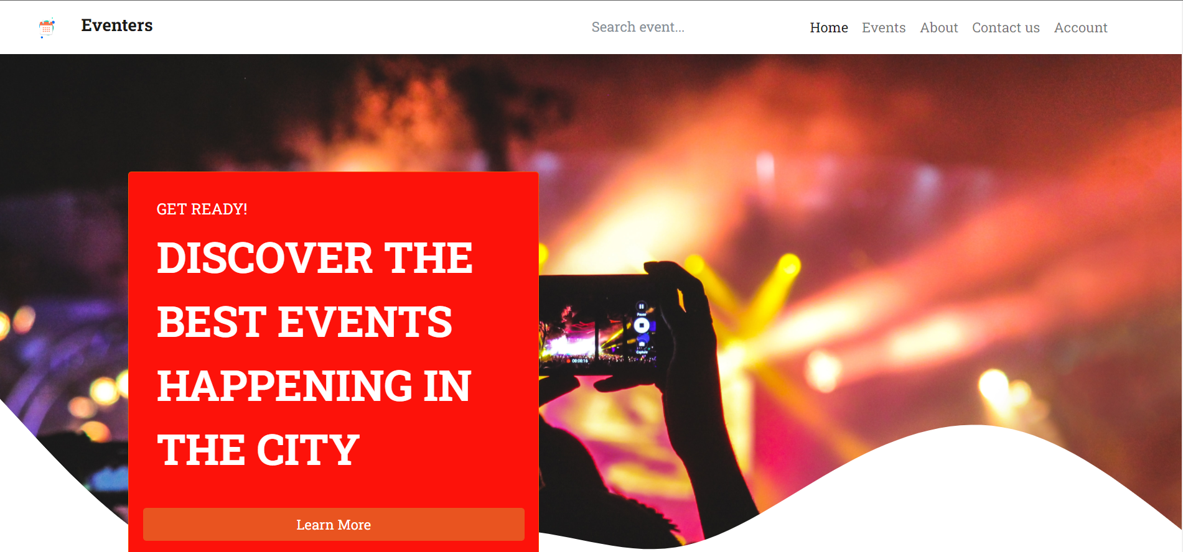

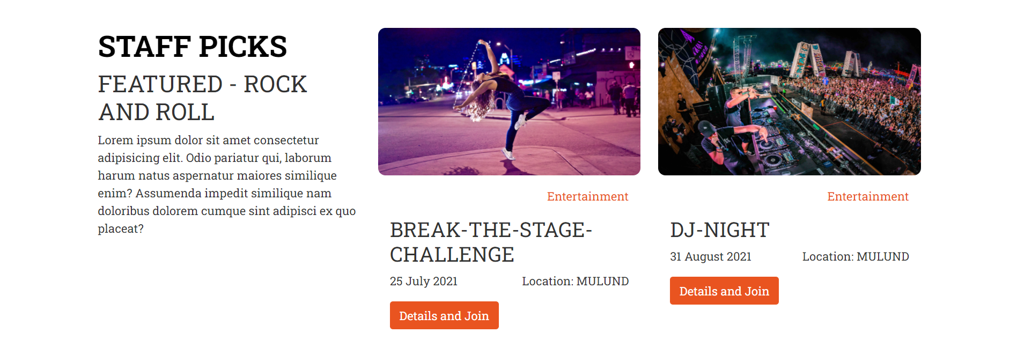

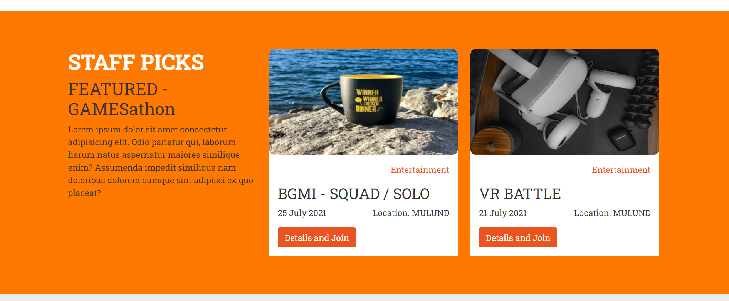

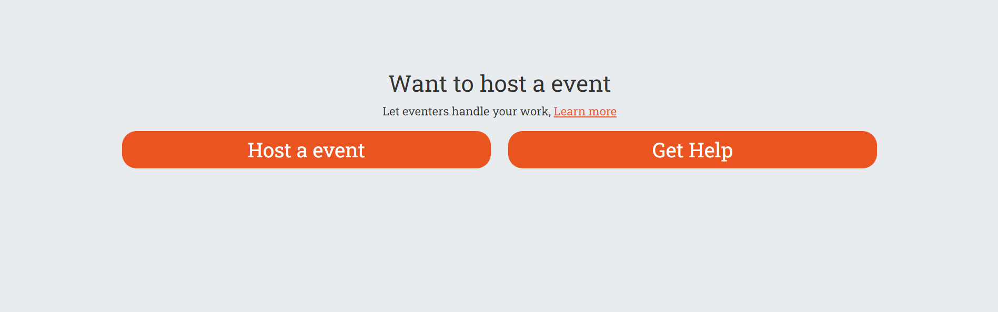

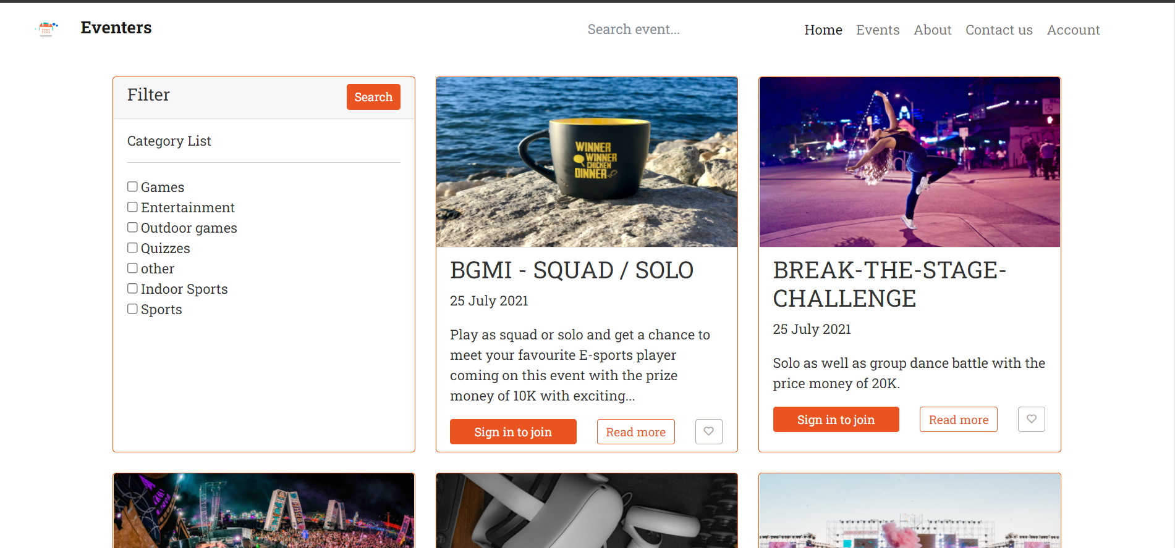

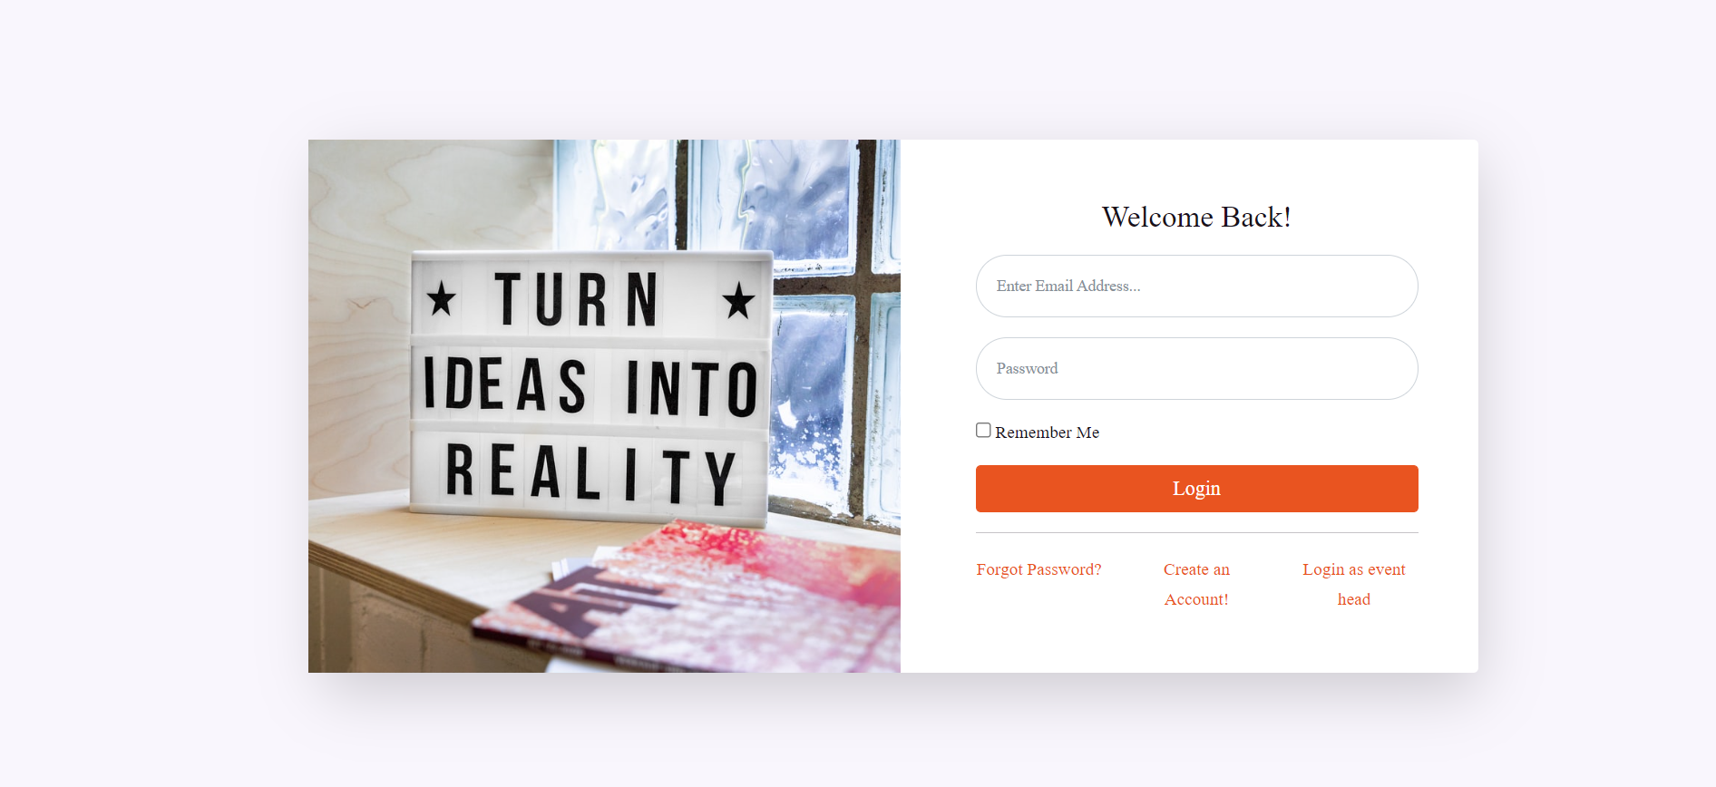

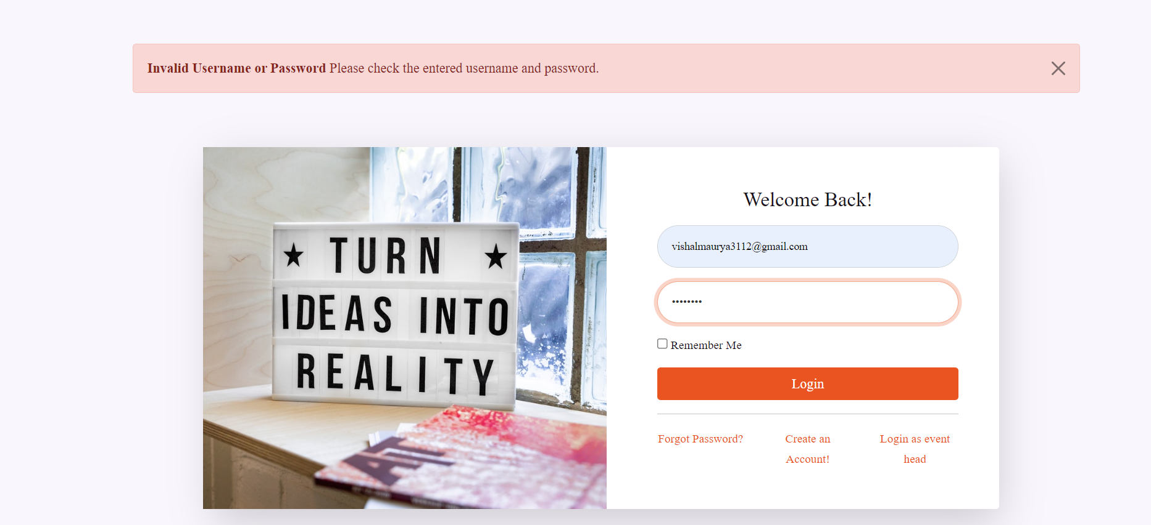

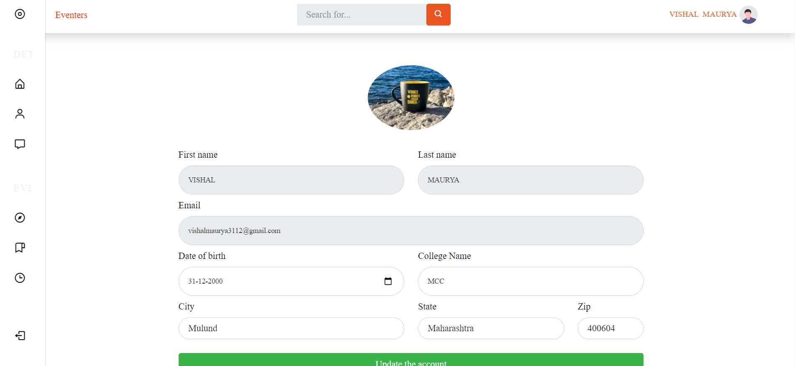

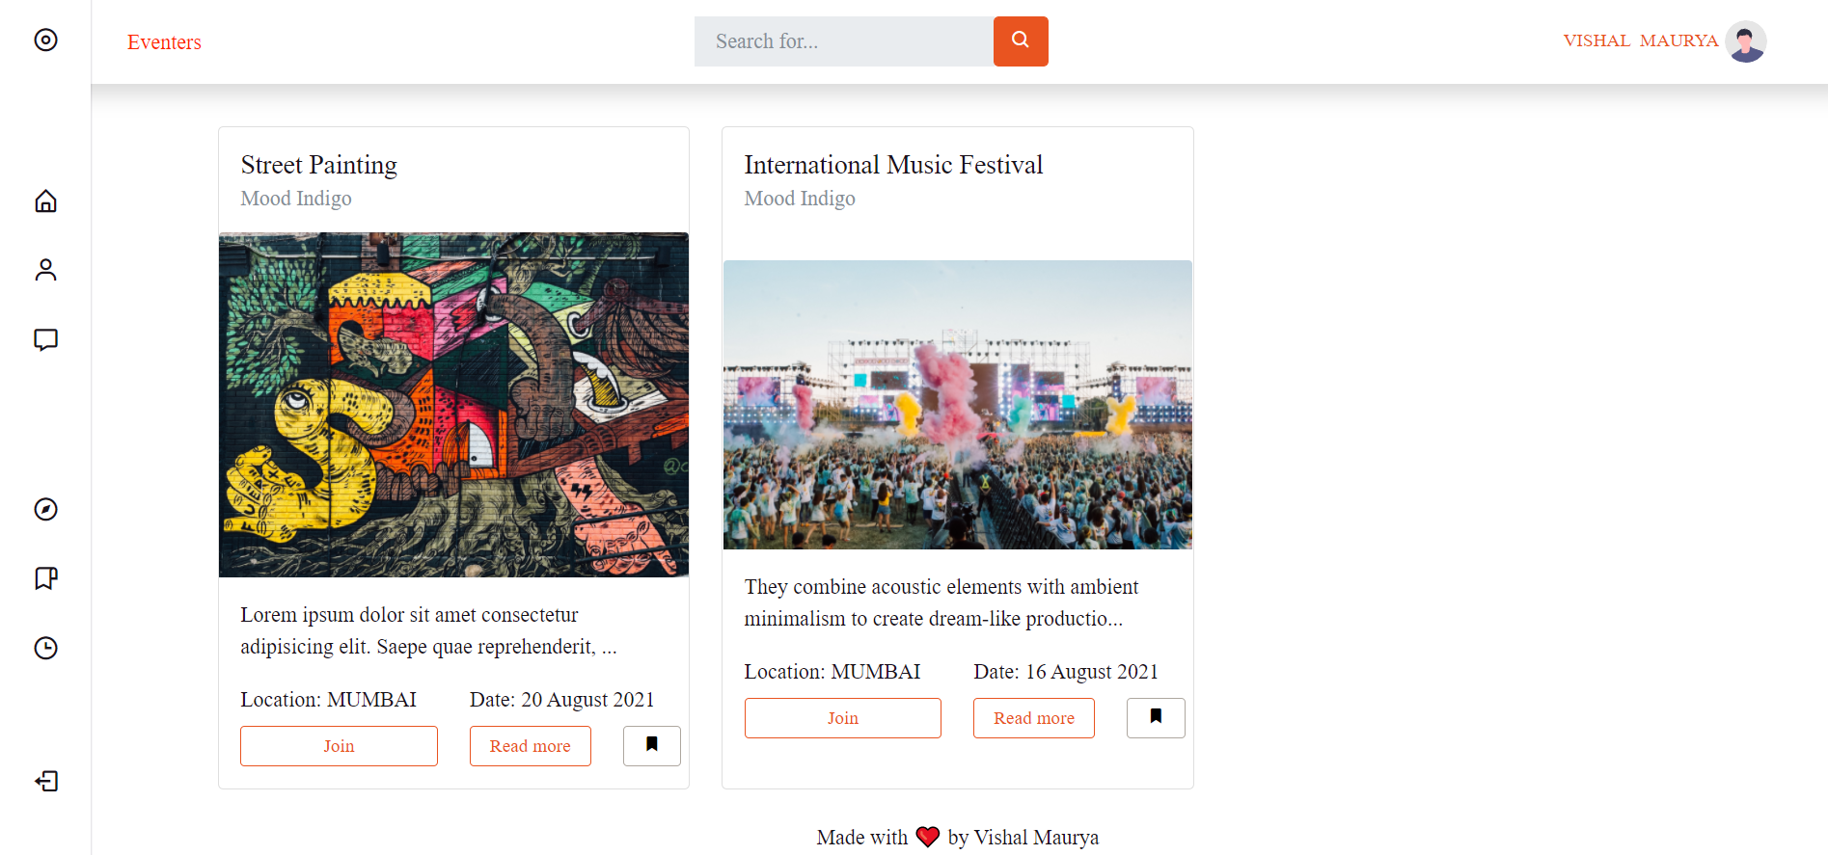

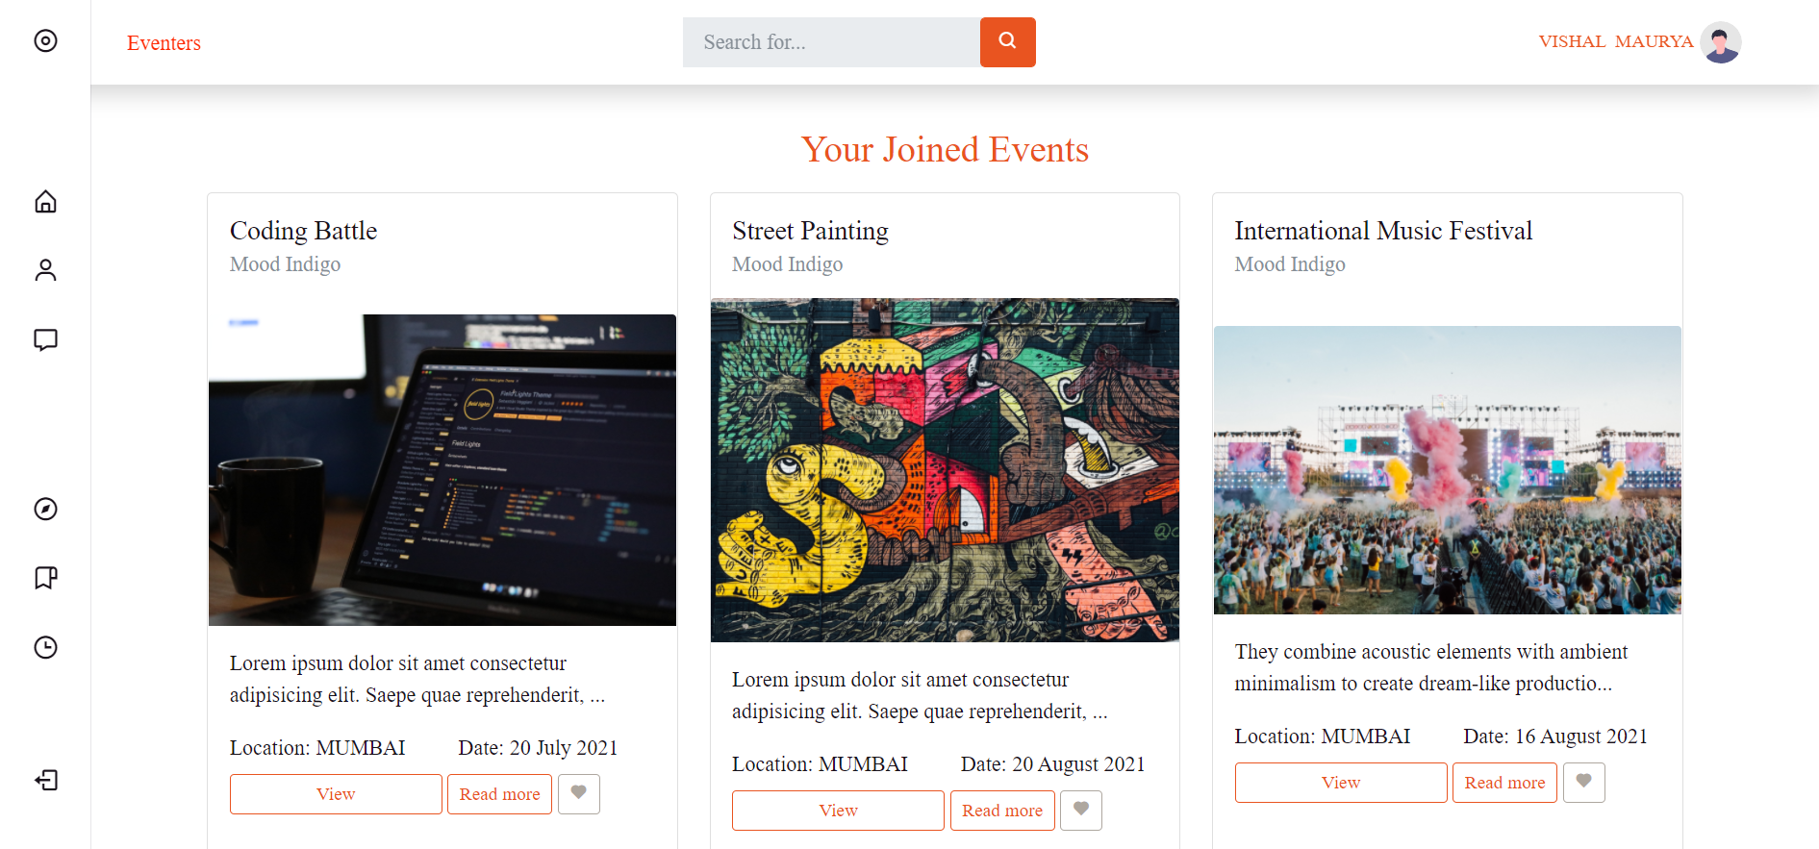

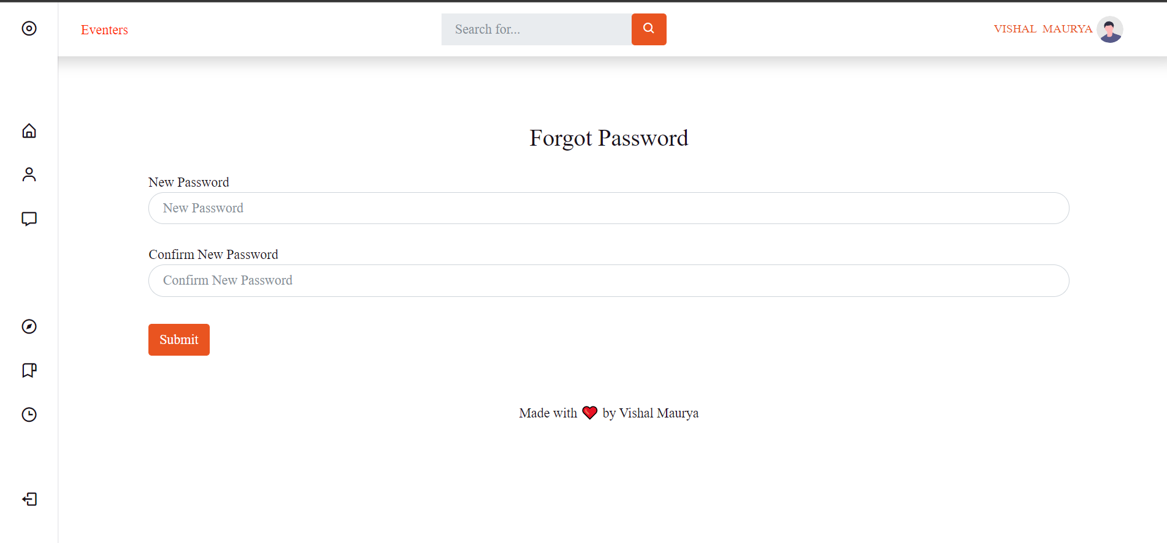

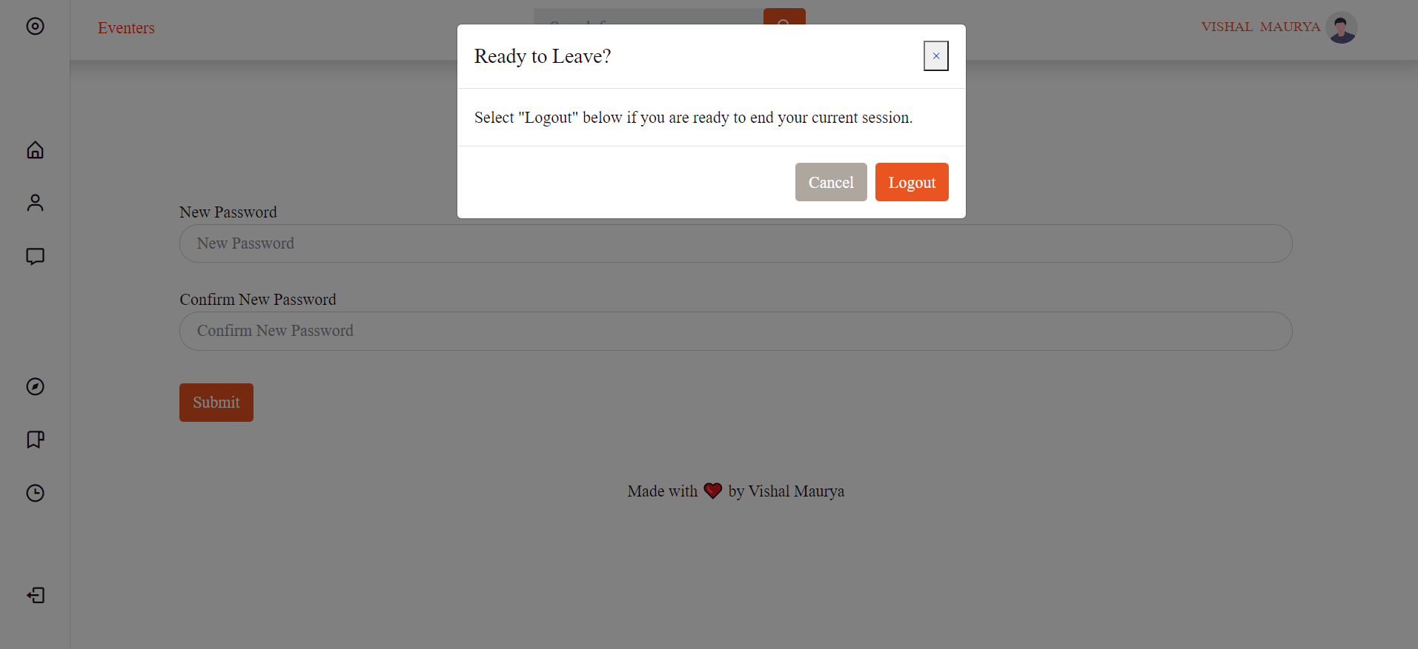

Event Head

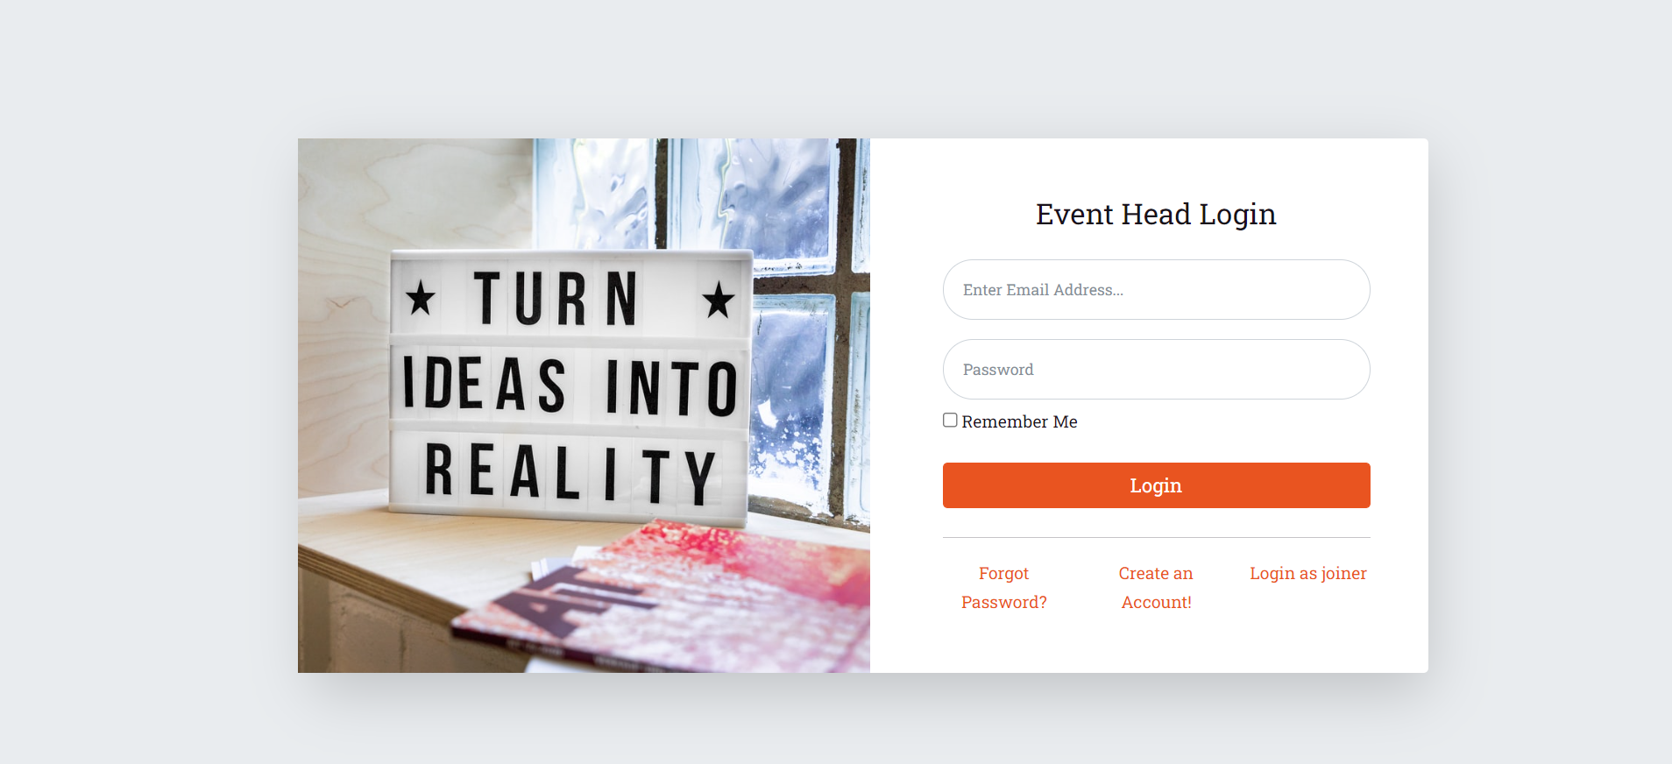

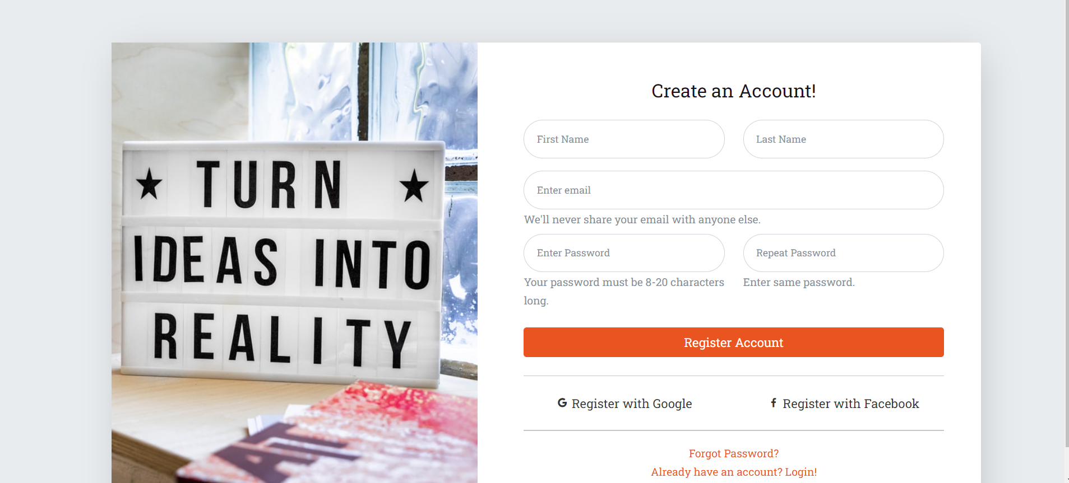

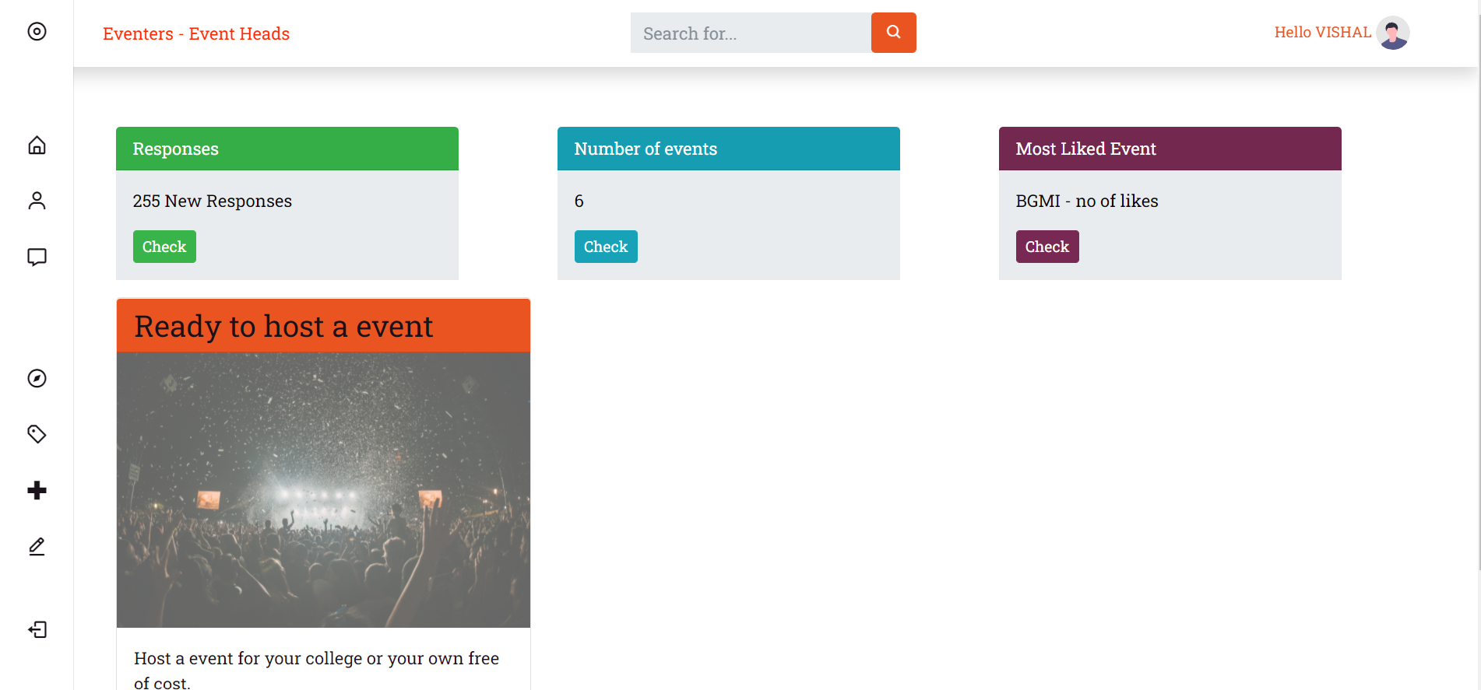

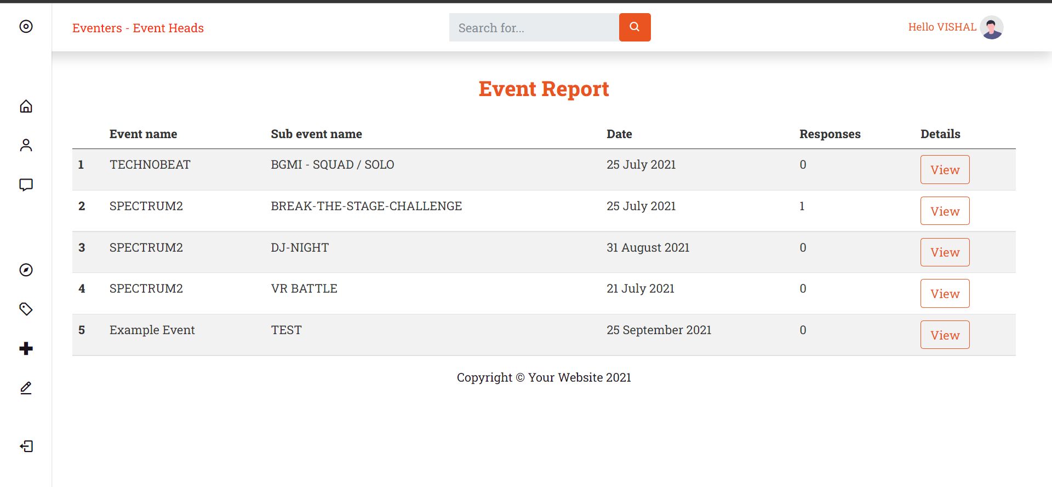

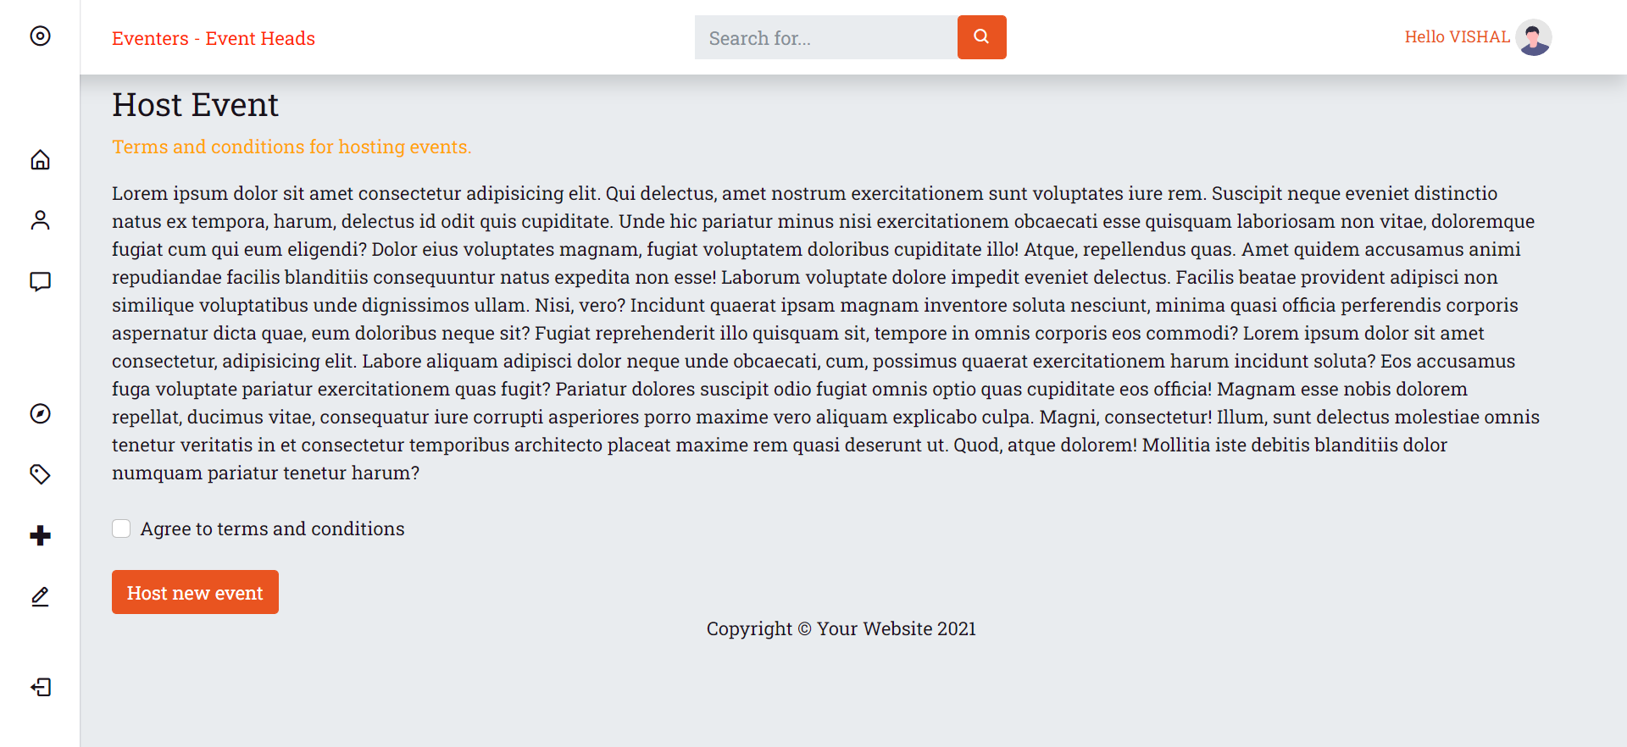

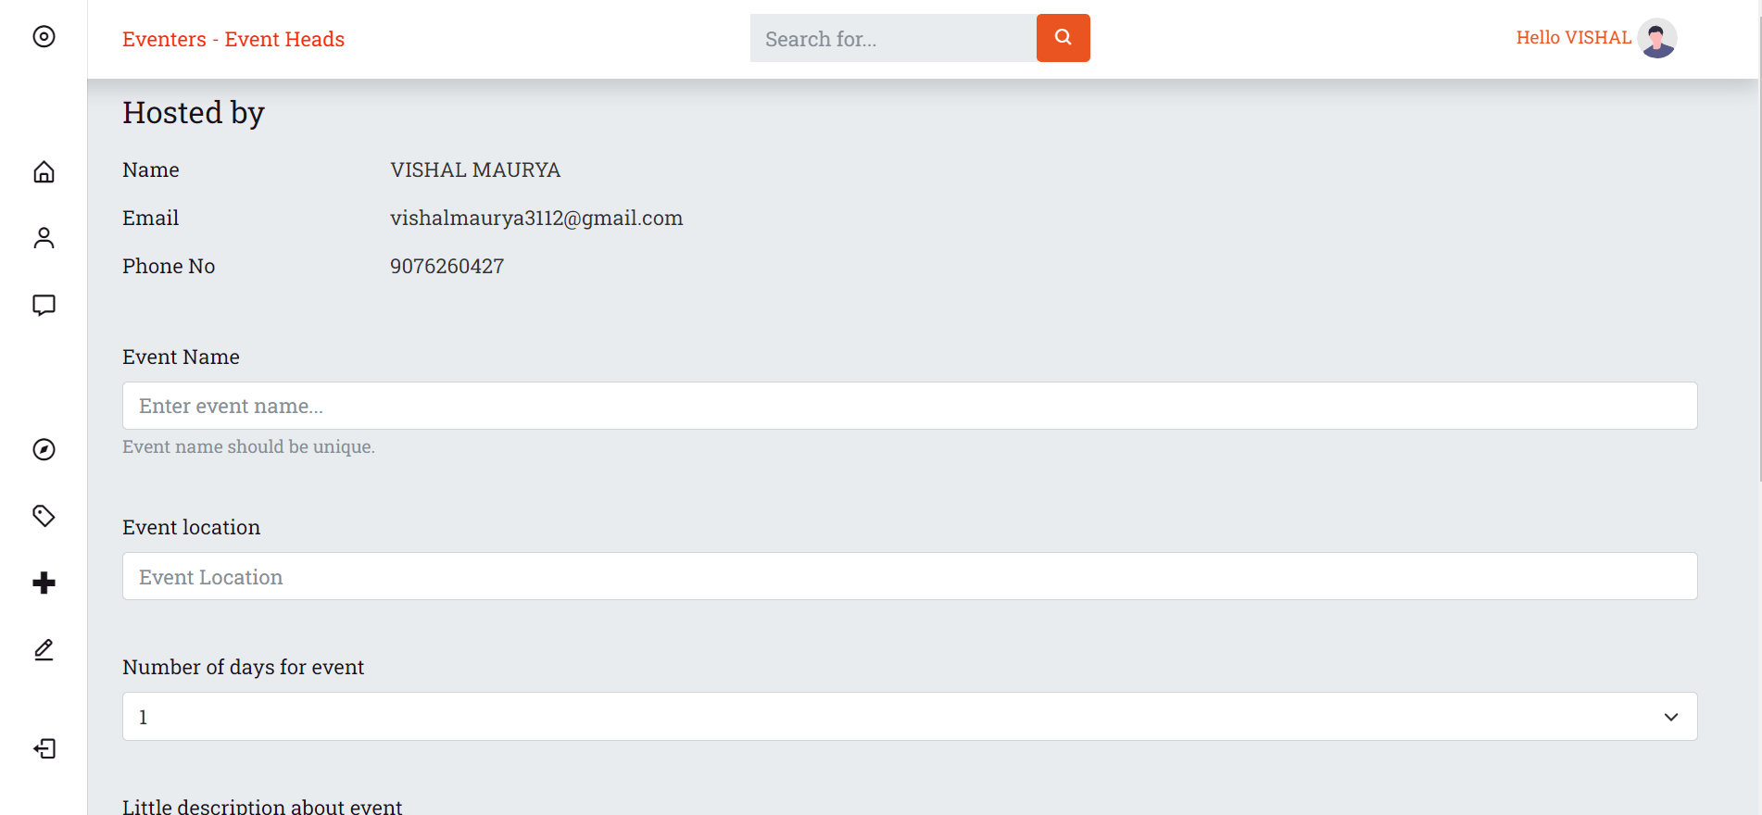

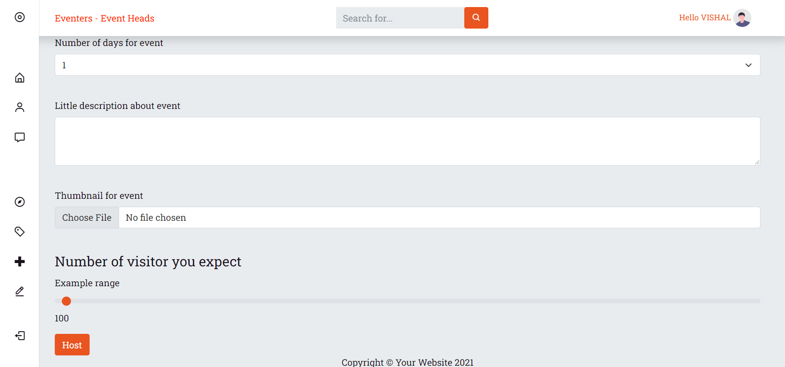

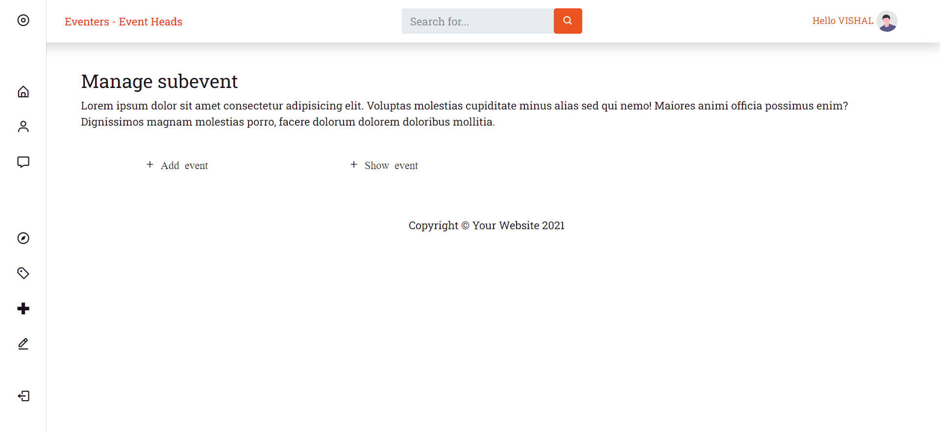

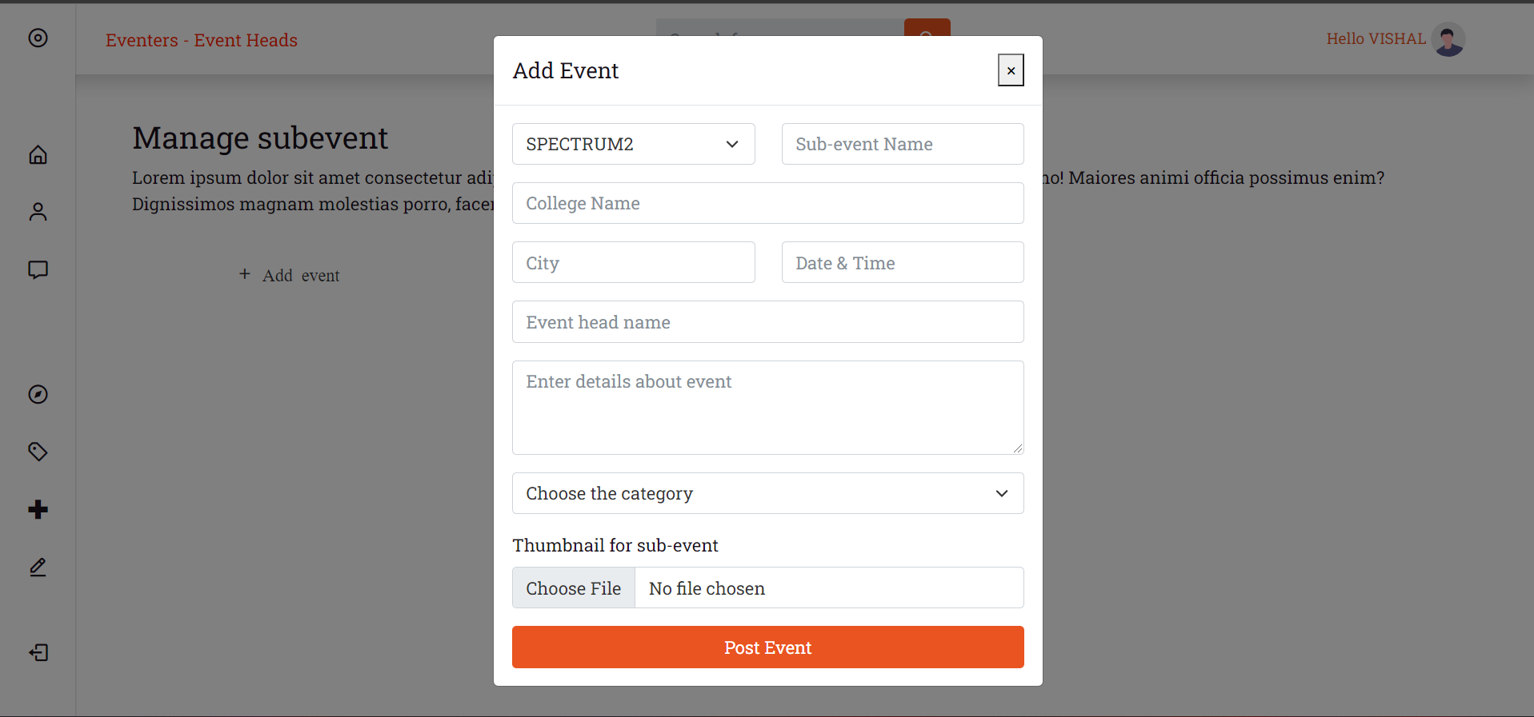

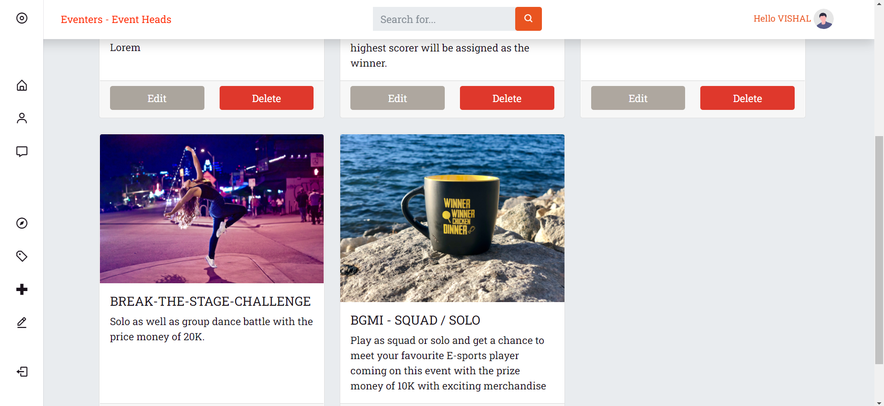

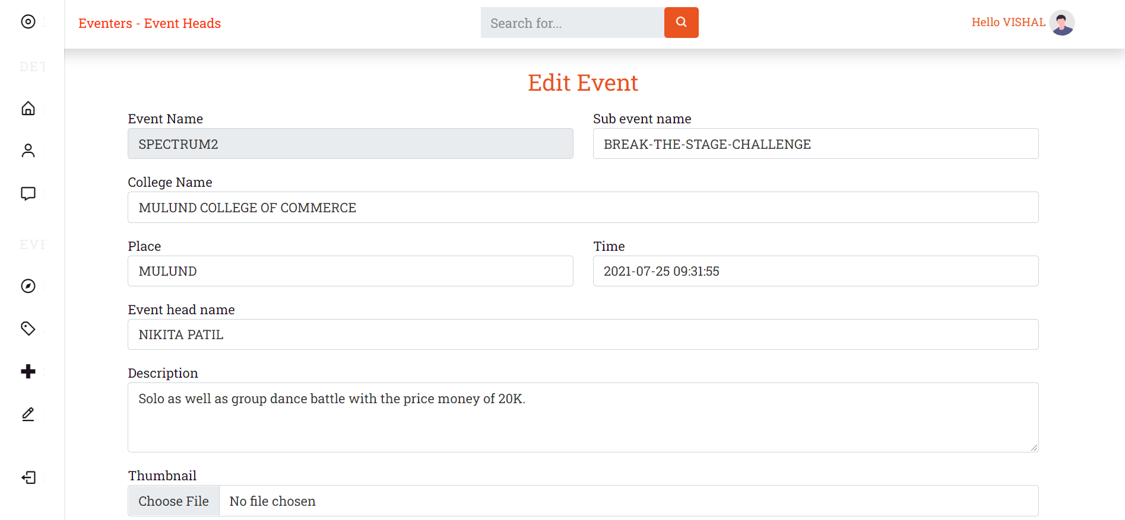

**7. CONCLUSION AND FUTURE ENHANCEMENT**

**7.1 Future enhancement :**

* Show Recommended event based on user previously joined event.
* Generating ticket or pass for joined event.
* Create more secure authentication using jwt tokens
* Addition of comments section
* Making report event for user so that people can report the event.
* Creating downloadable excel files for response on events.

**7.2 Conclusion:**

Eventers is a fully scalable website and ready to be deployed on cloud. It will help many colleges to manage event more properly without any requiring the PR team. The Website has admin section which will help to gather report of the responses on each event.

The website is completely free without any ads so that people can use it without any disturbance.

The user can join any event at any time hence user will have more flexibility.

**8 . REFERENCES**

**8.1 Web references:**

* <https://stackoverflow.com/>
* <https://www.youtube.com/>
* <https://www.php.net>

**ANNEXURE**

**List of Figures**

|  |  |  |
| --- | --- | --- |
| **Figure No.** | **Figure Name** | **Page No.** |
| 4.2 | Class Diagram | 6 |
| 4.3 | Use Case Diagram | 7 |
| 4.4 | Activity Diagram | 8 |
| 4.5 | Package Diagram | 9 |
| 4.6 | Sequence Diagram | 10 |
| 4.7 | Component Diagram | 12 |
| 4.8 | Deployment Diagram | 14 |
| 4.9 | State Diagram | 16 |

**List of Tables**

|  |  |  |
| --- | --- | --- |
| **Table No.** | **Table Name** | **Page No.** |
| **4.1** | **Event table** | **4-5** |
| **4.2 – 4.9** | **Diagrams** | **6-16** |
| **4.10** | **Database design** | **17 - 22** |
| **6.1.1** | **Control List** | **126** |